 |  |  |  | ADA Checklist for Existing Facilities
 |  |  |  | Priority 1 – Approach & Entrance
 |  |  |  | Based on the 2010 ADA Standards for Accessible Design
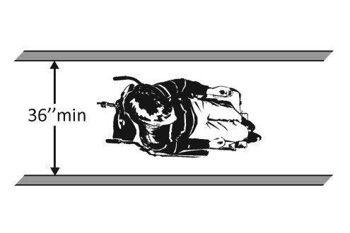 |  |  |  |  |  |  |  |  | Project
 |  |  |  |  |  |  |  |  | Building
 |  |  |  |  |  |  |  |  | Location
 |  |  |  |  |  |  |  |  | Date
 |  |  |  |  |  |  |  |  | Surveyors
 |  |  |  |  |  |  |  |  | Contact Information
 |  | An accessible route from site arrival points and an accessible entrance should be provided for everyone.
 |  |  | Institute for Human Centered Design  www.HumanCenteredDesign.org  Copyright © 2016 |  |  |  |  | ADA National Network  Questions on the ADA 800-949-4232 voice/tty  www.ADAchecklist.org

This checklist was produced by the New England ADA Center, a project of the Institute for Human Centered Design and a member of the ADA National Network. This checklist was developed under a grant from the Department of Education, NIDRR grant number H133A060092-09A. However the contents do not necessarily represent the policy of the Department of Education, and you should not assume endorsement by the Federal Government.
Questions or comments on the checklist contact the New England ADA Center at 617-695-0085 voice/tty or ADAinfo@NewEnglandADA.org
For the full set of checklists, including the checklists for recreation facilities visit www.ADAchecklist.org.
Copyright © 2016 ADA Checklist for Existing Materials. You can freely reproduce and distribute this content. Include proper attribution. But you must get permission before using this content as a fee-based product.

Priority 1 – Approach & Entrance |  |  |  | Comments |  |  | Possible Solutions
1.1 | Is there at least one route from site arrival points (parking, passenger loading zones, public sidewalks and public transportation stops) that does not require the use of stairs?  [See 2010 ADA Standards for Accessible Design – 206.2.1] | □Yes □No  If yes, location of route: |  |  | Photo #: | • Add a ramp  • Regrade to 1:20 maximum slope  • Add a lift if site constraints prevent other solutions
Parking Accessible parking spaces should be identified by size, access aisle and signage.
1.2 | If parking is provided for the public, are an adequate number of accessible spaces provided?  [208.2] | □Yes □No  Total #:  Accessible #: |  |  | Photo #: | • Reconfigure by repainting lines  •  •
  Total Spaces | Accessible Spaces
  1 - 25 | 1
  26 - 50 | 2
  51 - 75 | 3
  76 - 100 | 4
  100+ see 2010 Standards 208.2
1.3 | Of the accessible spaces, is at least one a van accessible space?*  [208.2.4] | □Yes □No | *For every 6 or fraction of 6 parking spaces required by the table above, at least 1 should be a van accessible space. |  | Photo #: | * If constructed before 3/15/2012, parking is compliant if at least 1 in every 8 accessible spaces is van accessible  • Reconfigure by repainting lines
1.4 | Are accessible spaces at least 8 feet wide with an access aisle at least 5 feet wide?  [502.2, 502.3]  Note: Two spaces may share an access aisle. Check state/local requirements; some specify that each space have its own aisle. | □Yes □No  Measurement: | 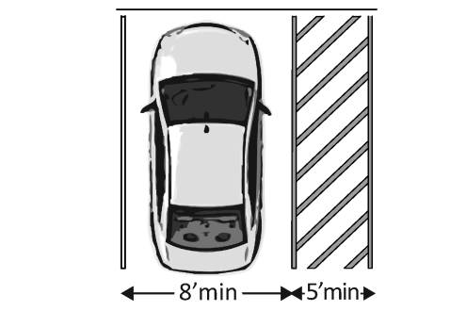 |  | Photo #: | • Reconfigure by repainting lines  •  •
1.5 | Is the van accessible space:  At least 11 feet wide with an access aisle at least 5 feet wide?  Or  At least 8 feet wide with an access aisle at least 8 feet wide?  [502.2] | □Yes □No  Measurement:  □Yes □No  Measurement: | 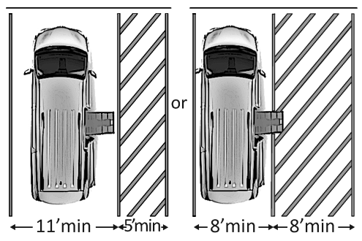 |  | Photo #: | • Reconfigure to provide van-accessible space(s)  •  •
1.6 | Is at least 98 inches of vertical clearance provided for the van accessible space?  [502.5] | □Yes □No  Measurement: | 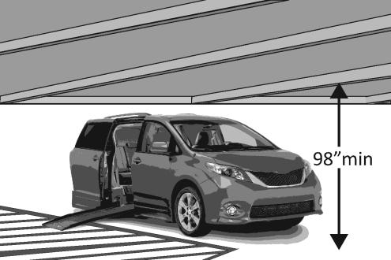 |  | Photo #: | • Reconfigure to provide van-accessible space(s)  •  •
1.7 | Are the access aisles marked so as to discourage parking in them?  [502.3.3]  Note: The marking method and color may be addressed by state/local requirements. | □Yes □No | 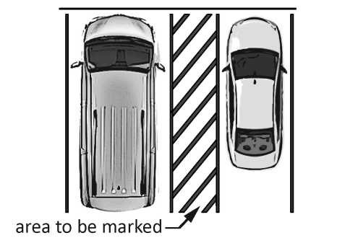 |  | Photo #: | • Mark access aisles  •  •
1.8 | Is the slope of the accessible parking spaces and access aisles no steeper than 1:48 in all directions?  [502.4] | □Yes □No  Measurement: |  |  | Photo #: | • Regrade surface  •  •
1.9 | Do the access aisles adjoin an accessible route?  [502.3] | □Yes □No | 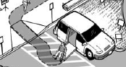 |  | Photo #: | • Create accessible route  • Relocate accessible space  •
1.10 | Are accessible spaces identified with a sign that includes the International Symbol of Accessibility?  Is the bottom of the sign at least 60 inches above the ground?  [502.6]  Note: The International Symbol of Accessibility is not required on the ground. | □Yes □No  □Yes □No  Measurement: | 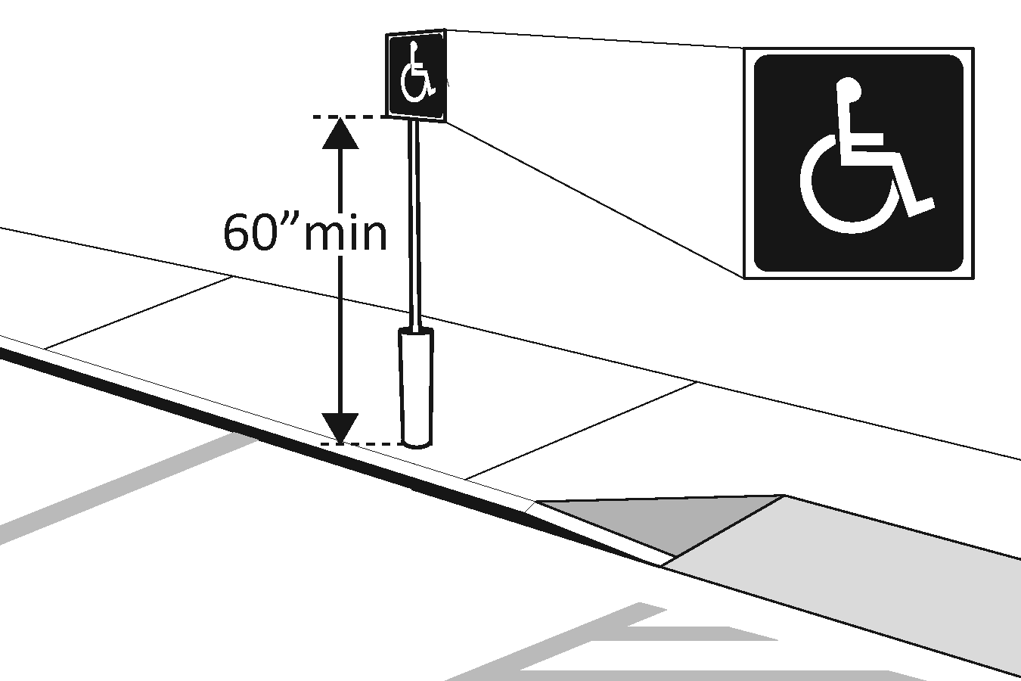 |  | Photo #: | • Install signs  •  •
1.11 | Are there signs reading “van accessible” at van accessible spaces?  [502.6] | □Yes □No | 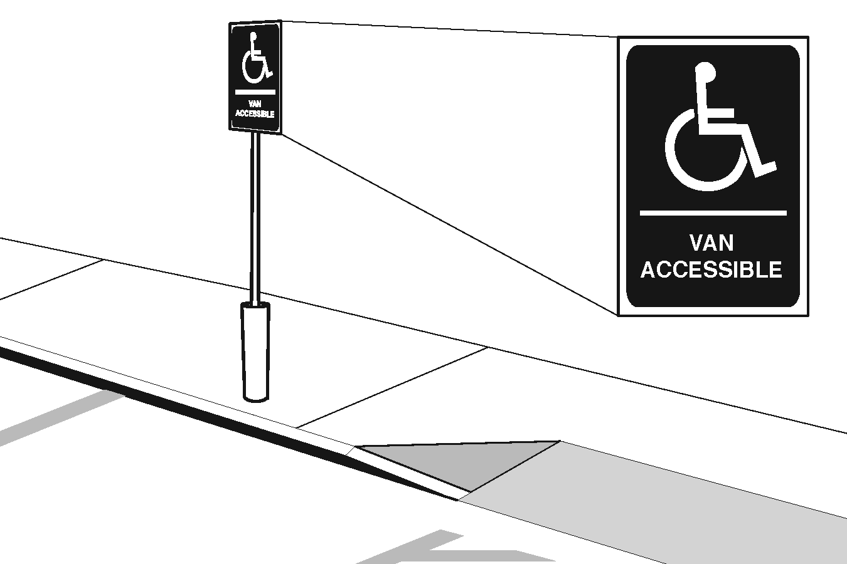 |  | Photo #: | • Install signs  •  •
1.12 | Of the total parking spaces, are the accessible spaces located on the closest accessible route to the accessible entrance(s)?  [208.3.1]  Note: If parking serves multiple entrances, accessible parking should be dispersed. | □Yes □No |  |  | Photo #: | • Reconfigure spaces  •  •
Exterior Accessible Route
1.13 | Is the route stable, firm and slip-resistant?  [302.1] | □Yes □No |  |  | Photo #: | • Repair uneven paving  • Fill small bumps and breaks with patches  • Replace gravel with asphalt or other surface
1.14 | Is the route at least 36 inches wide?  [403.5.1]  Note: The accessible route can narrow to 32 inches min. for a max. of 24 inches. These narrower portions of the route must be at least 48 inches from each other. | □Yes □No  Measurement: | 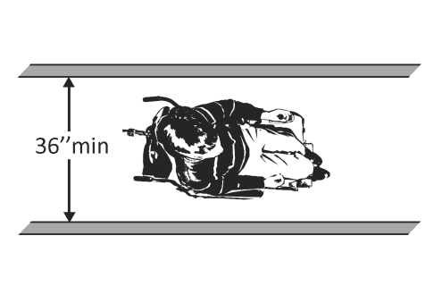  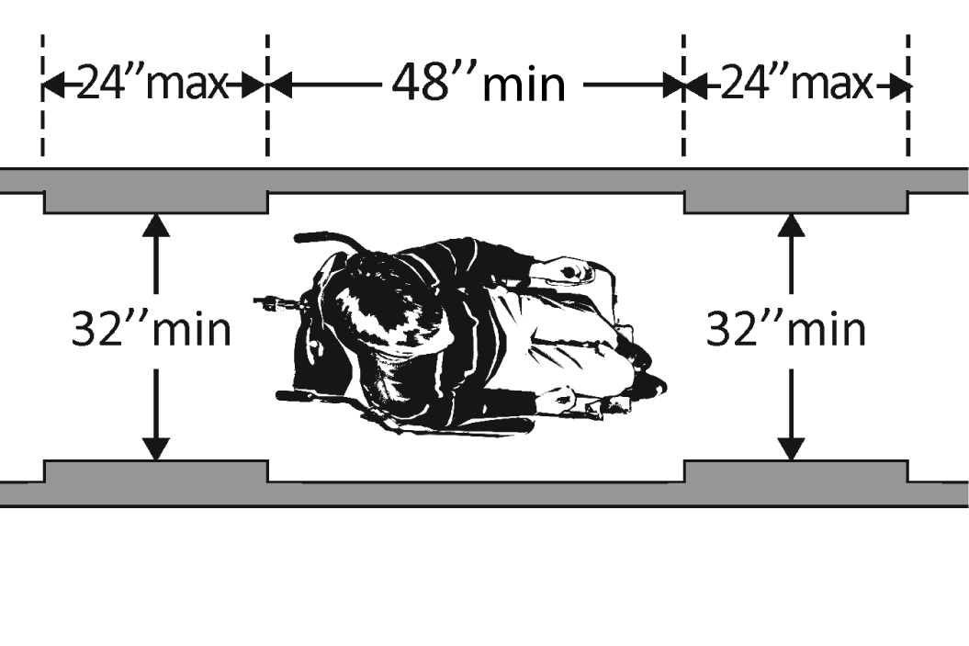 |  | Photo #: | • Change or move landscaping, furnishings or other items  • Widen route  •
1.15 | If the route is greater than 200 feet in length and less than 60 inches wide, is there a passing space no less than 60 x 60 inches?  [403.5.3] | □Yes □No  Measurement: | 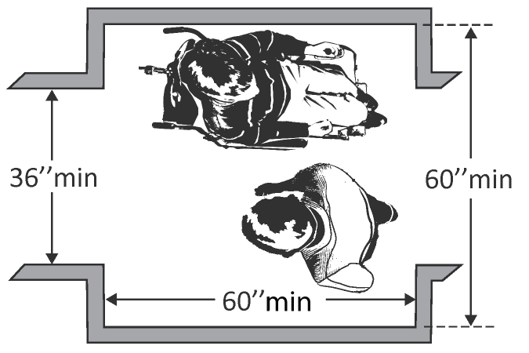 |  | Photo #: | • Widen route for passing space  •  •
1.16 | If there are grates or openings on the route, are the openings no larger than ½ inches?  Is the long dimension perpendicular to the dominant direction of travel?  [302.3] | □Yes □No  Measurement:  □Yes □No | 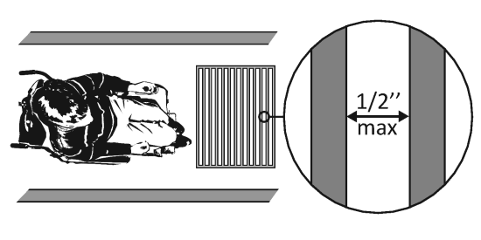 |  | Photo #: | • Replace or move grate  •  •
1.17 | Is the running slope no steeper than 1:20, i.e. for every inch of height change there are at least 20 inches of route run?  [403.3]  Note: If the running slope is steeper than 1:20, treat as a ramp and add features such as edge protection and handrails. | □Yes □No  Measurement: | 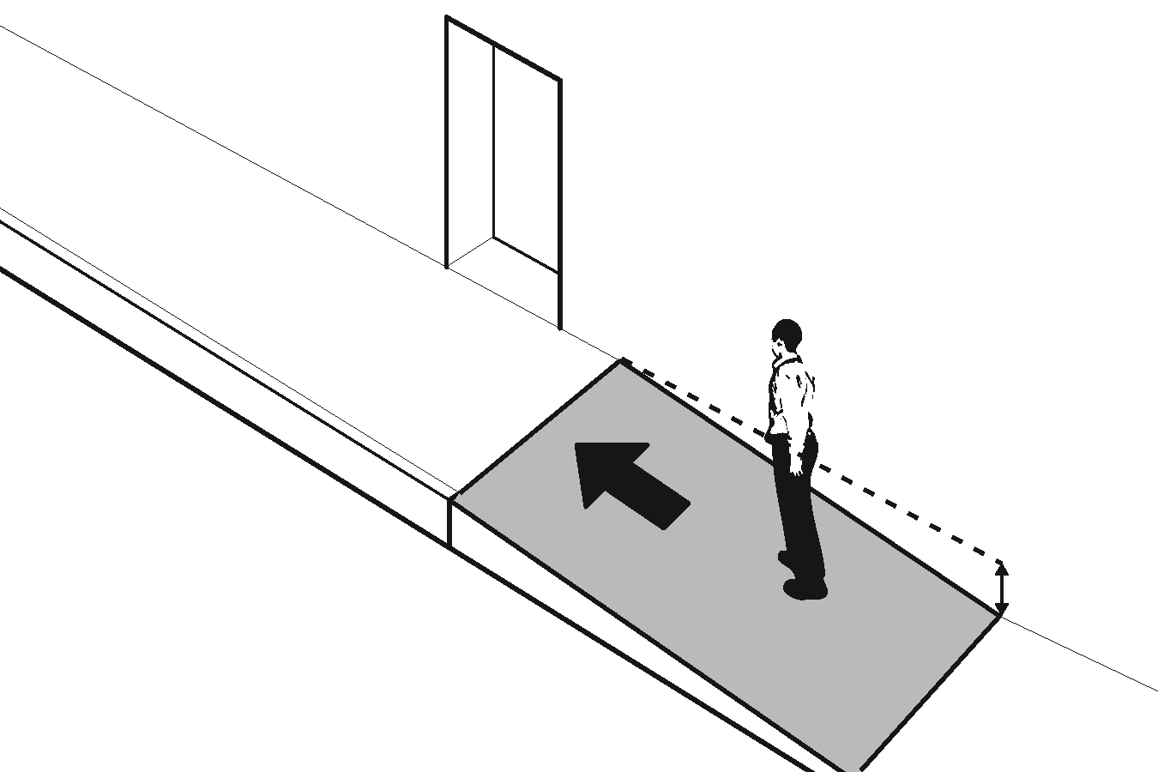 |  | Photo #: | • Regrade to 1:20 max.  •  •
1.18 | Is the cross slope no steeper than 1:48?  [403.3] | □Yes □No  Measurement: | 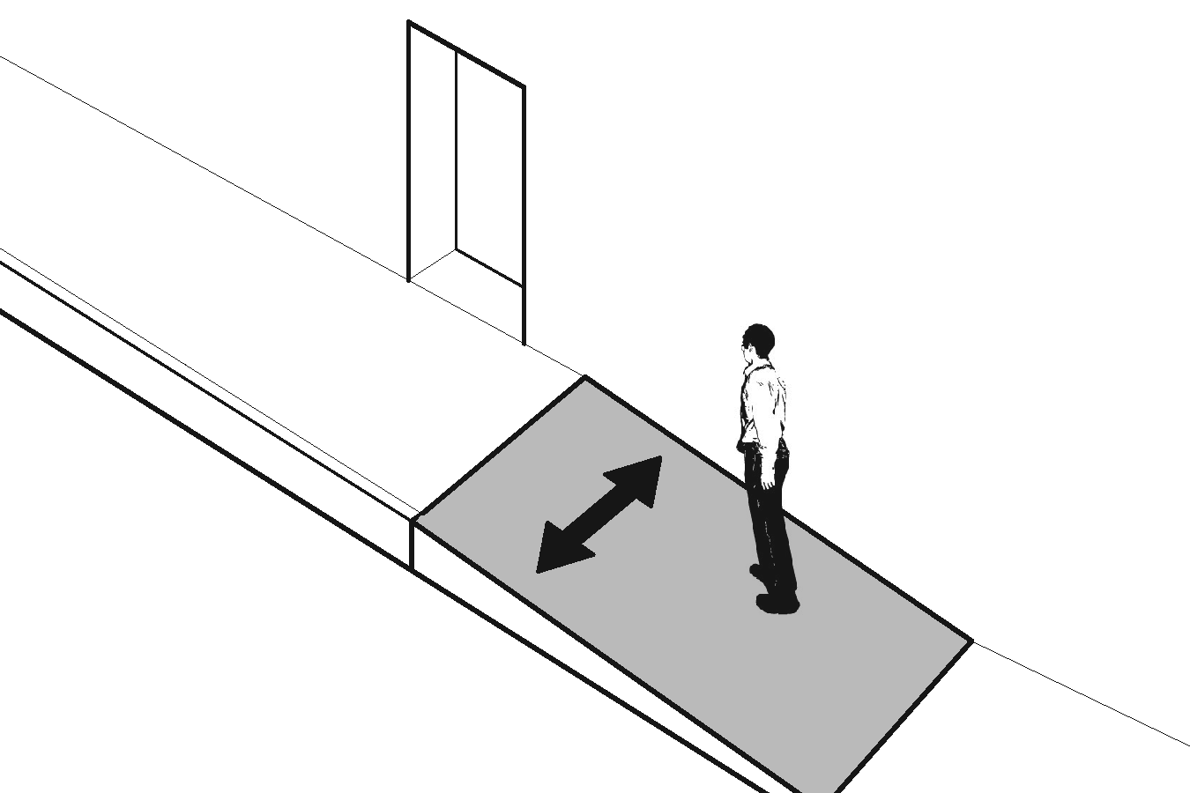 |  | Photo #: | • Regrade to 1:48 max.  •  •

Curb Ramps
1.19 | If the accessible route crosses a curb, is there a curb ramp?  [402.2] | □Yes □No | 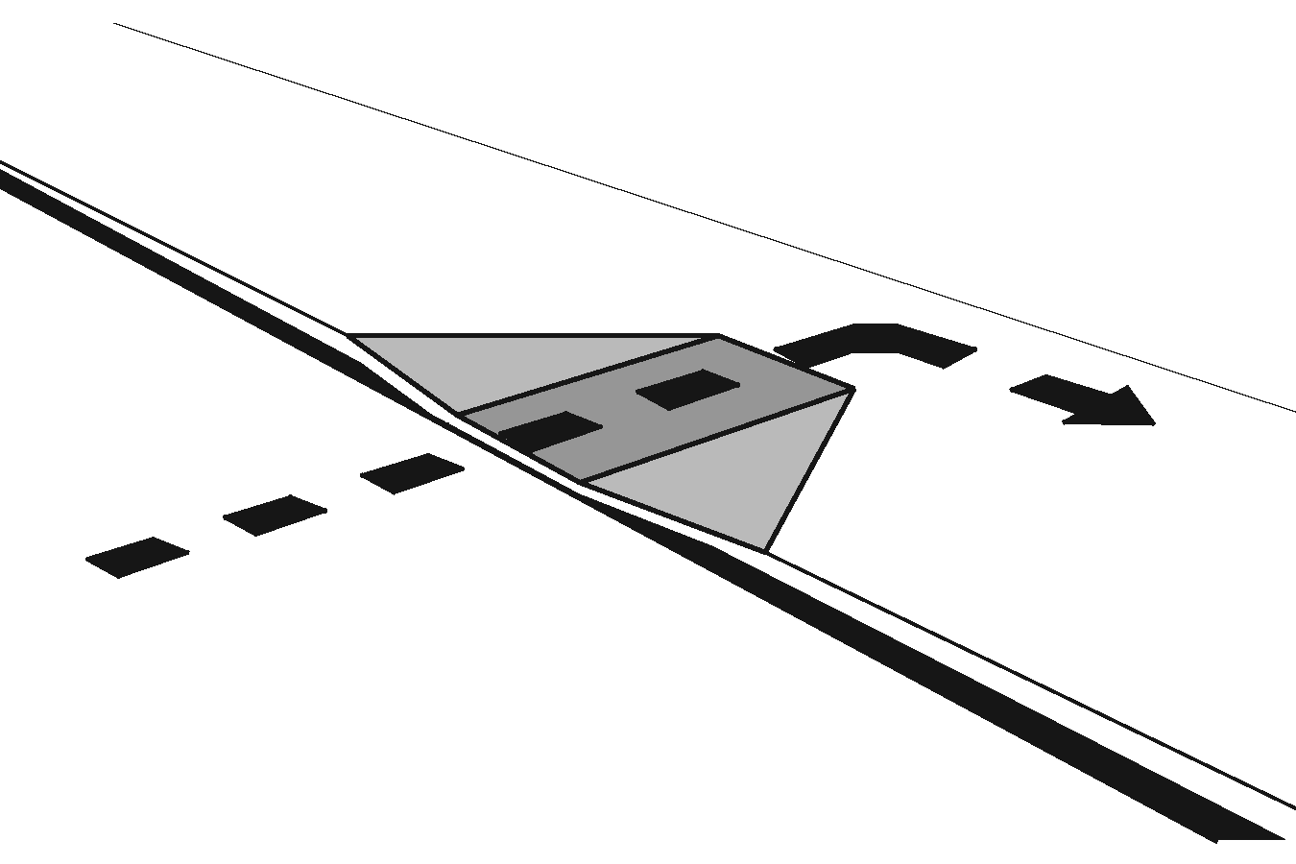 | Photo #: | • Install curb ramp  •  •
1.20 | Is the running slope of the curb ramp no steeper than 1:12, i.e. for every inch of height change there are at least 12 inches of curb ramp run?  [406.1, 405.2] | □Yes □No  Measurement: | 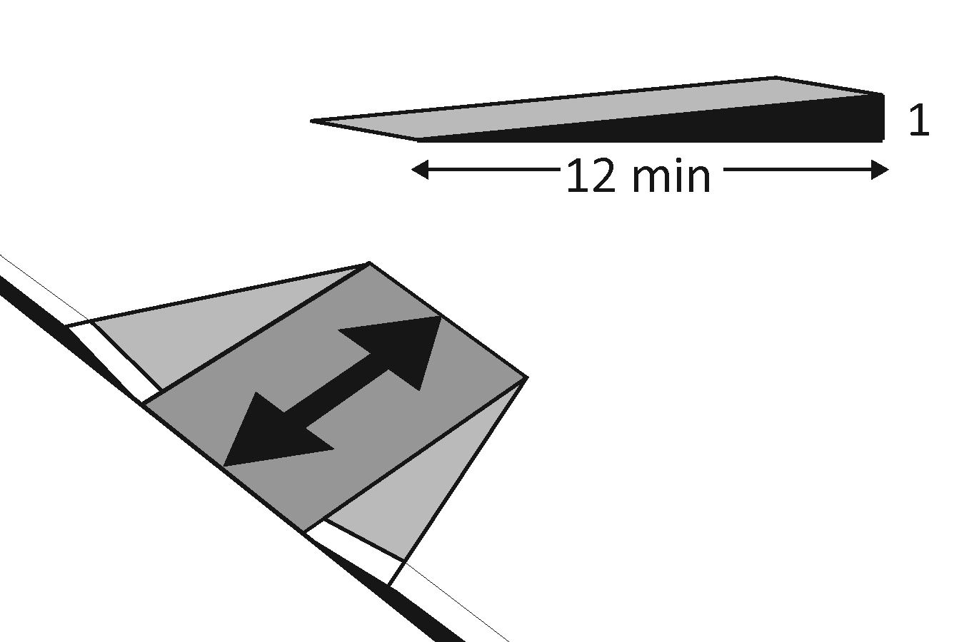 | Photo #: | • Regrade curb ramp  •  •
1.21 | Is the cross slope of the curb ramp, excluding flares, no steeper than 1:48?  [406.1, 405.3] | □Yes □No  Measurement: | 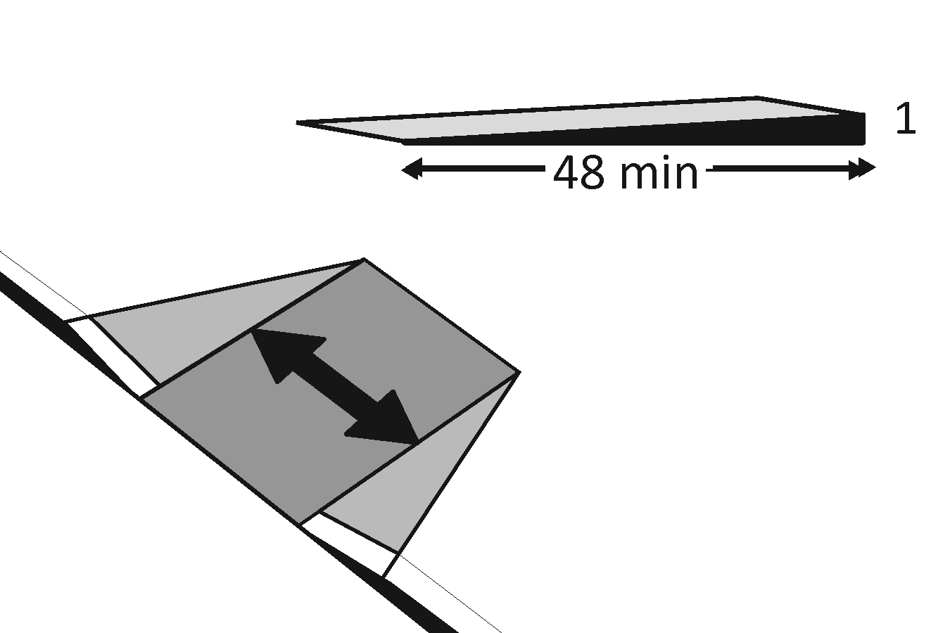 | Photo #: | • Regrade curb ramp  •  •
1.22 | Is the curb ramp, excluding flares, at least 36 inches wide?  [406.1, 405.5] | □Yes □No  Measurement: | 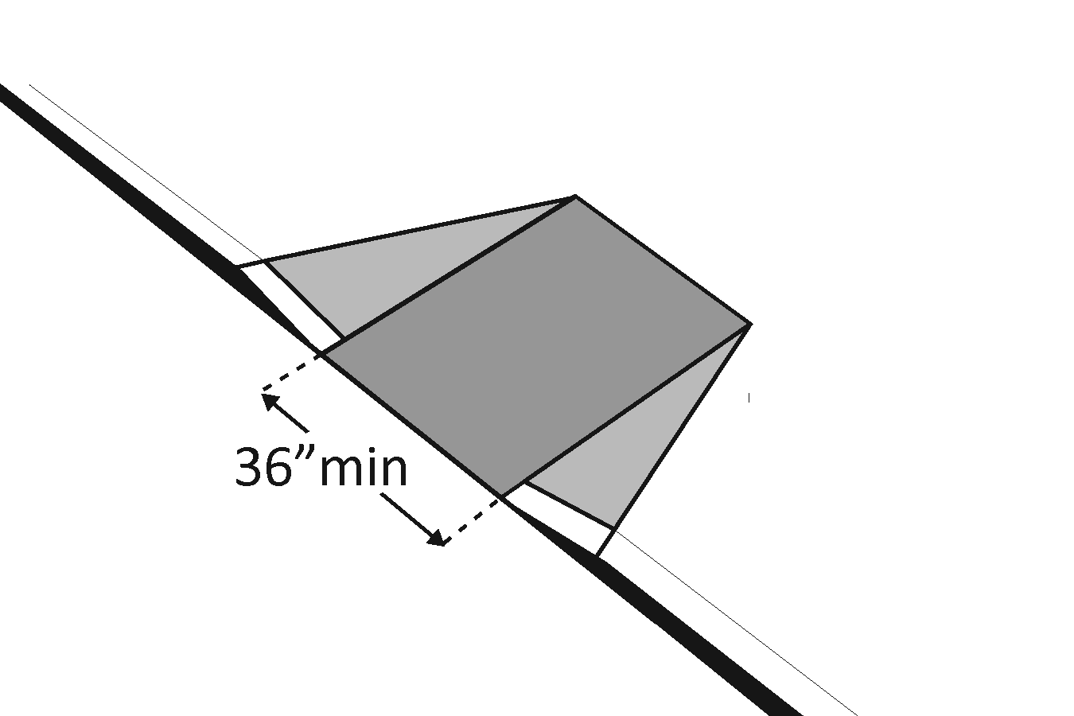 | Photo #: | • Widen curb ramp  •  •
1.23 | At the top of the curb ramp is there a level landing (slope no steeper than 1:48 in all directions) that is at least 36 inches long and at least as wide as the curb ramp?  [406.4]  If there are curb ramp flares, are the slopes of the flares no steeper than 1:10, i.e. for every inch of height change there are at least 10 inches of flare run?  [406.3] | □Yes □No  Measurement:  □Yes □No  Measurement: | 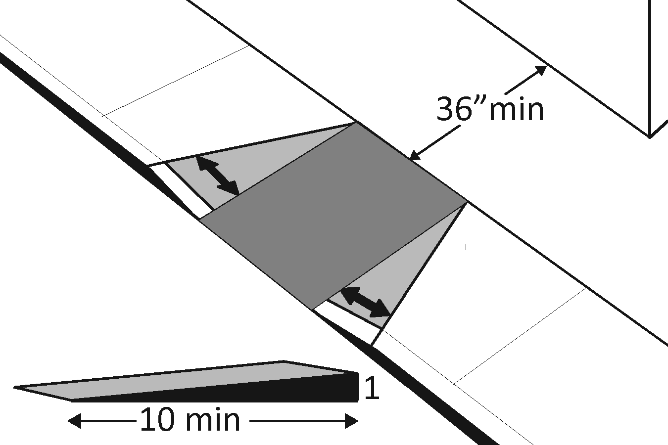 | Photo #: | • Reconfigure  • Add ramp flares  •
1.24 | If the landing at the top is less than 36 inches long, are there curb ramp flares?  Are the slopes of the flares no greater than 1:12, i.e. for every inch of height change there are at least 12 inches of flare run?  [406.4] | □Yes □No  □Yes □No  Measurement: | 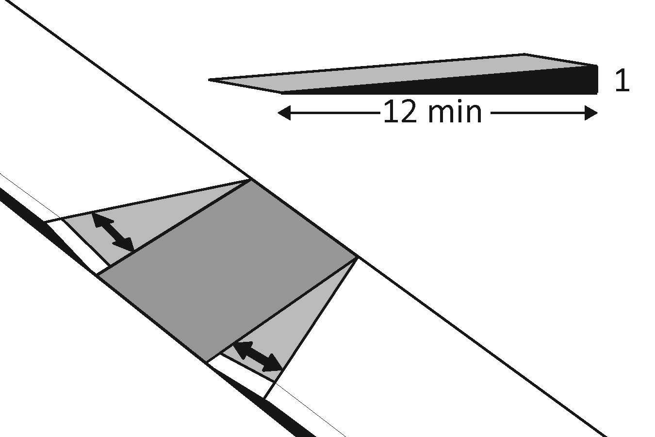 | Photo #: | • Add ramp flares  • Regrade flares  •

Ramps If any portion of the accessible route is steeper than 1:20, it should be treated as a ramp.
1.25 | If there is a ramp is it at least 36 inches wide?  [405.5]  Note: If there are handrails, measure between the handrails. | □Yes □No  Measurement: | 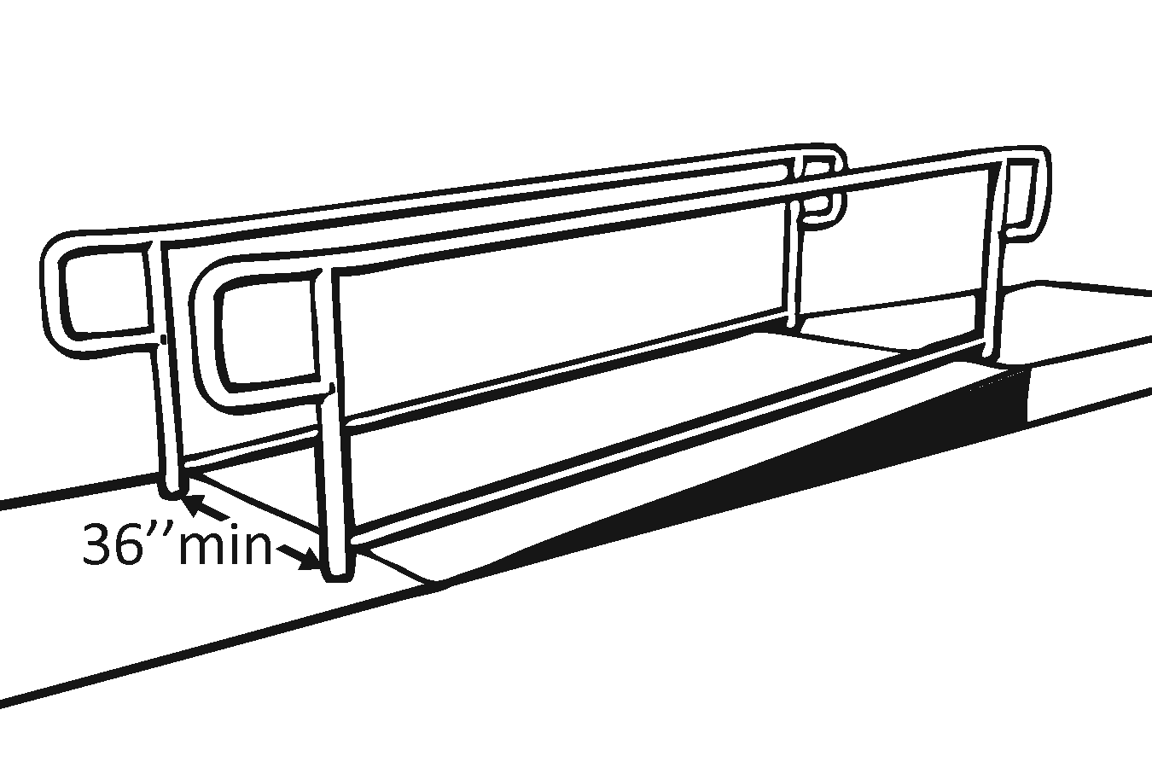 | Photo #: | • Alter ramp  •  •
1.26 | Is the surface stable, firm and slip resistant?  [405.4] | □Yes □No |  | Photo #: | • Resurface ramp  •  •
1.27 | For each section of the ramp, is the running slope no greater than 1:12, i.e. for every inch of height change there are at least 12 inches of ramp run?  [405.2]  Note: Rises no greater than 3 inches with a slope no steeper than 1:8 and rises no greater than 6 inches with a slope no steeper than 1:10 are permitted when such slopes are necessary due to space limitations. | □Yes □No  Measurement: | 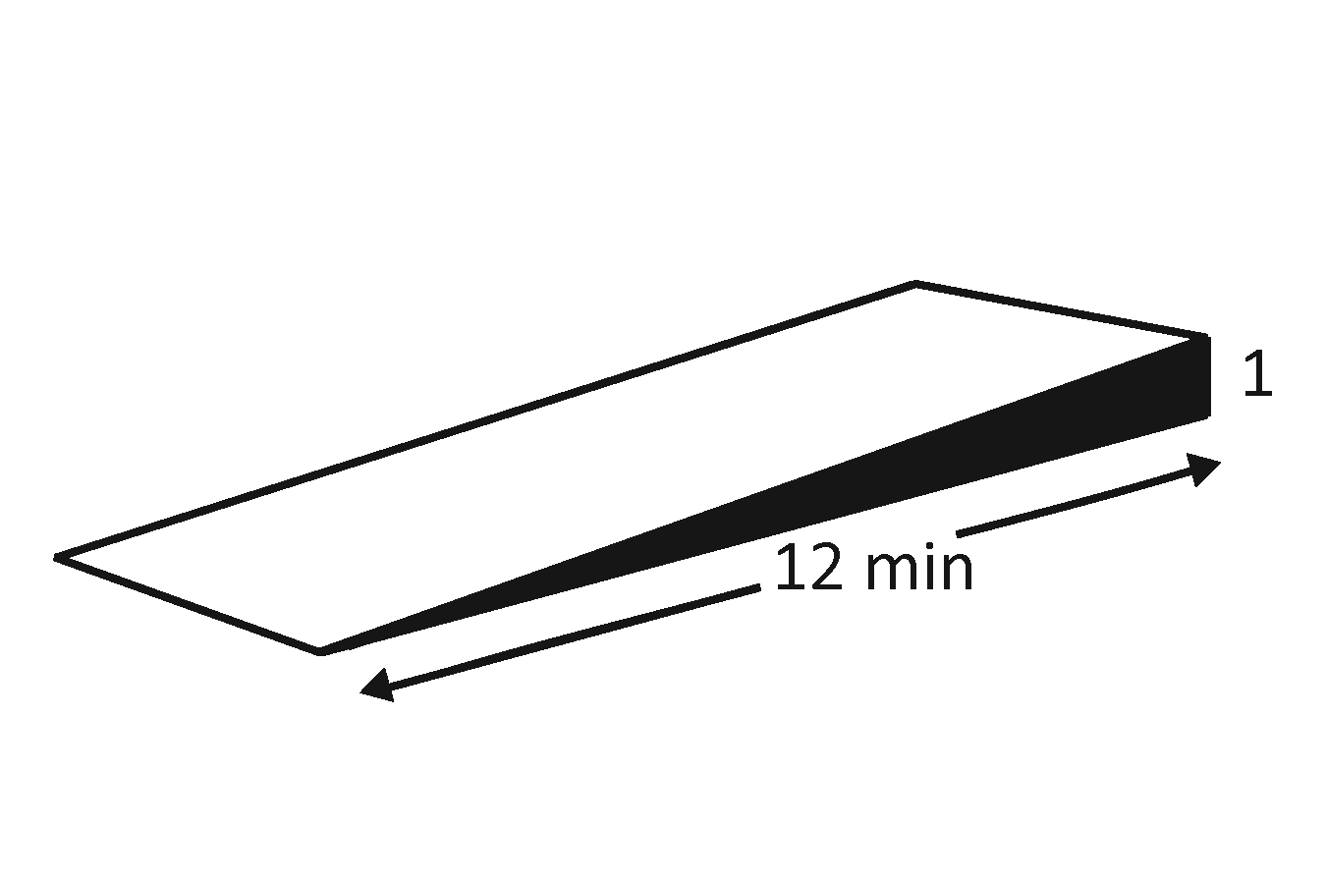 | Photo #: | • Relocate ramp  • Lengthen ramp to decrease slope  •
1.28 | Is there a level landing that is at least 60 inches long and at least as wide as the ramp:  At the top of the ramp?  At the bottom of the ramp?  [405.7.2, 405.7.3] | □Yes □No  Measurement:  □Yes □No  Measurement: | 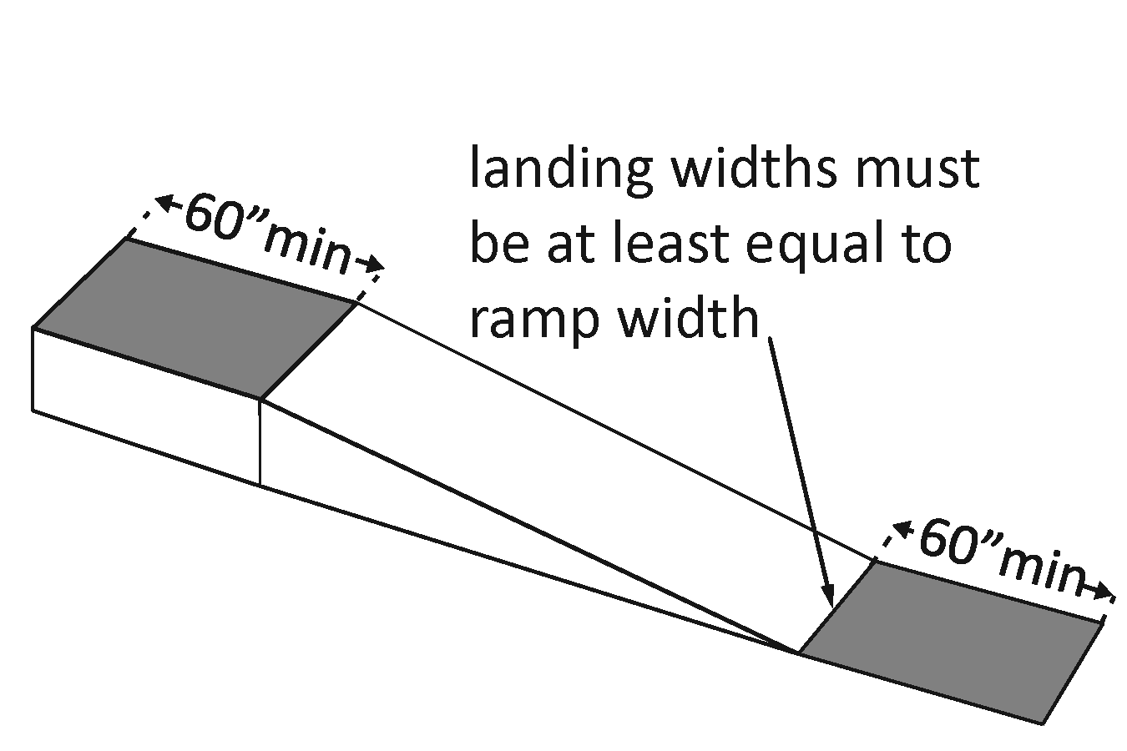 | Photo #: | • Alter ramp  • Relocate ramp  •
1.29 | Is there a level landing where the ramp changes direction that is at least 60 x 60 inches?  [405.7.4] | □Yes □No  Measurement: | 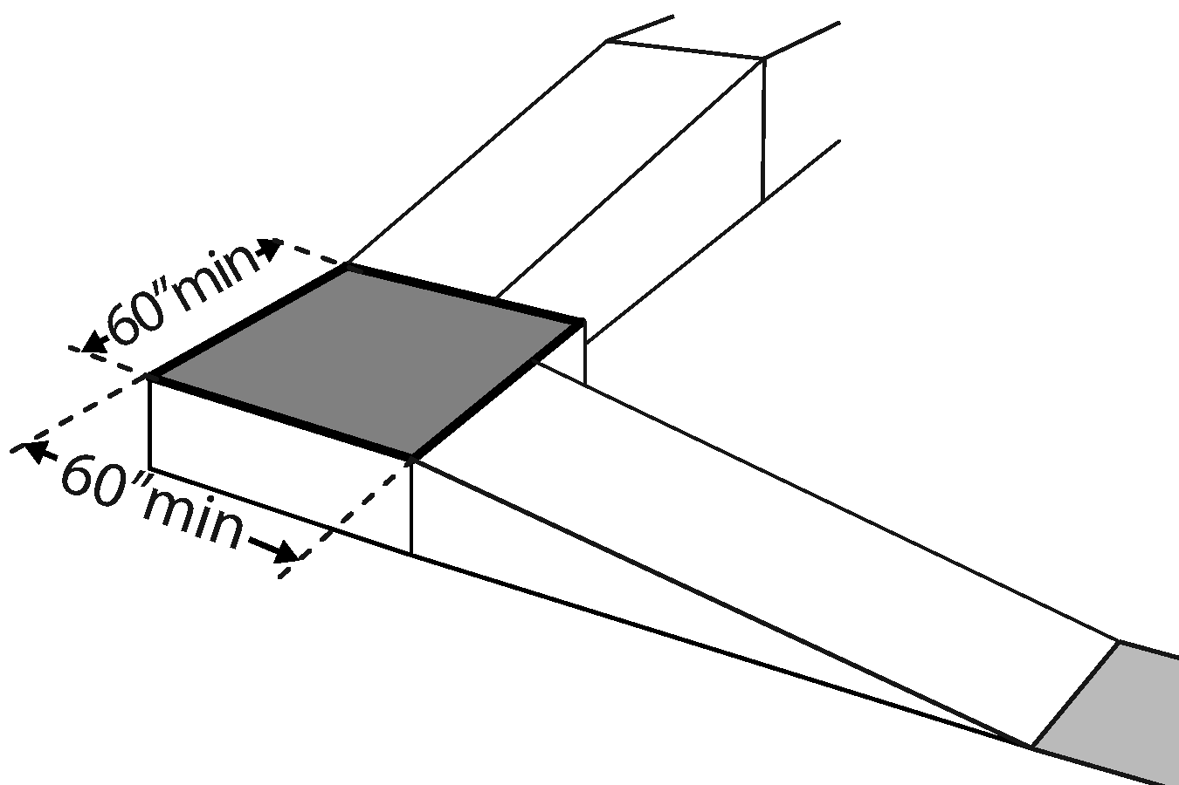 | Photo #: | • Alter ramp  • Increase landing size  •
1.30 | If the ramp has a rise higher than 6 inches, are there handrails on both sides?  [405.8]  Note: Curb ramps are not required to have handrails. | □Yes □No  Measurement: | 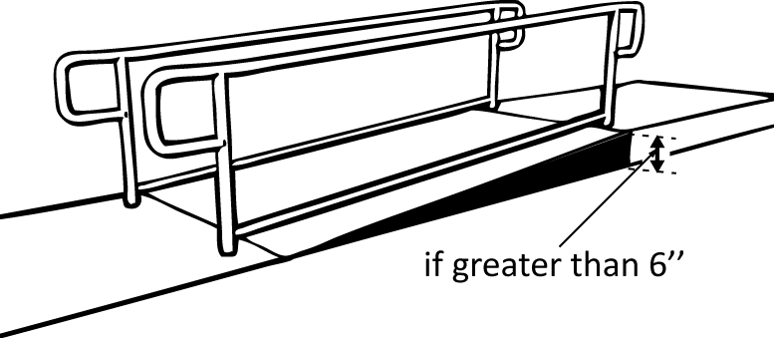 | Photo #: | • Add handrails  •  •
1.31 | Is the top of the handrail gripping surface no less than 34 inches and no greater than 38 inches above the ramp surface?  [505.4] | □Yes □No  Measurement: | 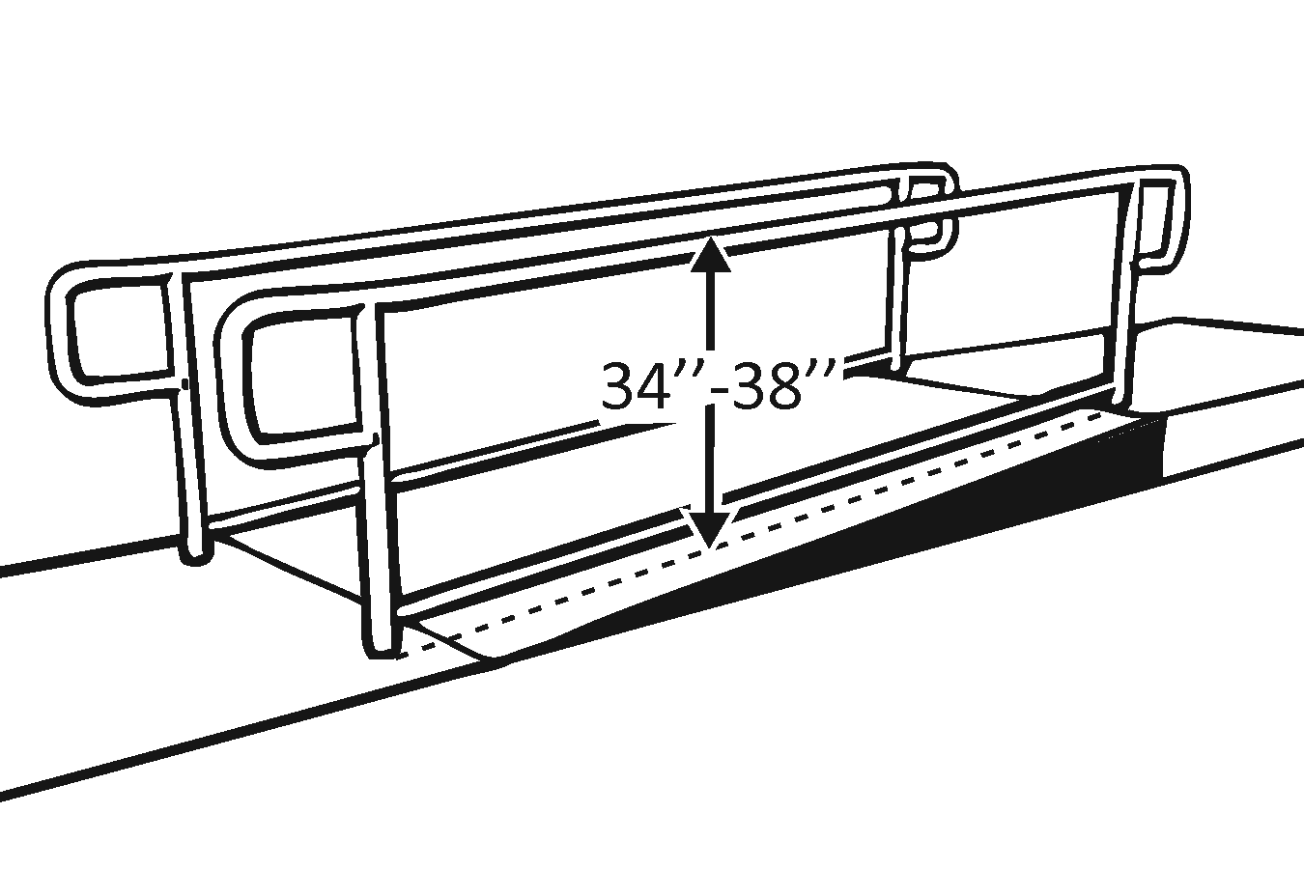 | Photo #: | • Reconfigure or replace handrails  • Adjust handrail height  •
1.32 | Is the handrail gripping surface continuous and not obstructed along the top or sides?  [505.3]  If there are obstructions, is the bottom of the gripping surface obstructed no greater than 20%?  [505.6] | □Yes □No  □Yes □No  Measurement: | 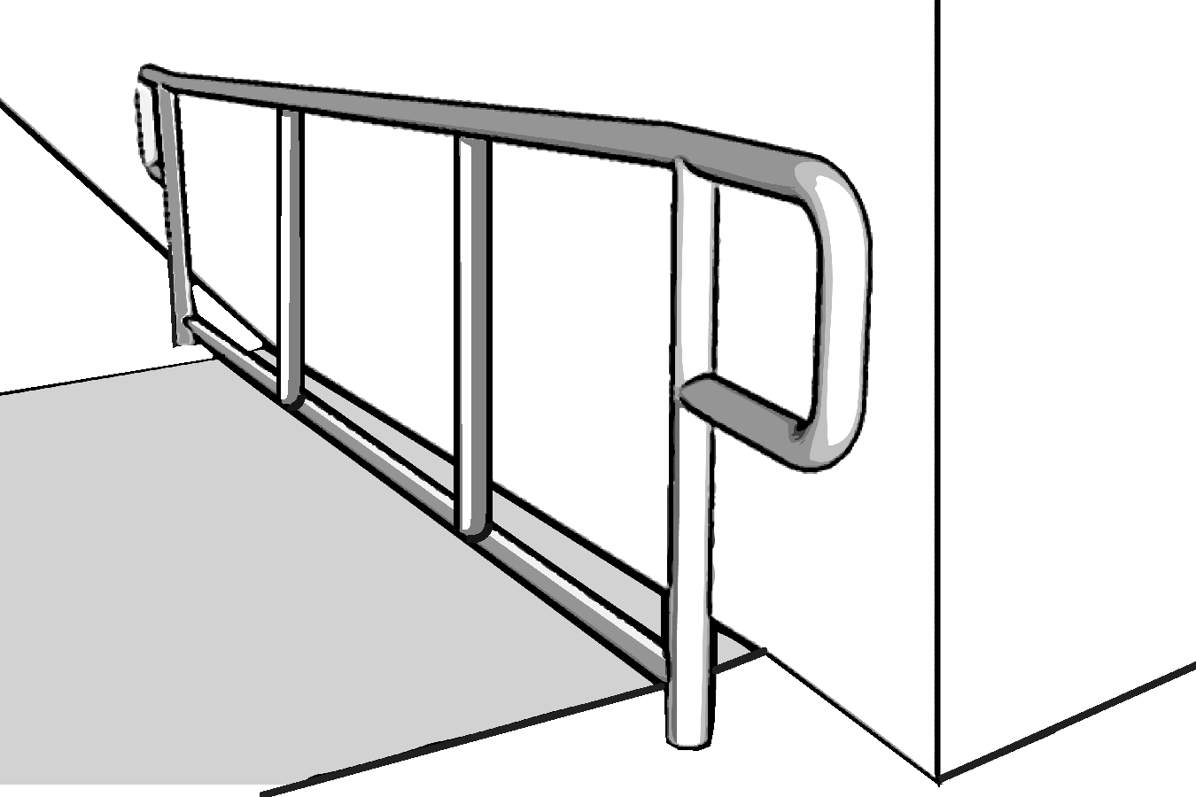 | Photo #: | • Reconfigure or replace handrails  •  •
1.33 | If the handrail gripping surface is circular, is it no less than 1 ¼ inches and no greater than 2 inches in diameter?  [505.7.1] | □Yes □No  Measurement: | 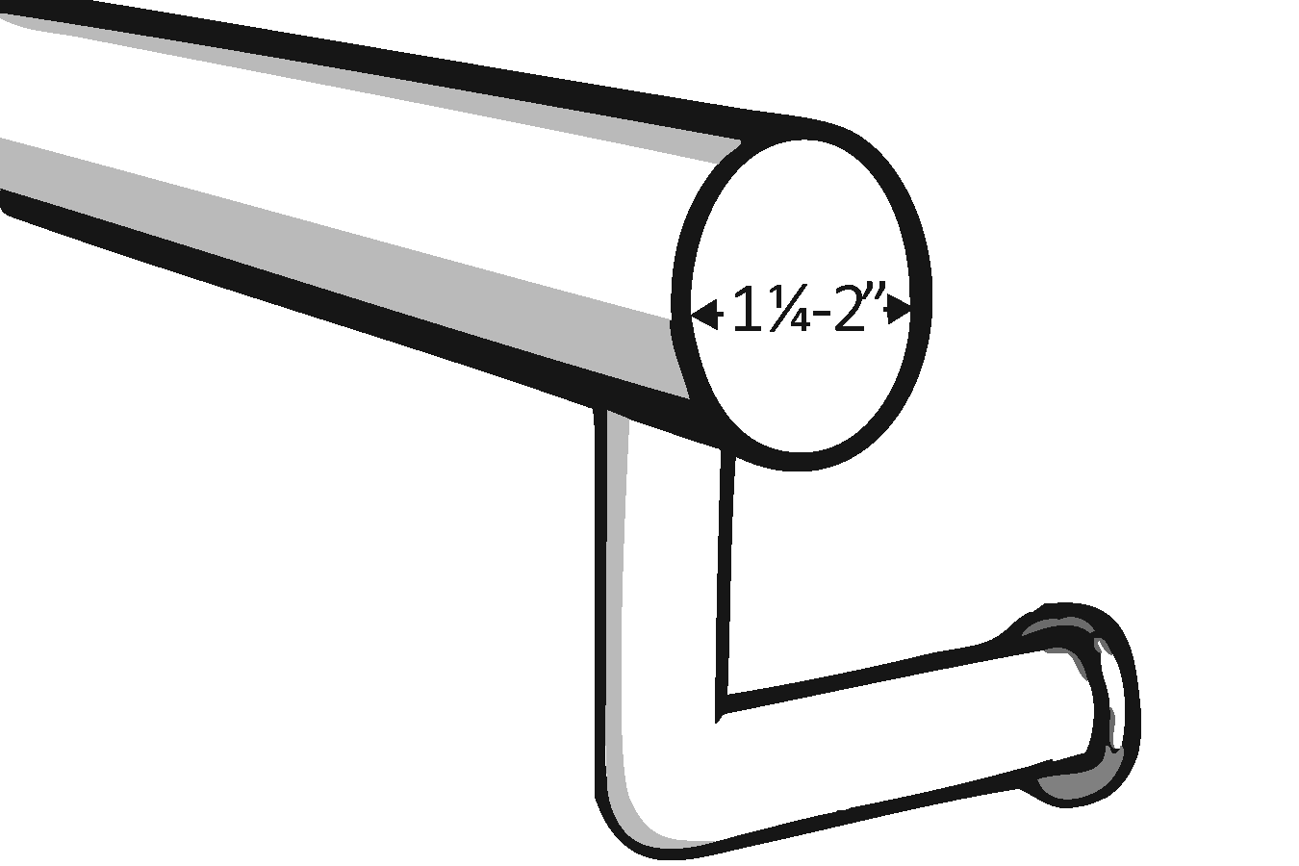 | Photo #: | • Replace handrails  •  •
1.34 | If the handrail gripping surface is non-circular:  Is the perimeter no less than 4 inches and no greater than 6¼ inches?  Is the cross section no greater than 2¼ inches?  [505.7.2] | □Yes □No  Measurement:  □Yes □No  Measurement:  □Yes □No  Measurement: | 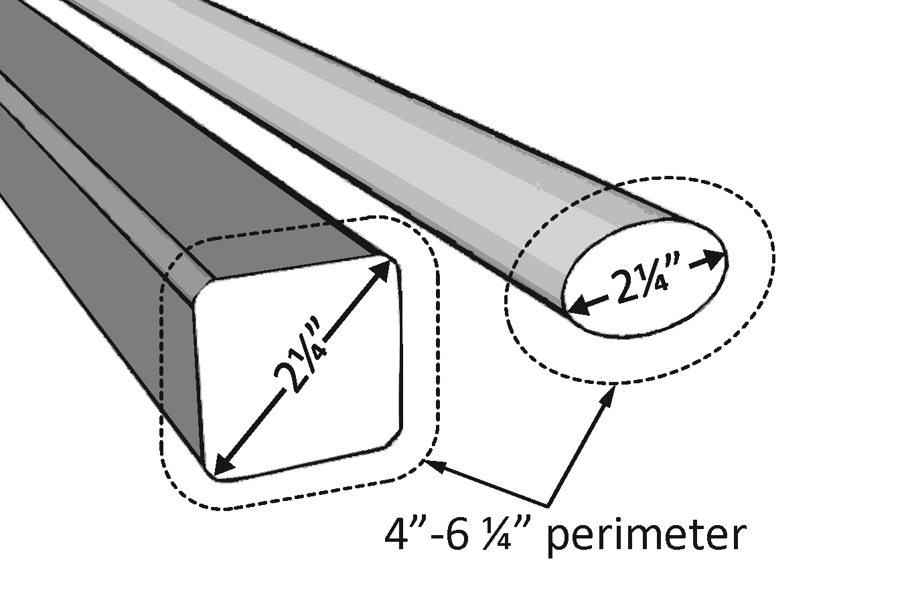 | Photo #: | • Replace handrails  •  •
1.35 | Does the handrail:  Extend at least 12 inches horizontally beyond the top and bottom of the ramp?  Return to a wall, guard, or landing surface?  [505.10.1]  Note: If a 12 inch extension would be a hazard (in circulation path) it is not required. | □Yes □No  Measurement:  □Yes □No | 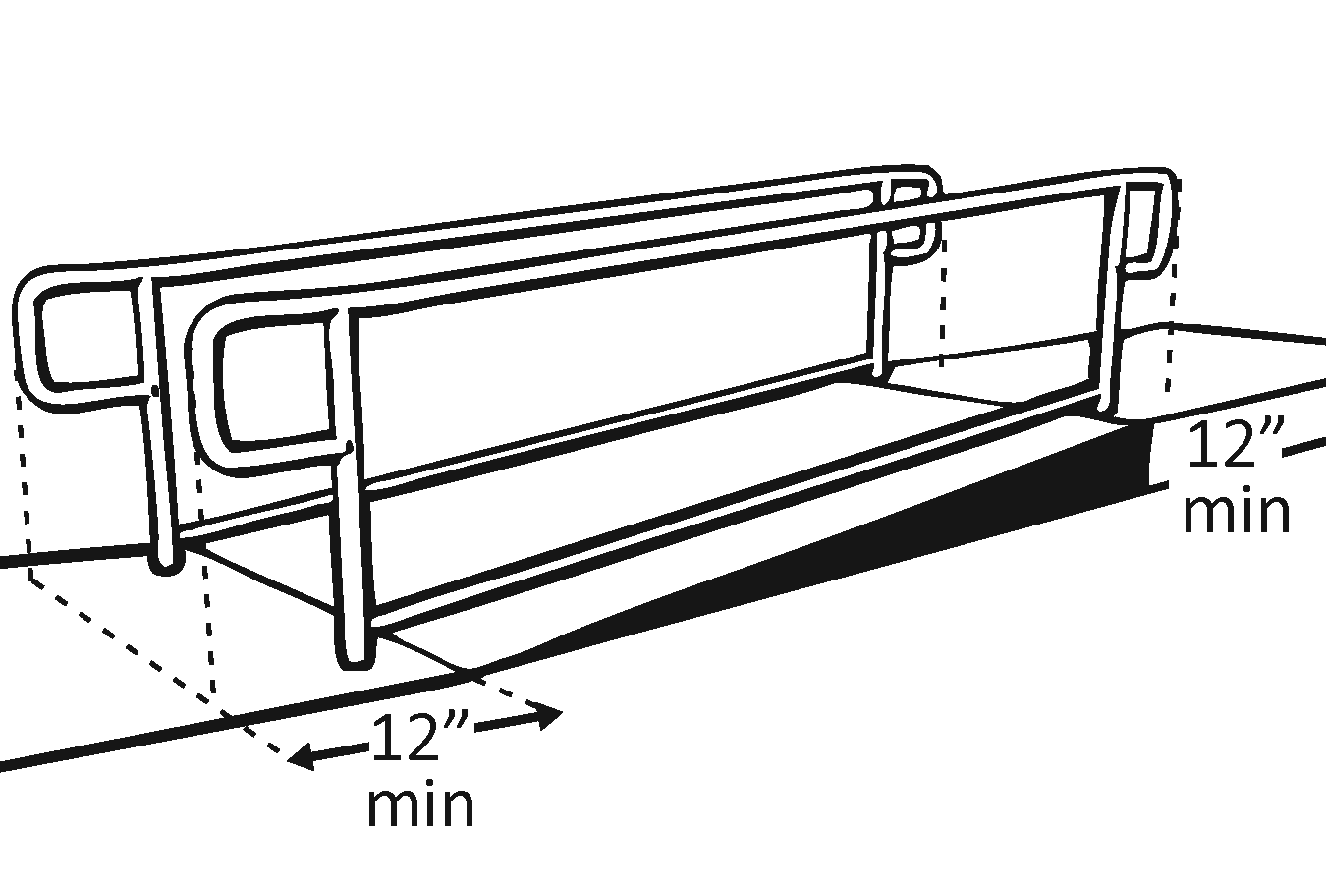 | Photo #: | • Alter handrails  •  •
1.36 | To prevent wheelchair casters and crutch tips from falling off:  Does the surface of the ramp extend at least 12 inches beyond the inside face of the handrail?  Or  Is there a curb or barrier that prevents the passage of a 4-inch diameter sphere?  [405.9.1, 405.9.2] | □Yes □No  Measurement:  □Yes □No  Measurement: | 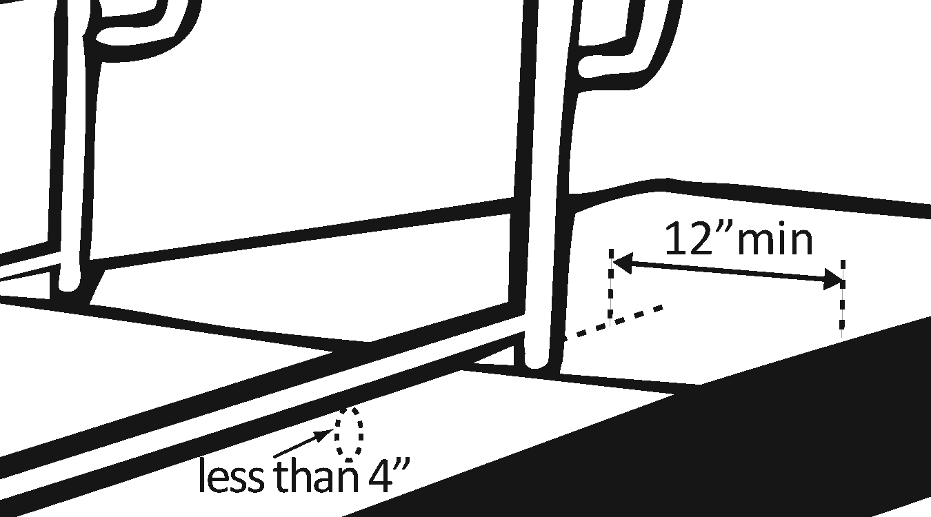 | Photo #: | • Add curb  • Add barrier  • Extend ramp width  •

Entrance
1.37 | Is the main entrance accessible? | □Yes □No |  | Photo #: | • Redesign to make it accessible  •  •
1.38 | If the main entrance is not accessible, is there an alternative accessible entrance?  Can the alternative accessible entrance be used independently and during the same hours as the main entrance? | □Yes □No  □Yes □No | 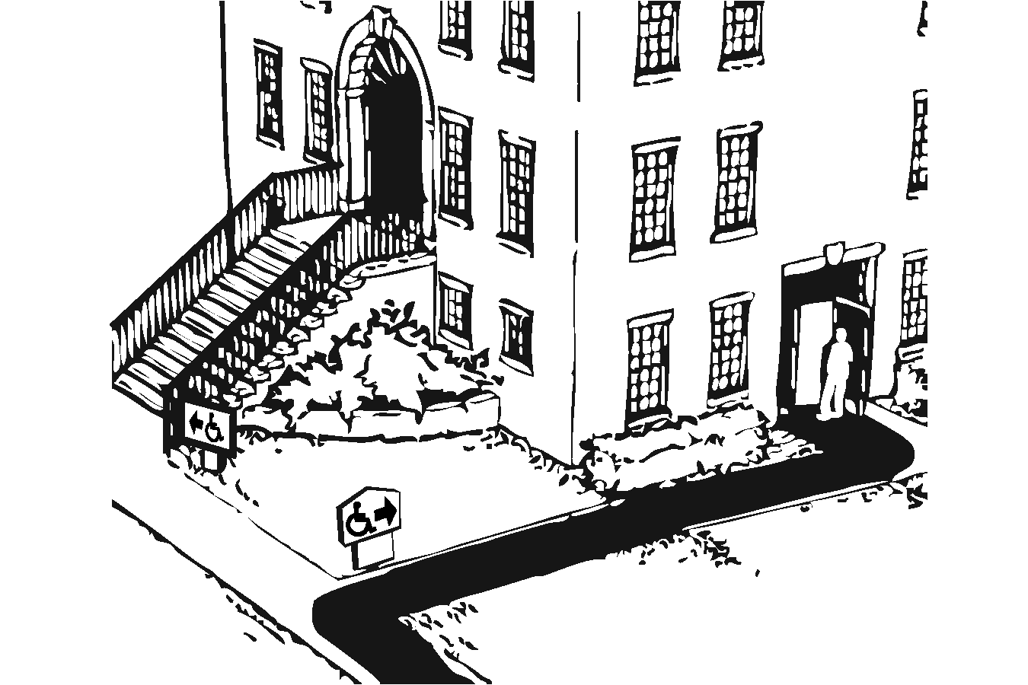 | Photo #: | • Designate an entrance and make it accessible  • Ensure that accessible entrance can be used independently and during the same hours as the main entrance  •
1.39 | Do all inaccessible entrances have signs indicating the location of the nearest accessible entrance?  [216.6] | □Yes □No | 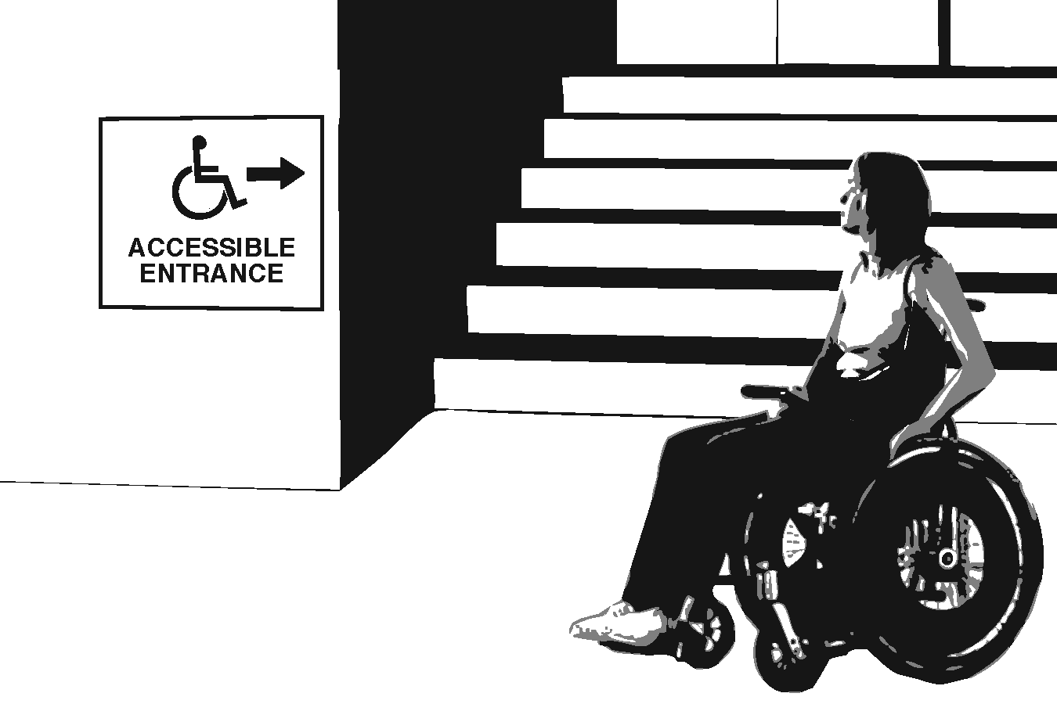 | Photo #: | • Install signs  • Install signs on route before people get to inaccessible entrances so that people do not have to turn around and retrace route  •
1.40 | If not all entrances are accessible, is there a sign at the accessible entrance with the International Symbol of Accessibility?  [216.6] | □Yes □No | 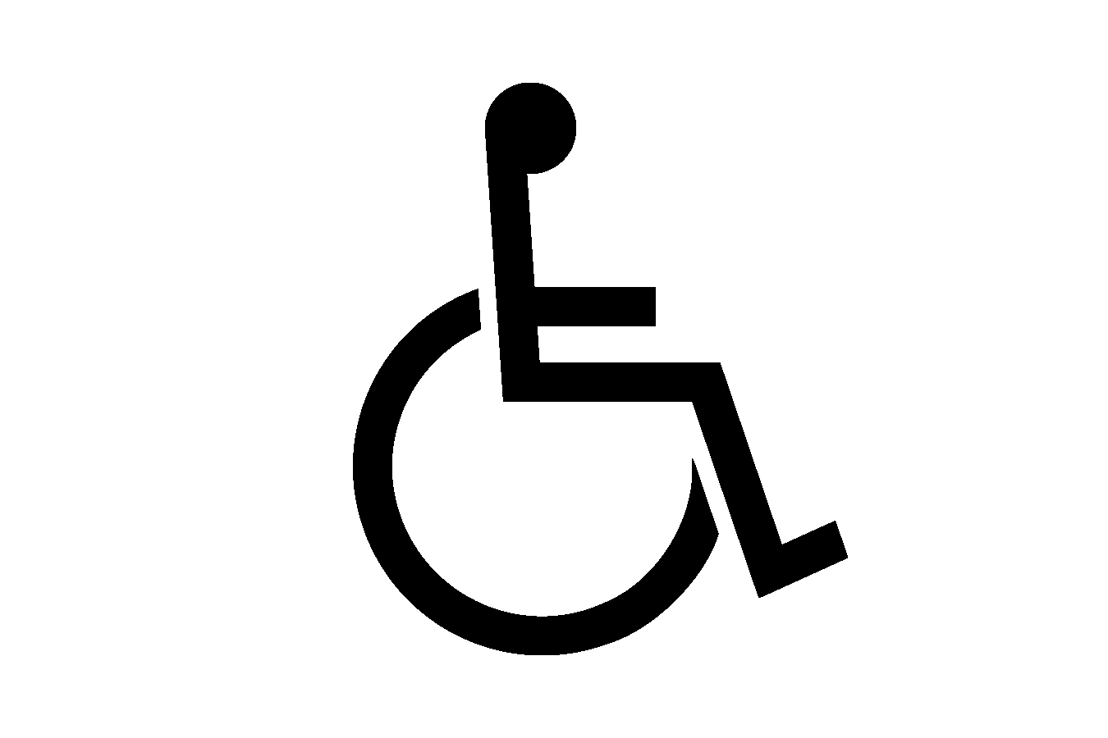 | Photo #: | • Install sign  •  •
1.41 | Is the clear opening width of the accessible entrance door at least 32 inches, between the face of the door and the stop, when the door is open 90 degrees?  [404.2.3] | □Yes □No  Measurement: | 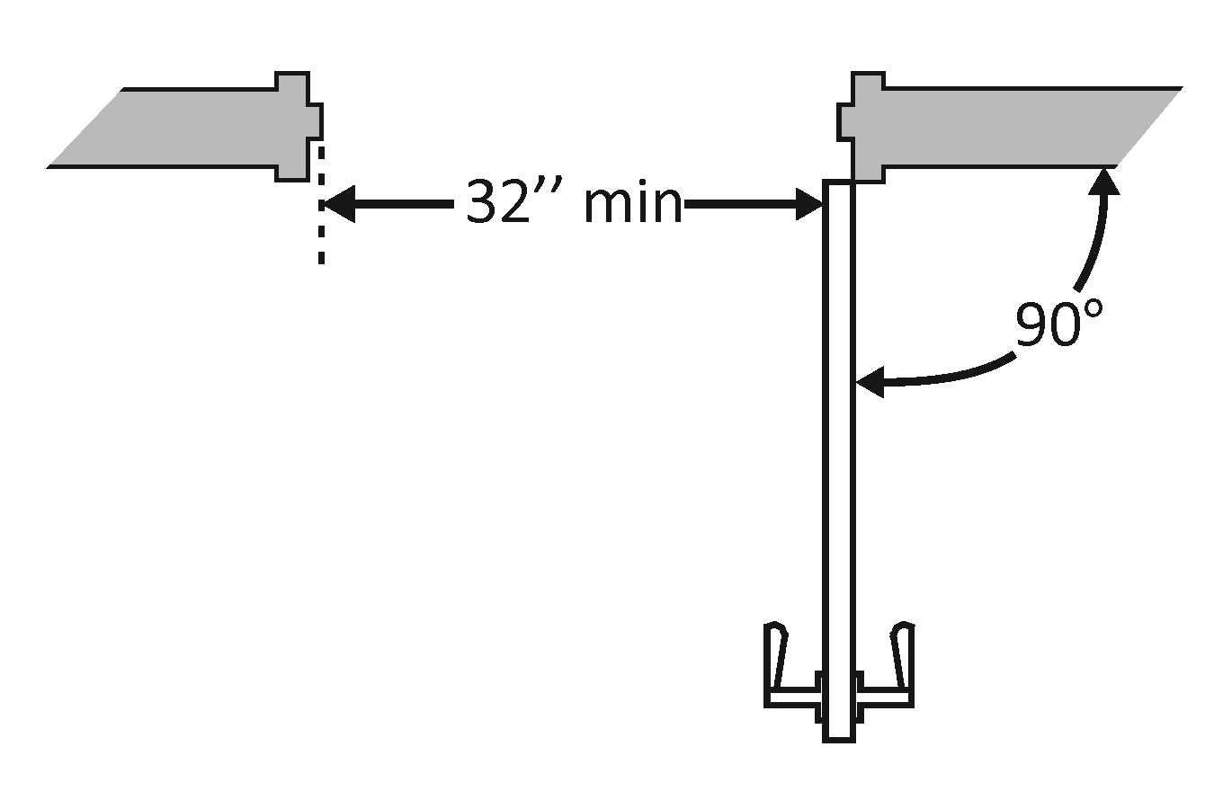 | Photo #: | • Alter door  • Install offset hinges  •
1.42 | If there is a front approach to the pull side of the door, is there at least 18 inches of maneuvering clearance beyond the latch side plus at least 60 inches clear depth?  Note: See 2010 Standards  404.2.4 for maneuvering  clearance requirements on  the push side of the door  and side approaches to the  pull side of the door  On both sides of the door, is the ground or floor surface of the maneuvering clearance level (no steeper than 1:48)?  [404.2.4] | □Yes □No  Measurement:  □Yes □No  Measurement: | 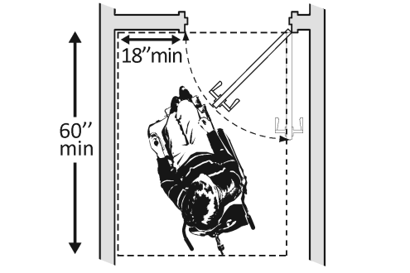 | Photo #: | • Remove obstructions  • Reconfigure walls  • Add automatic door opener
1.43 | If the threshold is vertical is it no more than ¼ inch high?  Or  No more than ½ inch high with the top ¼ inch beveled no steeper than 1:2, if the threshold was installed on or after the 1991 ADA Standards went into effect (1/26/93)?  Or  No more than ¾ inch high with the top ½ inch beveled no steeper than 1:2, if the threshold was installed before the 1991 ADA Standards went into effect (1/26/93)?  [404.2.5, 303.2]  Note: The first ¼ inch of the ½ or ¾ inch threshold may be vertical; the rest must be beveled. | □Yes □No  Measurement:  □Yes □No  Measurement:  □Yes □No  Measurement: | 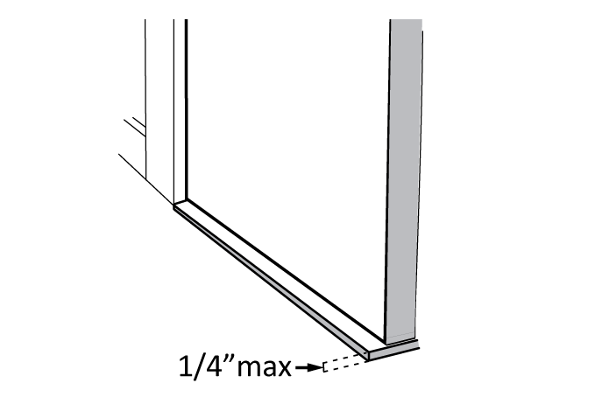  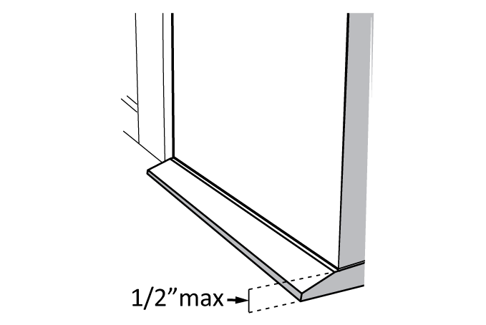  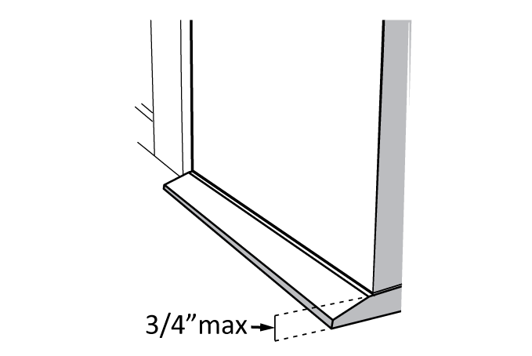 | Photo #: | • Remove or replace threshold  •  •
1.44 | Is the door equipped with hardware that is operable with one hand and does not require tight grasping, pinching or twisting of the wrist?  Door handle?  Lock (if provided)?  [404.2.7] | □Yes □No  □Yes □No  □Yes □No | 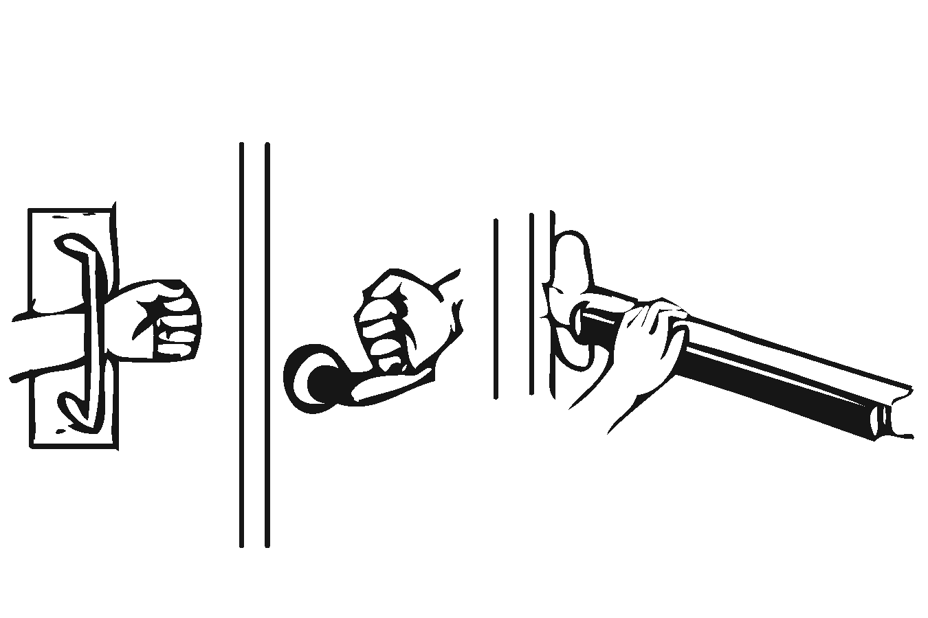 | Photo #: | • Replace inaccessible knob with lever, loop or push hardware  • Add automatic door opener  •
1.45 | Are the operable parts of the door hardware no less than 34 inches and no greater than 48 inches above the floor or ground surface?  [404.2.7] | □Yes □No  Measurement: | 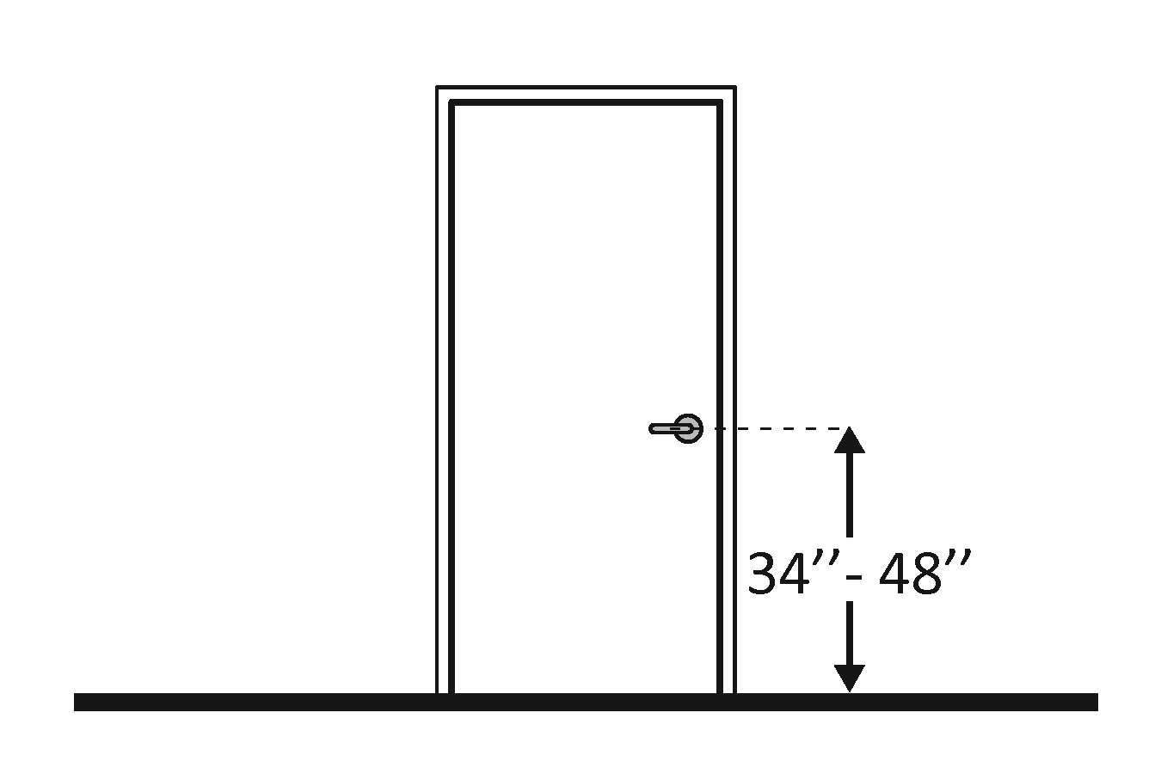 | Photo #: | • Change hardware height  •  •
1.46 | If the door has a closer, does it take at least 5 seconds to close from an open position of 90 degrees to a position of 12 degrees from the latch?  [404.2.8] | □Yes □No  Measurement: | 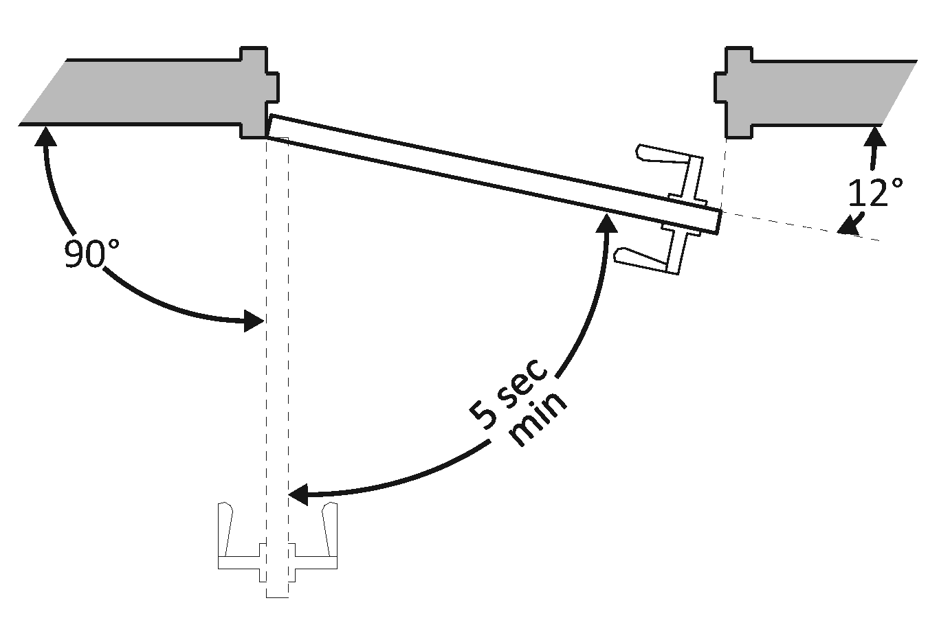 | Photo #: | • Adjust closer  •  •
1.47 | If there are two doors in a series, e.g. vestibule, is the distance between the doors at least 48 inches plus the width of the doors when swinging into the space?  [404.2.6] | □Yes □No  Measurement: | 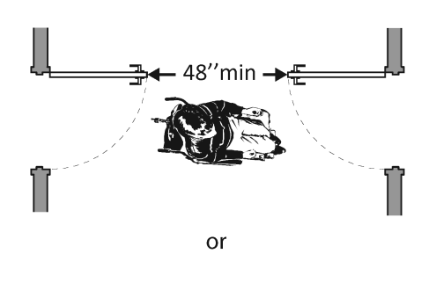  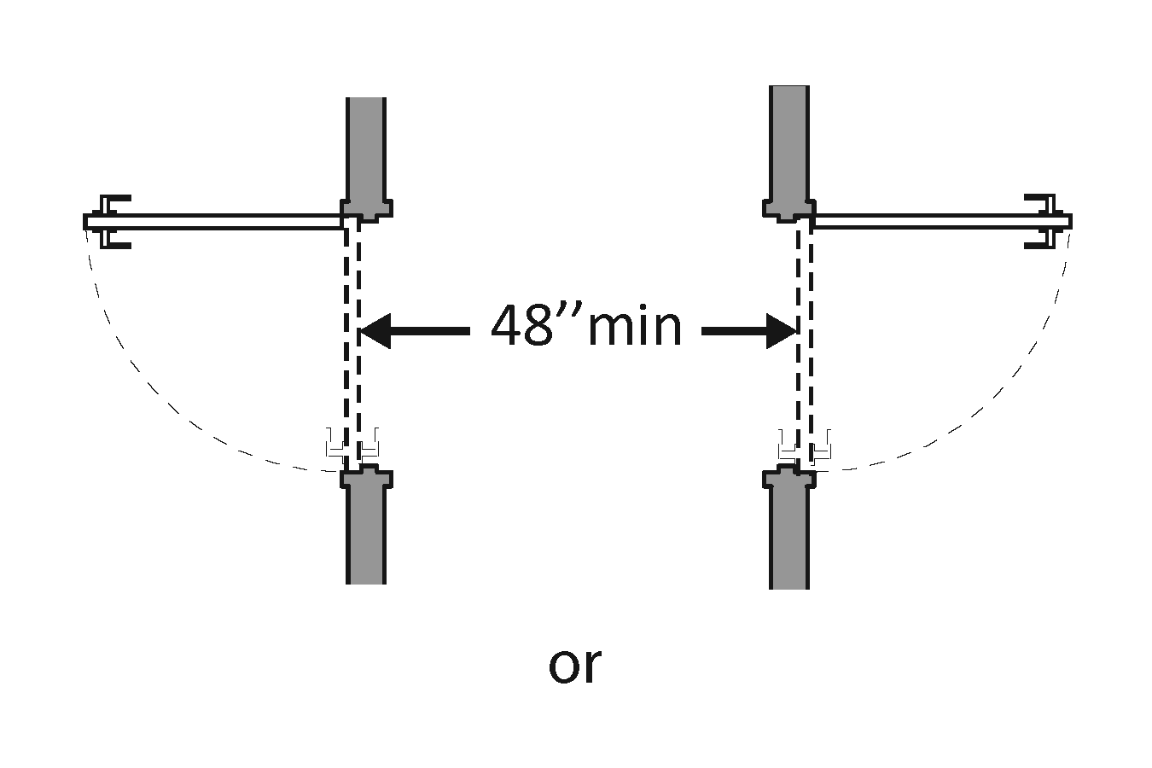  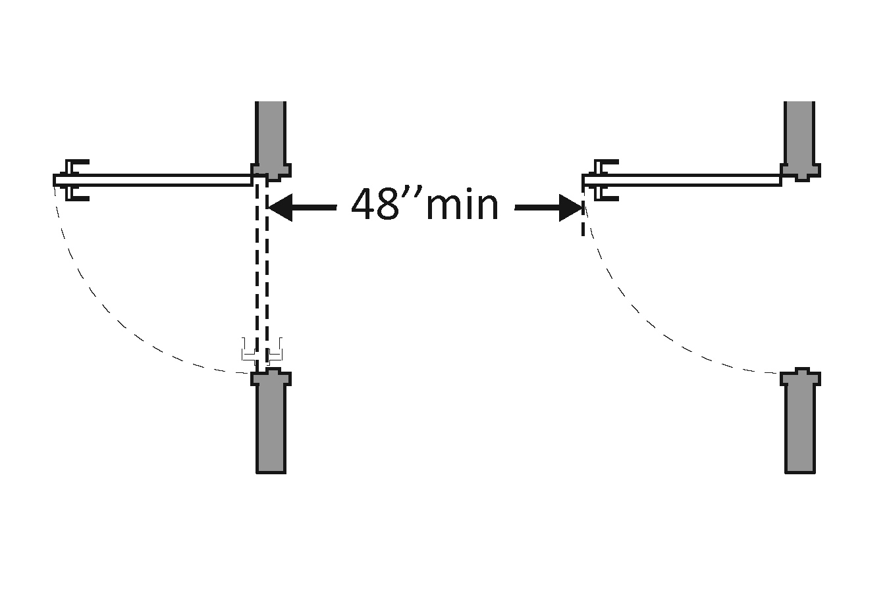 | Photo #: | • Remove inner door  • Change door swing  •
1.48 | If provided at the building entrance, are carpets or mats no higher than ½ inch thick?  [302.2] | □Yes □No  Measurement: | 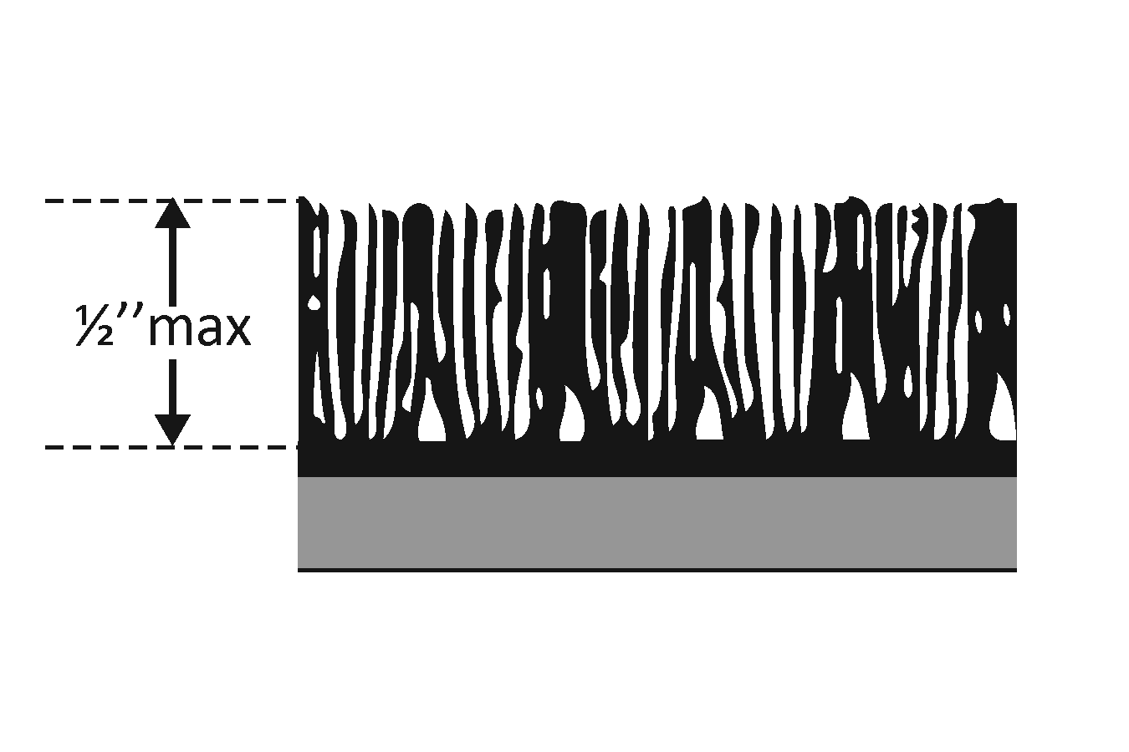 | Photo #: | • Replace or remove mats  •  •
1.49 | Are edges of carpets or mats securely attached to minimize tripping hazards?  [302.2] | □Yes □No |  | Photo #: | • Secure carpeting or mats at edges  •  •
 |  | □Yes □No |  | Photo #: | •  •  •
 |  | □Yes □No |  | Photo #: | •  •  •

