 |  |  | ADA Checklist for Existing Facilities
 |  |  | Recreational Boating Facilities
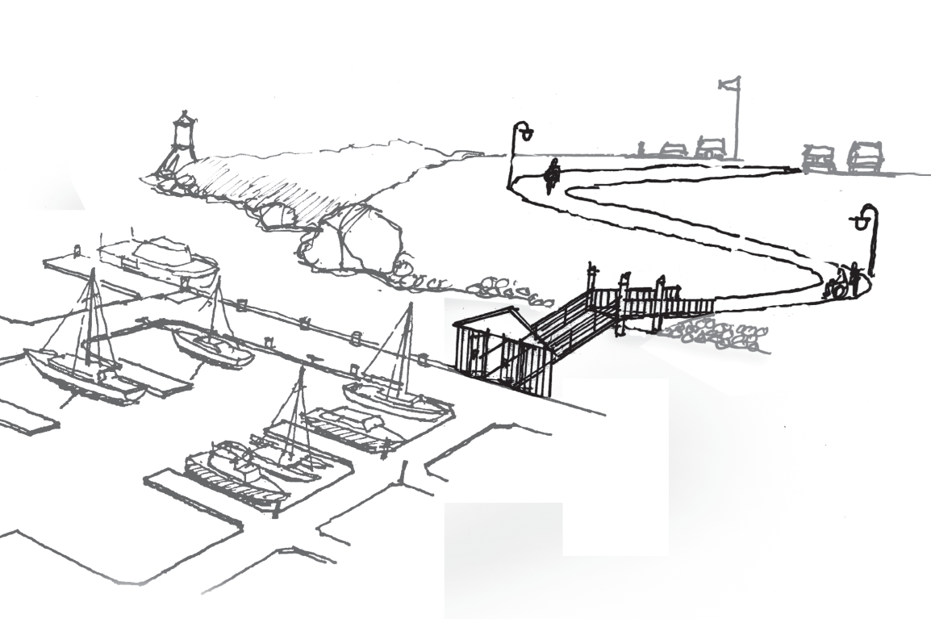 |  |  |  |  |  |  |  | Project
 |  |  |  |  |  |  |  | Building
 |  |  |  |  |  |  |  | Location
 |  |  |  |  |  |  |  | Date
 |  |  |  |  |  |  |  | Surveyors
 |  |  |  |  |  |  |  | Contact Information
 |  | Recreational boating facilities should be accessible to everyone, including people with disabilities.
 |  | Institute for Human Centered Design  www.HumanCenteredDesign.org  Copyright © 2016 |  |  |  |  | ADA National Network  Questions on the ADA 800-949-4232 voice/tty  www.ADAchecklist.org

This checklist was produced by the New England ADA Center, a project of the Institute for Human Centered Design and a member of the ADA National Network. This checklist was developed under a grant from the Department of Education, NIDRR grant number H133A060092-09A. However the contents do not necessarily represent the policy of the Department of Education, and you should not assume endorsement by the Federal Government.
Questions or comments on the checklist contact the New England ADA Center at 617-695-0085 voice/tty or ADAinfo@NewEnglandADA.org
For the full set of checklists, including the checklists for recreation facilities visit www.ADAchecklist.org.
Copyright © 2016 ADA Checklist for Existing Materials. You can freely reproduce and distribute this content. Include proper attribution. But you must get permission before using this content as a fee-based product.

Recreational Boating Facilities |  |  |  |  | Comments |  | Possible Solutions
Boating Facilities (Recreational) (2010 Standards – 206, 235 & 1003)
B1 | Is there an accessible route to the entrance of the boating facility?  Use the checklist for Priority 1: Approach & Entrance. | Yes No | 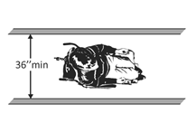 | Photo #: |  | • Add a ramp  • Regrade to 1:20 maximum slope  • Widen route  • Change route surface  • Add a platform lift, limited use/limited application elevator or a regular elevator
B2 | BOAT SLIPS  Where boat slips are provided are there an adequate number of accessible slips?  Note: If slips are not demarcated by length, count each 40 feet of slip edge along the pier perimeter as one slip.  A boat slip is the portion of a pier, main pier, finger pier or float where a boat is berthed or moored or used for embarking or disembarking that is not part of a boat launch ramp. A boat launch ramp is a sloped surface designed for launching and retrieving trailered boats and other watercraft to and from a body of water. | Yes No  Total slips:  Accessible slips: |  | Photo #: |  | • Create accessible slips  •  •
  Total Slips | Accessible  Slips
  1 - 25 | 1
  26 - 50 | 2
  51 - 100 | 3
  101 - 150 | 4
  151 - 300 | 5
  301 - 400 | 6
  401 - 500 | 7
  501 - 600 | 8
  601 - 700 | 9
  701 - 800 | 10
  801 - 900 | 11
  901 - 100 | 12
  1001 and over | 12 plus 1 for each 100 or fraction
B3 | Are the accessible boat slips dispersed among the different types of boat slips?  Note: Accessible boat slips must be dispersed throughout the various types of slips, but a facility does not have to provide more accessible boat slips than required in the table. Accessible slips may be grouped on one pier if the requirement for different types of slips is met. Types could include shallow-water or deep water; transient or longer-term lease; covered or uncovered; and whether slips are equipped with features such as telephone, water, electricity, or cable connections. | Yes No |  | Photo #: |  | • Relocate accessible slips  •  •
B4 | Is there an accessible route to the accessible boat slips?  Use the checklist for Priority 1: Approach and Entrance  To deal with varying water levels, exceptions apply when gangways are part of the accessible route. A gangway is a variable-sloped pedestrian walkway that links a fixed structure or land with a floating structure.  Exceptions:  1. Gangway rises may be greater than 30 inches. Therefore gangways may be any length and no intermediate landings are required.  2. Gangway slopes may be greater than 1:12 if the total length of a gangway or series of gangways serving as part of the accessible route is at least 80 feet.  3. Gangway slopes may be greater than 1:12 if the facility contains fewer than 25 boat slips and the total length of the gangway or series of gangway serving as part of the accessible route is at least 30 feet.  4. Level landings are not required where gangways connect to transition plates. A transition plate is a sloped pedestrian surface at the end of a gangway.  5. Where gangways and transition plates connect, handrail extensions are not required.  6. If there are handrail extensions on gangways or transition plates, the extensions are not required to be parallel with the ground surface.  7. Changes in level ¼ to ½ inch high, beveled with a slope no steeper than 1:20 are permitted on gangway surfaces.  Note:  When gangways, transition plates and floating piers and platforms are part of an accessible route, the cross slope requirement of 1:48 maximum is measured when they are in the static position, i.e. absence of movement that results from waves and wind. | Yes No | 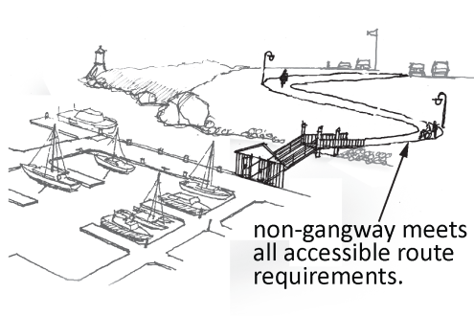  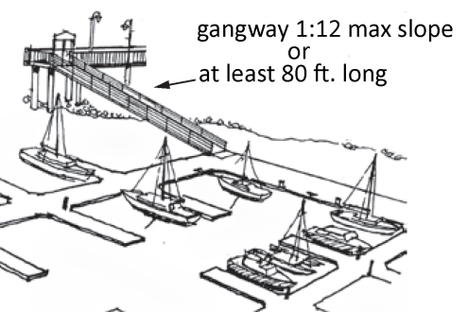 | Photo #: |  | • Add a ramp  • Regrade to 1:20 maximum slope  • Widen route  • Change route surface  • Add a platform lift, limited use/limited application elevator or a regular elevator
B5 | If there are transition plates is the slope of transition plates no greater than 1:20?  If the slope is greater than 1:20 is a there a landing at the end of the transition plate? | Yes No  Measurement:  Yes No  Measurement: | 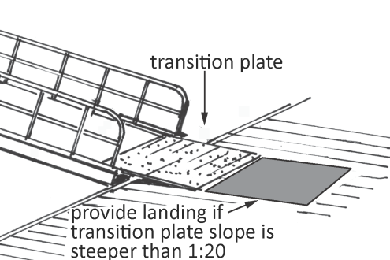 | Photo #: |  | • Regrade to 1:20 maximum slope  •  •
B6 | Is there clear pier space at the accessible boat slips that is:  At least as long as the slip by at least 60 inches wide?  Or  At least 36 inches wide for a length no greater than 24 inches, if multiple 36 inch wide segments are separated by segments that are at least 60 inches wide and at least 60 inches long?  Note: Clear pier space may be perpendicular to the boat slip if the space extends the width of the slip and the facility has at least one accessible boat slip parallel to the pier. | Yes No  Measurement:  Yes No  Measurement: | 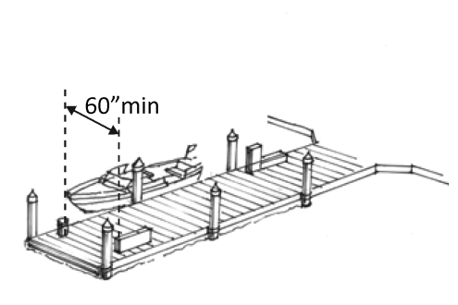  Or  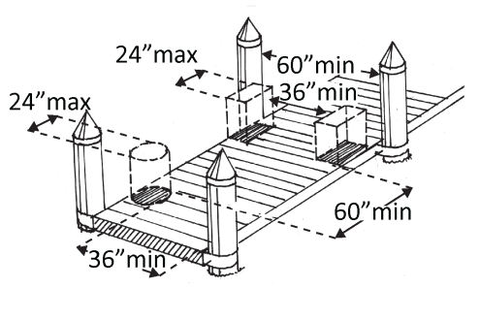 | Photo #: |  | • Add clear space  • Reconfigure clear space  •
B7 | For every 120 inches (10 feet) of linear pier edge serving the slips, is there a continuous clear opening at least 60 inches wide?  If there is edge protection at the clear opening, is it no higher than 4 inches and no wider than 2 inches? | Yes No  Measurement:  Yes No  Measurement: | 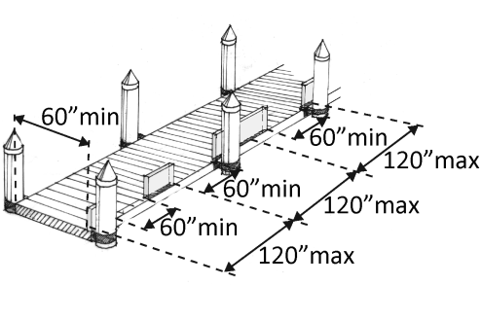  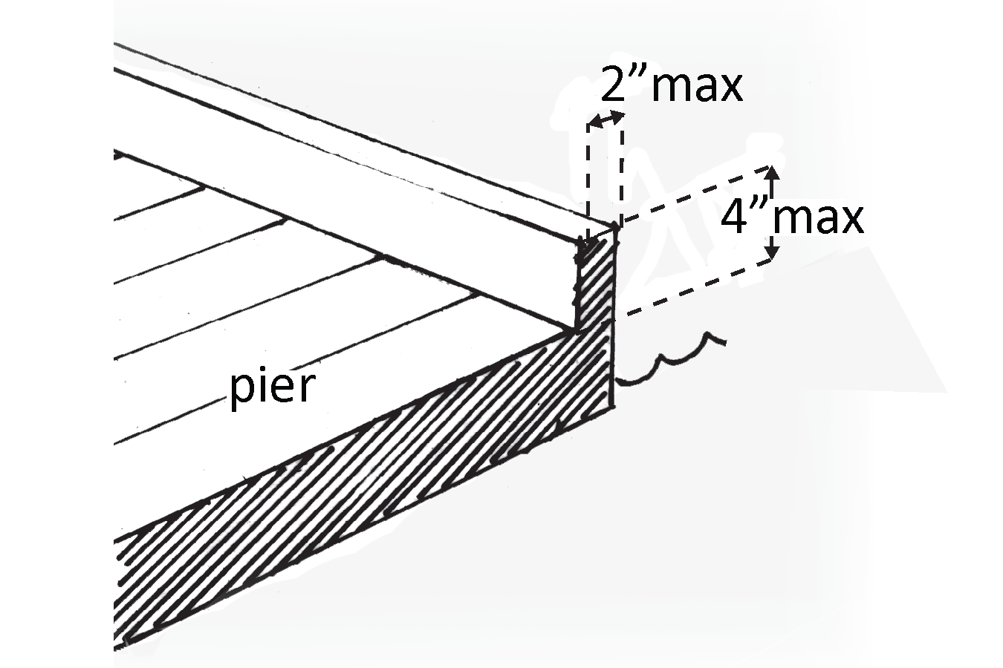 | Photo #: |  | • Add clear openings  • Relocate clear openings  • Change edge protection  •  •
B8 | If there are controls and operating mechanisms, such as hose bibbs, water supply hoses, outlets for electrical power, telephones, or cable TV:  Are they on an accessible route?  Is there a clear floor space next to each that is at least 30 inches by at least 48 inches?  Are operable parts no higher than 48 inches and no lower than 15 inches above the surface?* | Yes No  Yes No  Measurement:  Yes No  Measurement: | 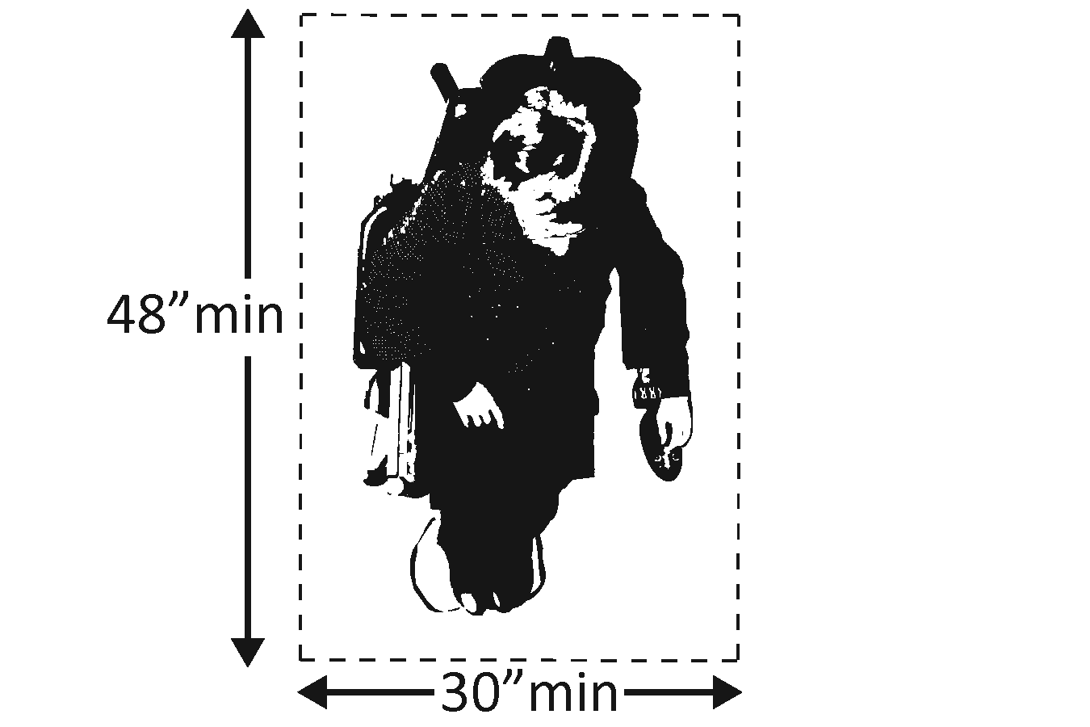  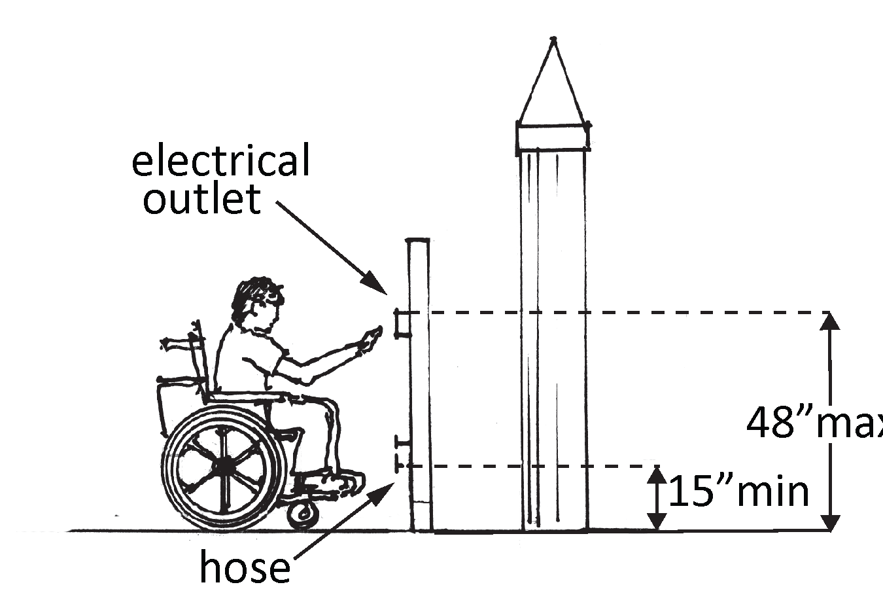  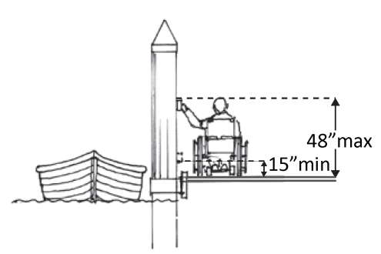 | Photo #: |  | • Relocate controls and/or operating mechanisms  • Relocate route  • Add clear floor space  • Change height of controls and/or operating mechanisms  •  •  *If constructed before 3/15/2012 and a side reach is provided operable parts may be no higher than 54 inches and no lower than 9 inches above the surface.
B9 | If there are cleats or other securement devices serving the accessible boat slips:  Are they on an accessible route?  Is there a clear floor space next to each that is at least 30 inches by at least 48 inches?  Note: Cleats and other boat securement devices at accessible slips can be any height; they do not have to comply with reach range requirements. | Yes No  Yes No  Measurement: |  | Photo #: |  | • Relocate securement devices  • Add clear floor space  •  •
B10 | BOARDING PIERS AT BOAT LAUNCH RAMPS  Where boarding piers are provided at boat launch ramps, are at least 5 percent, but no fewer than one, accessible?  Note: A boarding pier (sometimes called a courtesy pier or a launch dock) is where a boat is temporarily moored for embarking and disembarking. A boat launch ramp is a sloped surface for launching and retrieving trailered boats to and from the water. For boarding piers that are not part of a boat launch ramp, use the boat slips section. | Yes No  Number: |  | Photo #: |  | • Create accessible boarding piers  •  •
B11 | Is there an accessible route to and connecting the accessible boarding piers?  Use the checklist for Priority 1: Approach & Entrance.  To deal with varying water levels, exceptions apply when an accessible route connects to floating piers.  Exceptions:  1. Where the accessible route serving a floating boarding pier or skid pier is within a boat launch ramp, that portion does not have to comply with ramp requirements.  2. Gangway rises may be greater than 30 inches. Therefore gangways may be any length and no intermediate landings are required. A gangway is a variable-sloped pedestrian walkway that links a fixed structure or land with a floating structure.  3. Gangway slopes may be greater than 1:12 if the total length of a gangway or series of gangways serving as part of the accessible route is at least 30 feet.  4. Landings are not required where gangways connect to transition plates. A transition plate is a sloped pedestrian surface at the end of a gangway.  5. Where gangways and transition plates connect, handrail extensions are not required.  6. If there are handrail extensions on gangways or transition plates, the extensions are not required to be parallel with the ground surface.  7. Changes in level ¼ to ½ inch high, beveled with a slope no steeper than 1:20 are permitted on gangway surfaces.  Note:  When gangways, transition plates and floating piers and platforms are part of an accessible route, the cross slope requirement of 1:48 maximum is measured when they are in the static position, i.e. absence of movement that results from waves and wind. | Yes No |  | Photo #: |  | • Add a ramp  • Regrade to 1:20 maximum slope  • Lengthen gangway  • Widen route  • Change route surface  • Add a platform lift, limited use/ limited application elevator or a regular elevator
B12 | Is there clear pier space at the boarding pier that is the full length of the boarding pier and:  At least 60 inches wide?  Or  At least 36 inches wide for a length of no greater than 24 inches if there are multiple 36-inch-wide segments that are separated by segments measuring at least 60 inches wide and at least  60 inches long?  Note: There is no minimum length of the pier. The accessible boarding pier should be at least as long as other piers provided at the facility. | Yes No  Measurement:  Yes No  Measurement: | Or | Photo #: |  | • Add clear space  • Reconfigure clear space  •
B13 | For every 120 inches (10 feet) of linear pier edge, is there a continuous clear opening at least 60 inches wide?  If there is edge protection at the clear opening, is it no higher than 4 inches and no wider than 2 inches? | Yes No  Measurement:  Yes No  Measurement: | 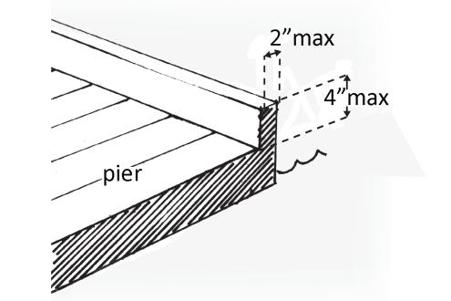 | Photo #: |  | • Add clear openings  • Relocate clear openings  • Change edge protection  •  •
B14 | If there are controls and operating mechanisms, such as hose bibbs, water supply hoses, outlets for electrical power:  Are they on an accessible route?  Is there a clear floor space next to each that is 30 inches by 48 inches minimum?  Are operable parts no higher than 48 inches and no lower than 15 inches above the surface?* | Yes No  Yes No  Measurement:  Yes No  Measurement: |  | Photo #: |  | • Relocate controls and/or operating mechanisms  • Relocate route  • Add clear floor space  • Change height of controls and/or operating mechanisms  •  •  *If constructed before 3/15/2012 and a side reach is provided operable parts may be no higher than 54 inches and no lower than 9 inches above the surface.
B15 | If there are cleats or other securement devices serving boarding piers at boat launch ramps:  Are they on an accessible route?  Is there a clear floor space next to each that is at least 30 inches by at least 48 inches?  Note: Cleats and other boat securement devices at boarding piers at boat launch ramps can be any height; they do not have to comply with reach range requirements. | Yes No  Yes No  Measurement: |  | Photo #: |  | • Relocate securement devices  • Add clear floor space  •  •
 |  | Yes No |  | Photo #: |  | •  •  •
 |  | Yes No |  | Photo #: |  | •  •  •
 |  | Yes No |  | Photo #: |  | •  •  •
 |  | Yes No |  | Photo #: |  | •  •  •
 |  | Yes No |  | Photo #: |  | •  •  •

