 |  |  | ADA Checklist for Existing Facilities
 |  |  | Golf Facilities
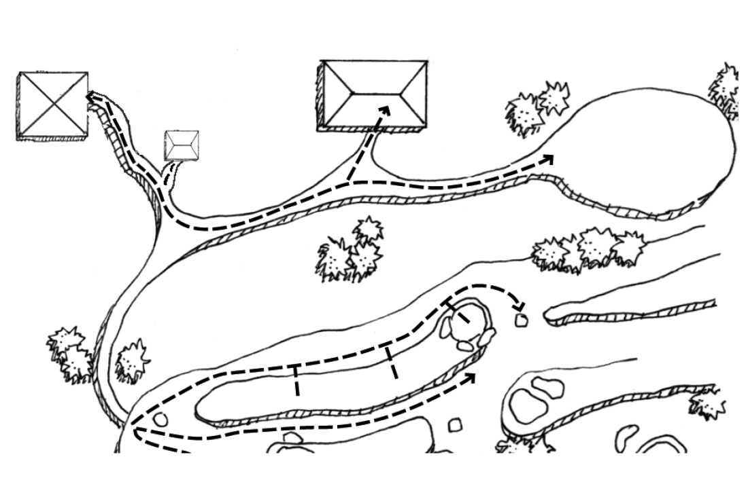 |  |  |  |  |  |  |  | Project
 |  |  |  |  |  |  |  | Building
 |  |  |  |  |  |  |  | Location
 |  |  |  |  |  |  |  | Date
 |  |  |  |  |  |  |  | Surveyors
 |  |  |  |  |  |  |  | Contact Information
 |  | Golf facilities should be accessible to everyone, including people with disabilities.
 |  | Institute for Human Centered Design  www.HumanCenteredDesign.org  Copyright © 2016 |  |  |  |  | ADA National Network  Questions on the ADA 800-949-4232 voice/tty  www.ADAchecklist.org

This checklist was produced by the New England ADA Center, a project of the Institute for Human Centered Design and a member of the ADA National Network. This checklist was developed under a grant from the Department of Education, NIDRR grant number H133A060092-09A. However the contents do not necessarily represent the policy of the Department of Education, and you should not assume endorsement by the Federal Government.
Questions or comments on the checklist contact the New England ADA Center at 617-695-0085 voice/tty or ADAinfo@NewEnglandADA.org
For the full set of checklists, including the checklists for recreation facilities visit www.ADAchecklist.org.
Copyright © 2016 ADA Checklist for Existing Materials. You can freely reproduce and distribute this content. Include proper attribution. But you must get permission before using this content as a fee-based product.

Golf Facilities |  |  |  | Comments |  | Possible Solutions
Golf Facilities (2010 Standards – 206, 238 & 1006)
G1 | Is there an accessible route to the entrance of the golf facility?  Use the checklist for Priority 1: Approach & Entrance. | Yes No | 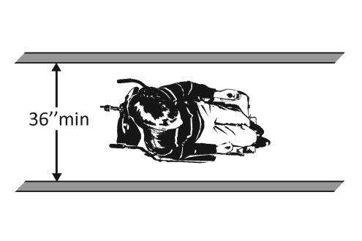 |  | Photo #: |  | •Regrade to 1:20 maximum slope  • Install a ramp  • Install a platform lift or limited –use/limited access elevator
G2 | Is there an accessible route or golf car passage that connects to the:  Golf car rental area?  Bag drop area?  Weather shelter?  Course toilet room?  Practice putting green?  Practice teeing ground?  Teeing ground?  Driving range teeing station?  Note: A golf car passage is a continuous passage on which a motorized golf car can operate. It may be substituted for all or part of the accessible route. It does not need to have a prepared surface. It may be on fairways, greens and teeing surfaces. | Yes No  Yes No  Yes No  Yes No  Yes No  Yes No  Yes No  Yes No | 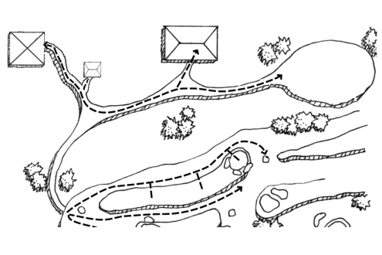 |  | Photo #: |  | • Alter route  •  •
G3 | Is the accessible route at least 48 inches wide or at least 60 inches wide if there are handrails?  Note: Handrails are not required on golf courses. If there are handrails, they do not have to comply with the ADA Standards. | Yes No  Measurement: |  |  | Photo #: |  | • Widen route  •  •
G4 | If a golf car passage is provided instead of an accessible route is the clear width of the passage at least 48 inches? | Yes No  Measurement: | 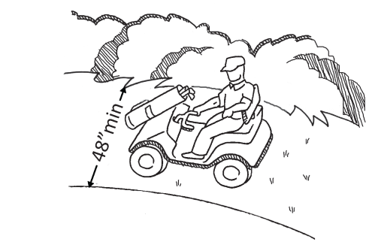 |  | Photo #: |  | • Widen route  •  •
G5 | If a curb or other barrier on the golf car passage prevents golf cars from entering a fairway, is there an opening at least 60 inches wide at intervals no more than 75 yards apart for golf car passages? | Yes No  Measurement: | 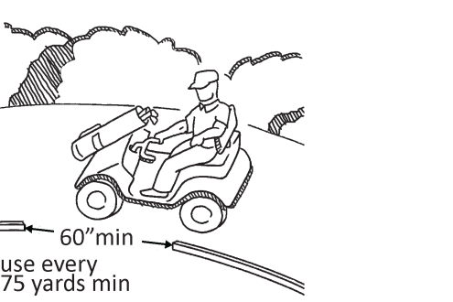 |  | Photo #: |  | • Alter curb  • Alter barrier  • Remove barriers  •  •
G6 | If there is one teeing ground for a hole, can a golf car enter and exit the teeing ground?  Note: A teeing ground is the starting place for a hole of golf. A rectangular area usually two club-lengths in depth, the teeing ground’s borders are defined by the outside limits of two tee-markers. | Yes No | 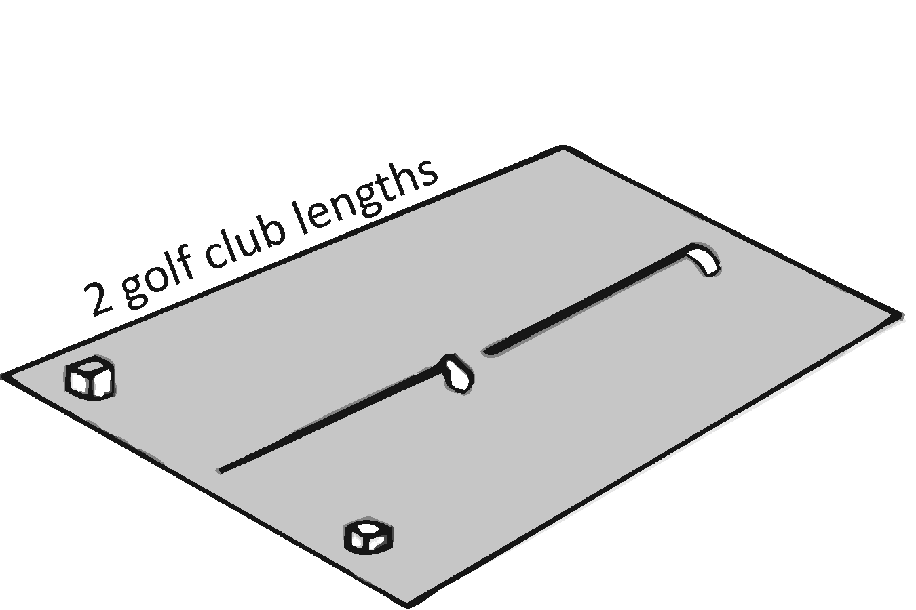 |  | Photo #: |  | • Alter route to teeing ground  • Alter teeing ground  •
G7 | If there are two teeing grounds for a hole:  Can a golf car enter and exit the forward teeing ground, unless it is not possible due to terrain?  If a golf car cannot enter and exit the forward teeing ground, can it enter and exit the other teeing ground? | Yes No  Yes No | 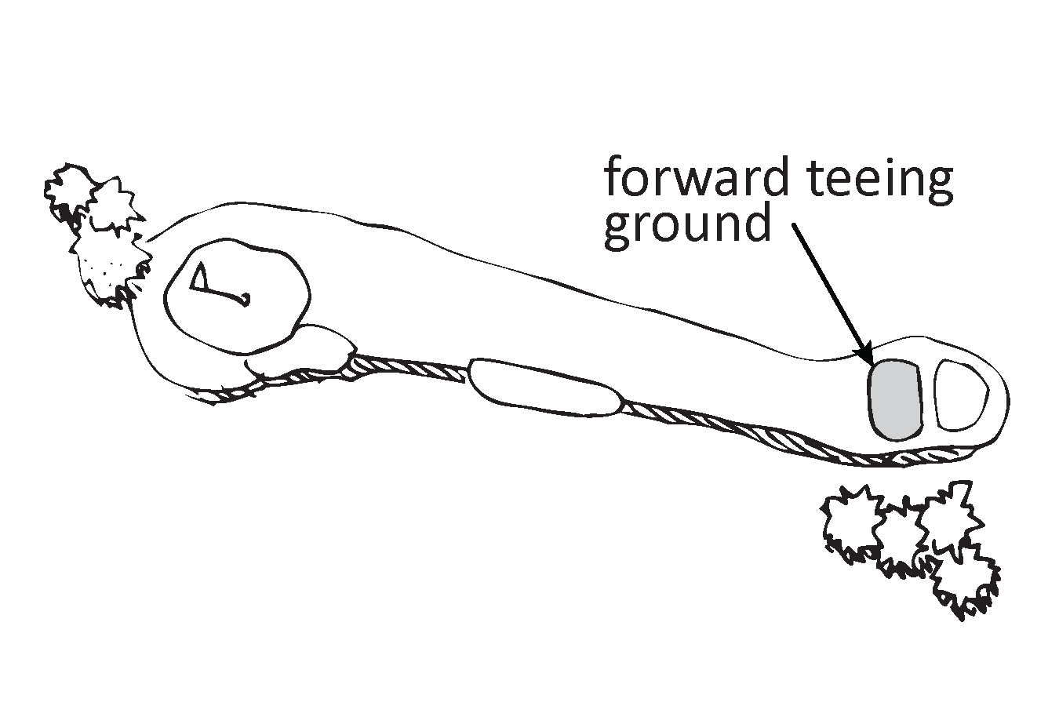 |  | Photo #: |  | • Alter route to forward teeing ground  • Alter route to other teeing ground  • Alter teeing ground  •  •
G8 | If there are three or more teeing grounds for a hole:  Can a golf car enter and exit at least two teeing grounds, including the forward teeing ground unless it is not possible due to terrain?  If a golf car cannot enter and exit the forward teeing ground can it enter and exit the other two teeing grounds? | Yes No  Yes No |  |  | Photo #: |  | • Alter route to forward and at least one other teeing ground  • Alter route to other teeing grounds  • Alter teeing ground(s)  •  •
G9 | Can a golf car enter and exit each putting green? | Yes No | 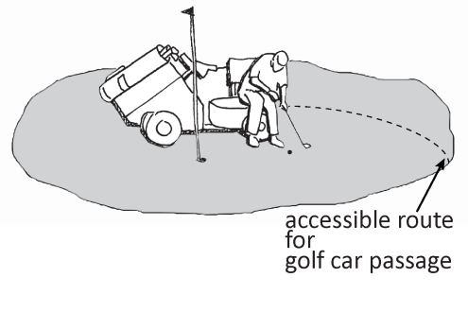 |  | Photo #: |  | • Alter route to putting green(s)  • Alter putting green(s)  •
G10 | Can a golf car enter at least 5 percent but not fewer than one of:  Practice putting greens?  Practice teeing grounds?  Teeing stations at a driving range? | Yes No  Yes No  Yes No | 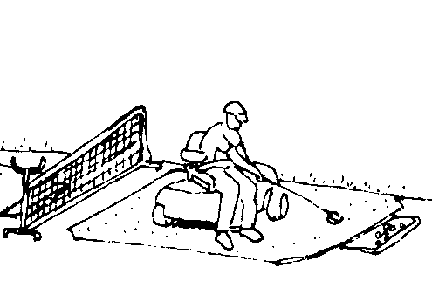 |  | Photo #: |  | • Alter route  • Alter practice putting green(s)  • Alter practice teeing ground(s)  • Alter teeing stations(s)  •  •
G11 | If there is a weather shelter:  Can a golf car enter and exit the shelter?  Is there a clear floor/ground space at least 60 inches by at least 96 inches within the shelter? | Yes No  Yes No  Measurement: | 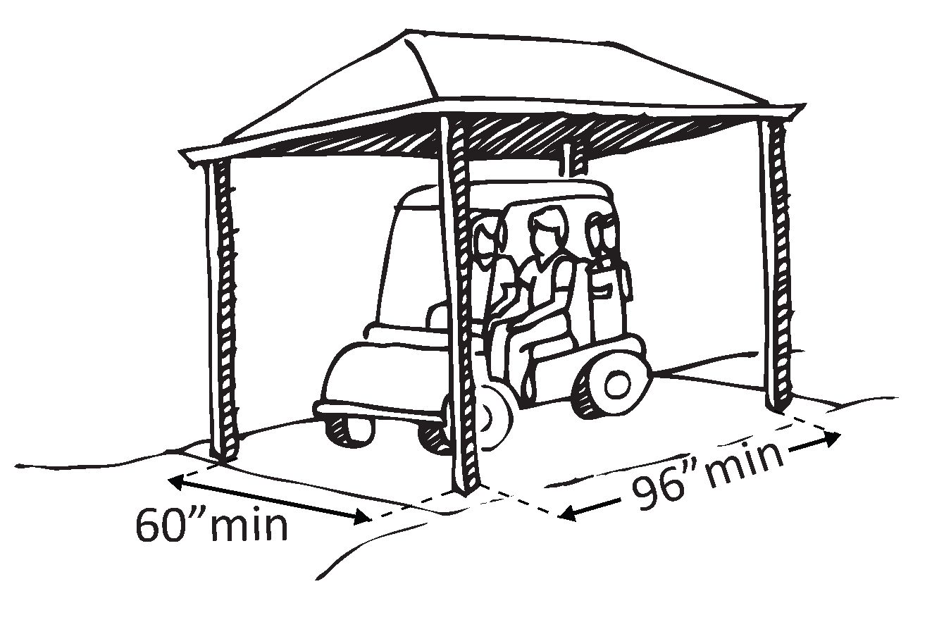 |  | Photo #: |  | • Alter route to shelter  • Alter shelter  •
 |  | Yes No |  |  | Photo #: |  | •  •  •
 |  | Yes No |  |  | Photo #: |  | •  •  •
 |  | Yes No |  |  | Photo #: |  | •  •  •
 |  | Yes No |  |  | Photo #: |  | •  •  •
 |  | Yes No |  |  | Photo #: |  | •  •  •
 |  | Yes No |  |  | Photo #: |  | •  •  •

