 |  |  | ADA Checklist for Existing Facilities
 |  |  | Miniature Golf Facilities
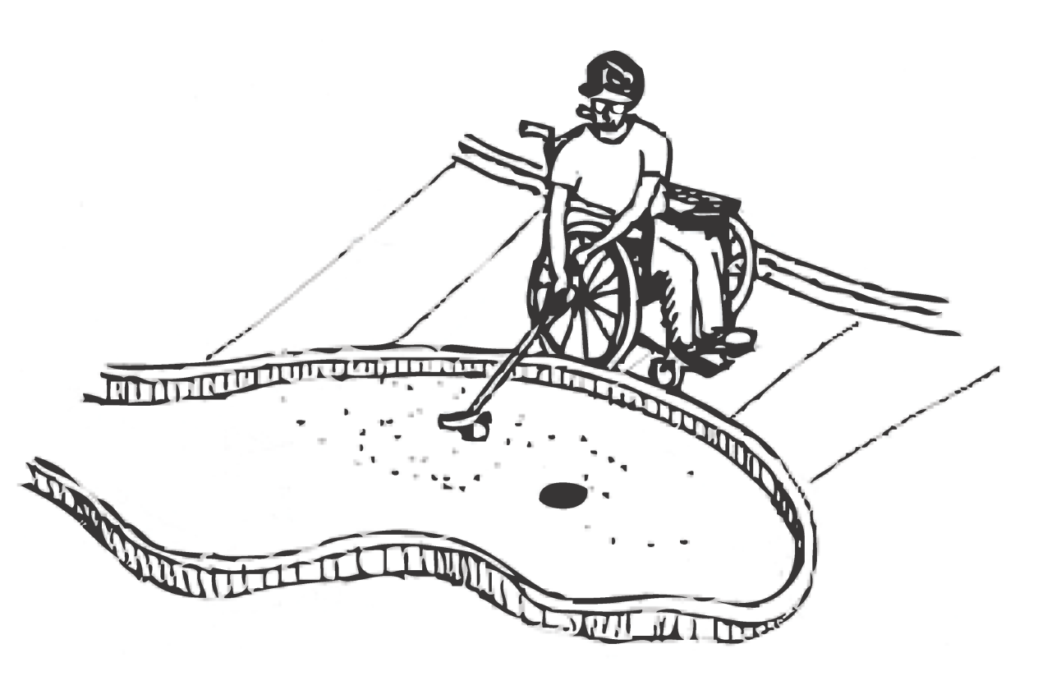 |  |  |  |  |  |  |  | Project
 |  |  |  |  |  |  |  | Building
 |  |  |  |  |  |  |  | Location
 |  |  |  |  |  |  |  | Date
 |  |  |  |  |  |  |  | Surveyors
 |  |  |  |  |  |  |  | Contact Information
 |  | Miniature golf facilities should be accessible to everyone, including people with disabilities.
 |  | Institute for Human Centered Design  www.HumanCenteredDesign.org  Copyright © 2016 |  |  |  |  | ADA National Network  Questions on the ADA 800-949-4232 voice/tty  www.ADAchecklist.org

This checklist was produced by the New England ADA Center, a project of the Institute for Human Centered Design and a member of the ADA National Network. This checklist was developed under a grant from the Department of Education, NIDRR grant number H133A060092-09A. However the contents do not necessarily represent the policy of the Department of Education, and you should not assume endorsement by the Federal Government.
Questions or comments on the checklist contact the New England ADA Center at 617-695-0085 voice/tty or ADAinfo@NewEnglandADA.org
For the full set of checklists, including the checklists for recreation facilities visit www.ADAchecklist.org.
Copyright © 2016 ADA Checklist for Existing Materials. You can freely reproduce and distribute this content. Include proper attribution. But you must get permission before using this content as a fee-based product.

Miniature Golf Facilities |  |  |  | Comments |  | Possible Solutions
Miniature Golf Facilities (2010 Standards – 206, 239 & 1007)
M1 | Is there an accessible route to the entrance of the miniature golf facility?  Use the checklist for Priority 1: Approach & Entrance. | Yes No | 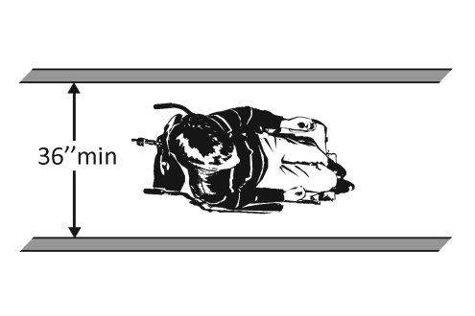 |  | Photo #: |  | •Regrade to 1:20  maximum slope  •Install a ramp  •Install a platform lift or limited –use/limited access elevator
M2 | Is there an accessible route to at least 50 percent of the golf holes, including the start of play?  Where the accessible route is provided on the play surface of the accessible holes, the following exceptions apply:  1. If there is carpet, it may be higher than ½ inch thick and does not have to be securely attached.  2. If the accessible route intersects the playing surface of a hole, a curb no higher than 1 inch is permitted for a width of at least 32 inches.  3. If the rise is no greater than 4 inches, a slope no greater than 1:4 is permitted.  4. If there is a ramp with landings: the landing slope is permitted to be no greater than 1:20; length of the landing at the top and bottom is permitted to be at least 48 inches long; and the size of the landing where the ramp changes direction is permitted to be at least 48 inches by at least 60 inches.  5. Handrails are not required on holes. | Yes No  Number: | 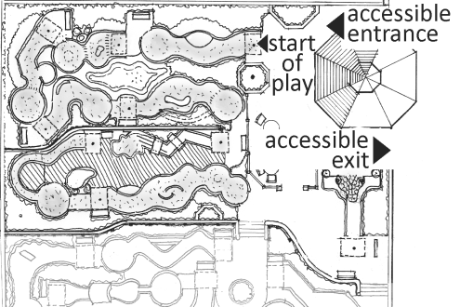  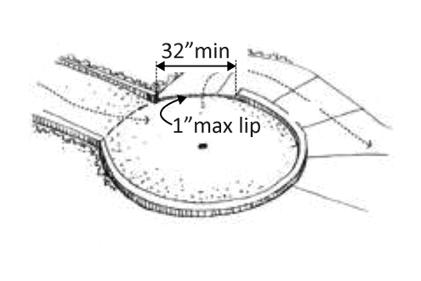  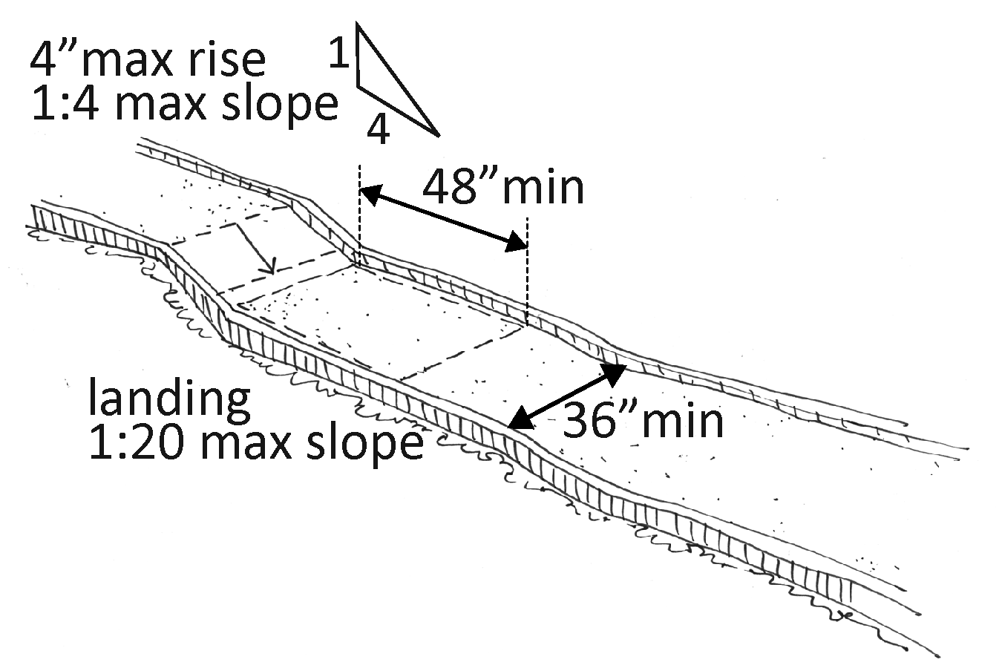 |  | Photo #: |  | •Regrade to 1:20 maximum slope where the route is not on the hole play surface  •Regrade to 1:4 maximum slope where the route is on the hole play surface and the rise is no greater than 4 inches  •Install a ramp  •Install a platform lift
M3 | Are the accessible holes connected by the accessible route consecutive?  Exception:  One break in the sequence of consecutive holes is permitted if the last hole on the course is the last hole in the sequence. | Yes No |  |  | Photo #: |  | • Alter route  • Alter consecutive holes  •
M4 | Is there an accessible route from the last accessible hole to the course entrance or exit that does not require travel through any other holes on the course? | Yes No |  |  | Photo #: |  | • Alter route  • Regrade to 1:20 maximum slope  • Install a ramp  •
M5 | At the start of play for the accessible holes, is there a clear floor/ground space at least 48 inches by at least 60 inches?  Is the slope of the clear space no greater than 1:48, i.e. for every inch of height change there are at least 48 inches of run? | Yes No  Measurement:  Yes No  Measurement: | 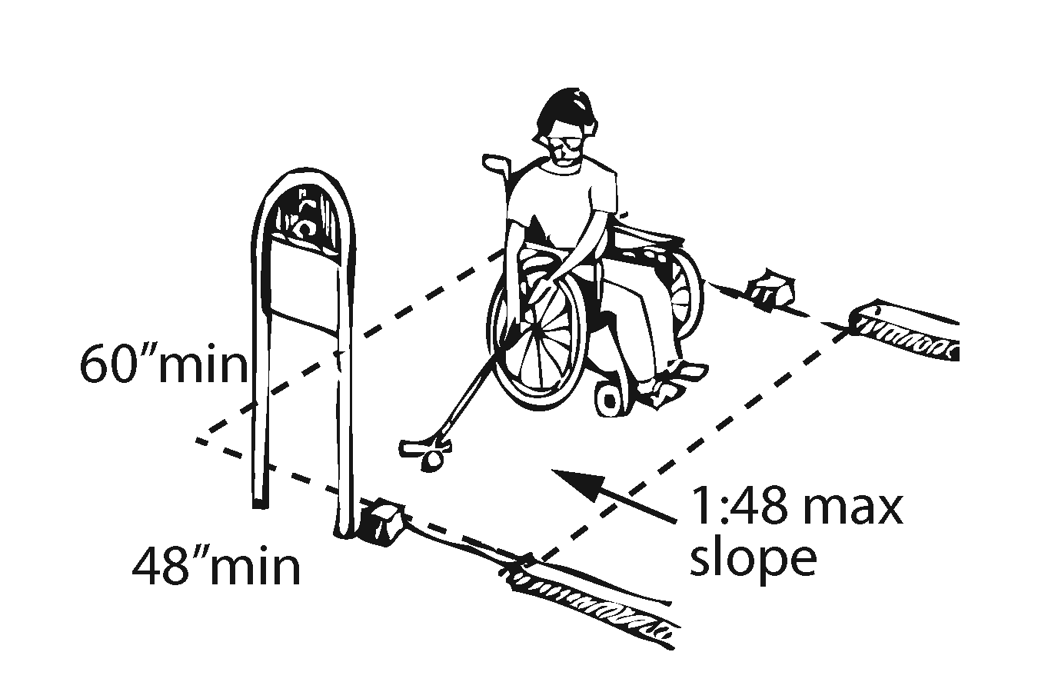  Or  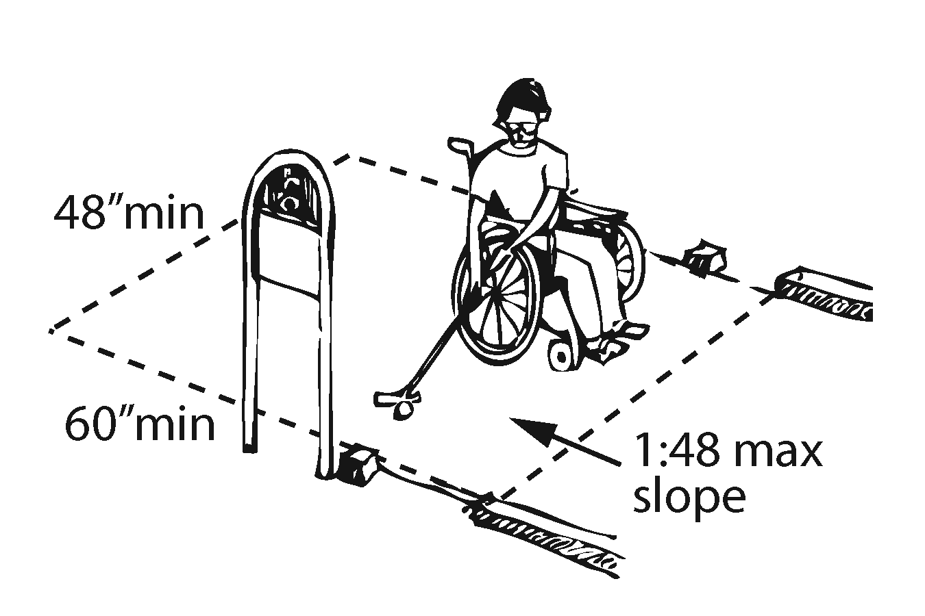 |  | Photo #: |  | • Alter hole  • Remove obstructions  • Regrade to maximum 1:48 slope  •
M6 | At the accessible holes where golf balls rest, is there a clear floor/ground space at least 36 inches wide by at least 48 inches long?  Is the running slope of the clear space no greater than 1:20, i.e. for every inch of height change there are at least 20 inches of run? | Yes No  Measurement:  Yes No  Measurement: | 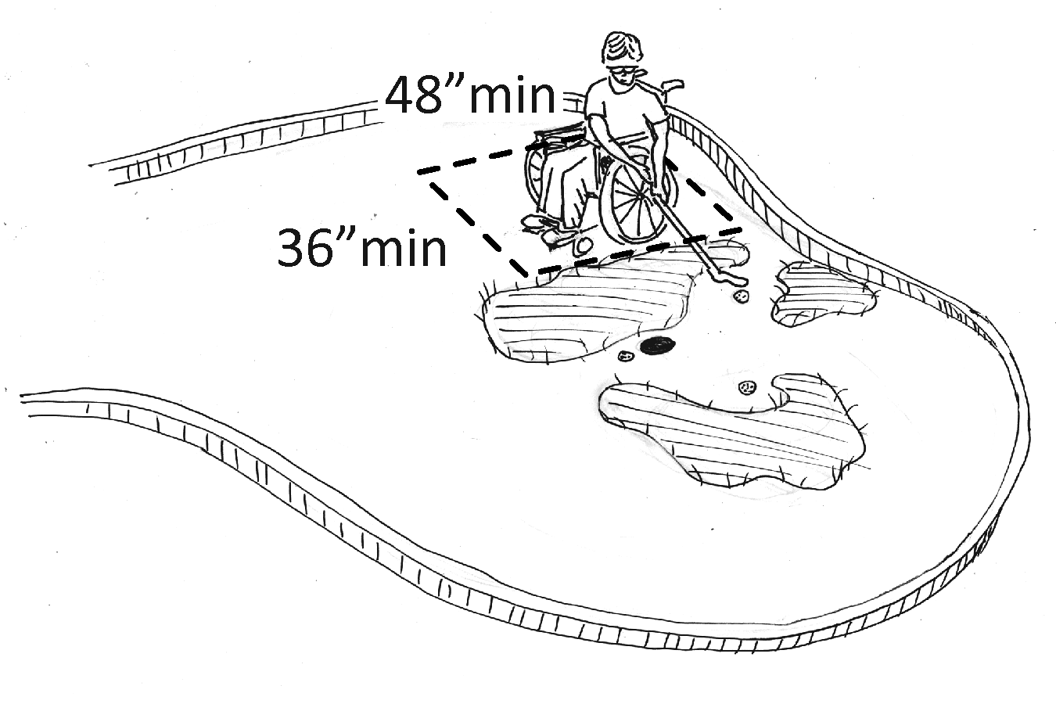 |  | Photo #: |  | • Alter hole  • Remove obstructions  • Regrade to 1:20 maximum slope  •
M7 | Are all areas of accessible holes where golf balls rest no greater than 36 inches from the clear space? | Yes No  Measurement: | 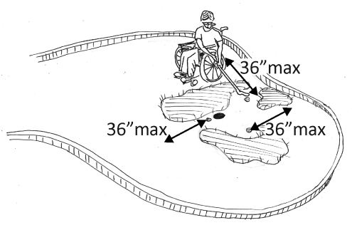  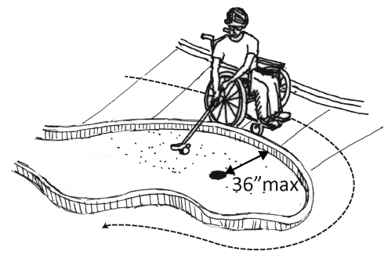 |  | Photo #: |  | • Alter hole  •  •
 |  | Yes No |  |  | Photo #: |  | •  •  •
 |  | Yes No |  |  | Photo #: |  | •  •  •
 |  | Yes No |  |  | Photo #: |  | •  •  •

