 |  |  |  | ADA Checklist for Existing Facilities
 |  |  |  | Play Areas
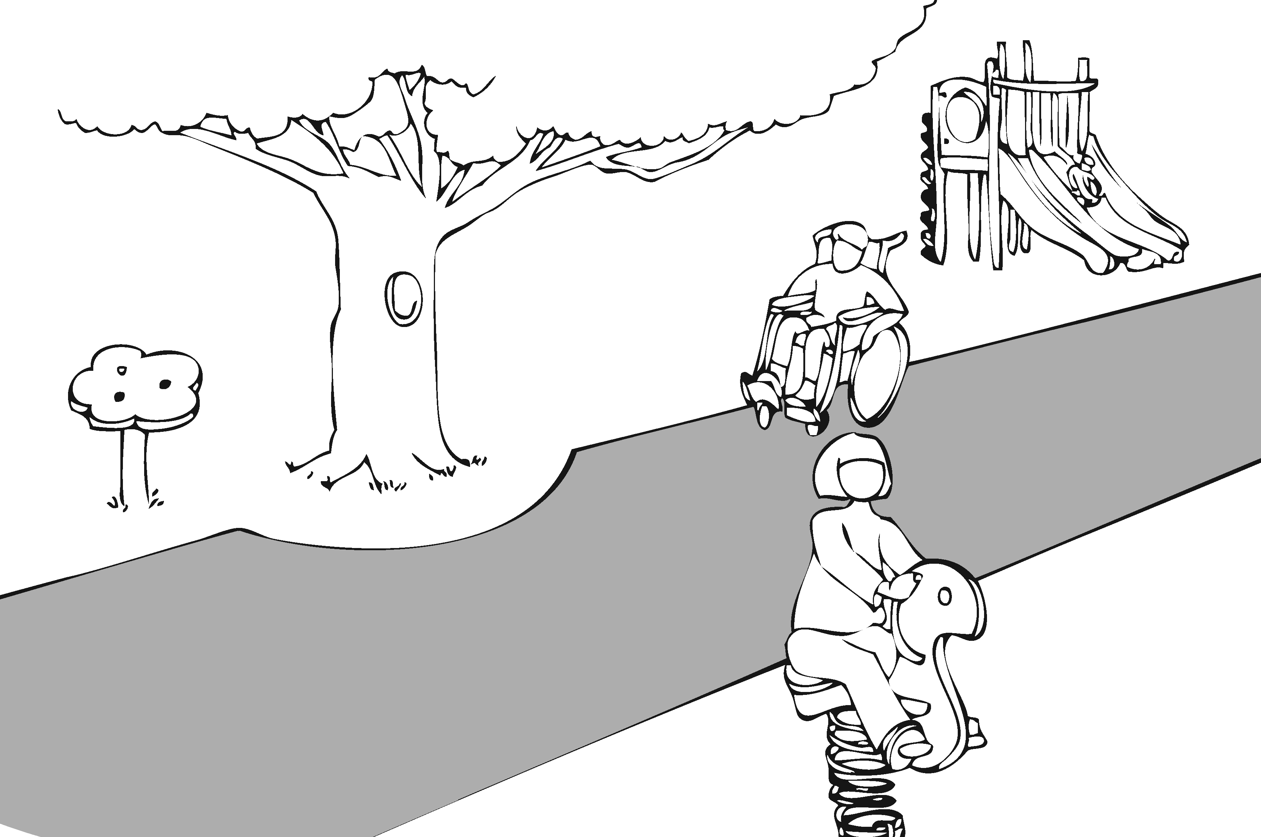 |  |  |  |  |  |  |  |  |  | Project
 |  |  |  |  |  |  |  |  |  | Building
 |  |  |  |  |  |  |  |  |  | Location
 |  |  |  |  |  |  |  |  |  | Date
 |  |  |  |  |  |  |  |  |  | Surveyors
 |  |  |  |  |  |  |  |  |  | Contact Information
 |  | Play areas should be accessible to everyone, including people with disabilities.
 |  |  | Institute for Human Centered Design  www.HumanCenteredDesign.org  Copyright © 2016 |  |  |  |  |  | ADA National Network  Questions on the ADA 800-949-4232 voice/tty  www.ADAchecklist.org

This checklist was produced by the New England ADA Center, a project of the Institute for Human Centered Design and a member of the ADA National Network. This checklist was developed under a grant from the Department of Education, NIDRR grant number H133A060092-09A. However the contents do not necessarily represent the policy of the Department of Education, and you should not assume endorsement by the Federal Government.
Questions or comments on the checklist contact the New England ADA Center at 617-695-0085 voice/tty or ADAinfo@NewEnglandADA.org
For the full set of checklists, including the checklists for recreation facilities visit www.ADAchecklist.org.
Copyright © 2016 ADA Checklist for Existing Materials. You can freely reproduce and distribute this content. Include proper attribution. But you must get permission before using this content as a fee-based product.

Play Areas |  |  |  | Comments |  | Possible Solutions
Play Areas (2010 Standards – 206, 240 & 1008) Note: Play areas for children under age 2 and play areas in family child care facilities where the proprietor resides do not have to comply.
P1 | Is there an accessible route to the entrance of the play area?  If there are separate play areas within a site for specific age groups, is there an accessible route to each play area?  Is there an accessible route within the play area connecting ground level play components that are on an accessible route and elevated play components that are on an accessible route including the entry and exit points of those components?  Use the checklist for Priority 1: Approach & Entrance | Yes No  Yes No  Yes No |  |  | Photo #: |  | •  •  •
P2 | Ground Level Play Components  Is there an accessible route to at least one of each type of ground level play component?  Notes:  1. A play component is an element designed to generate play, socialization and learning. In the 2010 Standards ramps, transfer systems, steps, decks and roofs are not considered play components.  2. Ground level play components are components that can be approached and exited at ground level. Examples include rockers, swings, diggers, and stand-alone slides. When distinguishing between types of components consider the experience provided. Examples include rocking, swinging, climbing, digging, spinning and sliding. | Yes No |  |  | Photo #: |  | •  •  •
P3 | If there are elevated play components, is there an accessible route to at least the following number and type of ground level play components? See chart below.  Notes:  1. The intent is to provide a variety of experiences for children who want to remain in their wheelchair or with another mobility device and who choose not to transfer to elevated components.  2. If a play area includes two or more composite structures for the same age group, use the total number of elevated components to determine the additional number and types of ground level play components to provide on an accessible route.  3. If ramps provide access to at least 50 percent of the elevated components and the ramped route goes to at least three different elevated play types, the ground level components in the chart are not required.  4. The number of ground level components determined by “one of each type” can fulfill the minimum ground level requirements in the table. | Yes No |  |  | Photo #: |  | •  •  •
Number of Elevated Play Components Provided | Minimum Number of Ground Level Play Components Required to be on an Accessible Route | Minimum Number of Different Types of Ground Level Play Components Required to be on an Accessible Route
1 | n/a | n/a
2 to 4 | 1 | 1
5 to 7 | 2 | 2
8 to 10 | 3 | 3
11 to 13 | 4 | 3
14 to 16 | 5 | 3
17 to 19 | 6 | 3
20 to 22 | 7 | 4
23 to 25 | 8 | 4
26 and over | 8, plus 1 for each additional 3, or fraction thereof, over 25 | 5

P4 | If two or more ground level play components are on an accessible route are they dispersed throughout the play area and integrated with other play components? | Yes No |  |  | Photo #: |  | •  •  •
P5 | If there is a soft contained play structure with three or fewer entry point, is there an accessible route to at least one entry point?  It there are four or more entry points, are there accessible routes to at least two entry points?  Notes:  1. A soft contained play area is a play structure made of one or more components on which a person enters a fully enclosed play environment that uses pliable materials such as plastic, soft padding and fabric. | Yes No  Yes No |  |  | Photo #: |  | •  •  •
P6 | Accessible Route Connecting Ground Level Play Components  Use the checklist for Priority 1: Approach & Entrance with the following exceptions and requirements.  Note: If there is a water play component and the accessible route is submerged, it is not required to be slip resistant, the running slope may be steeper than 1:12 and the cross slope may be steeper than 1:48. |  |  |  | Photo #: |  | •  •  •
P7 | Is the vertical clearance of the accessible route at least 80 inches above the ground surface?  Note: Objects below 80 inches may not protrude into the accessible route. | Yes No  Measurement: |  |  | Photo #: |  | •  •  •
P8 | If the play area is less than 1000 square feet:  Is the route at least 44 inches wide?  If the route exceeds 30 feet in length is a wheelchair turning space provided, i.e. a circle at least 60 inches in diameter or a T-shaped space within a 60-inch square? | Yes No  Measurement:  Yes No  Measurement: |  |  | Photo #: |  | •  •  •
P9 | If the play area is 1000 square feet or greater is the route at least:  60 inches wide  or  36 inches wide for a distance no greater than 60 inches if reduced segments are separated by segments at least 60 wide and at least 60 inches long?  Note: This permits flexibility around site features such as trees and equipment. | Yes No  Measurement:  Yes No  Measurement: |  |  | Photo #: |  | •  •  •
P10 | Is the route no steeper than 1:16, i.e. for every inch of height change there are at least 16 inches of run? | Yes No  Measurement: |  |  | Photo #: |  | •  •  •
P11 | If the route is steeper than 1:20 and the rise for a ramp run is higher than 6 inches are there handrails on both sides of the ramp run?  Notes:  1. Handrail extensions are not required.  2. Handrails are not required on ramps within ground level use zones. The use zone is the area beneath and adjacent to a play structure upon which a user would land when falling from or exiting a play structure. | Yes No |  |  | Photo #: |  | •  •  •
P12 | Is the top of the handrail gripping surface no less than 20 inches and no greater than 28 inches above the ramp surface? | Yes No  Measurement: |  |  | Photo #: |  | •  •  •
P13 | Is the handrail gripping surface:  Circular with an outside diameter of at least .95 inch and no more than 1.55 inches?  or  Non-circular providing an equivalent gripping surface? | Yes No  Measurement: |  |  | Photo #: |  | •  •  •
P14 | Elevated Play Components  Is there an accessible route to entry and exit points of at least 50 percent of elevated components?  Note: An elevated play component is a component approached above or below grade that is part of a structure of two or more play components providing more than one play activity. | Yes No  Measurement: |  |  | Photo #: |  | •  •  •
P15 | If there are 20 or more elevated play components are at least 25% connected by ramps?  Are the other 25% that are required to be on an accessible route connected by either ramps or transfer systems? | Yes No  Yes No |  |  | Photo #: |  | •  •  •
P16 | If there are fewer than 20 elevated play components are at least 50% connected by either ramps or transfer systems.  Note: Ramps are preferred but are not required. | Yes No |  |  | Photo #: |  | •  •  •
P17 | Elevated Play Components  Accessible Route  Use the checklist for Priority 1: Approach & Entrance and the following exceptions and requirements.  Is the accessible route connecting elevated play components:  At least 36 inches wide?  or  At least 32 inches wide for a distance no greater than 24 inches if the reduced width segments are separated by segments at least 48 inches long and at least 36 inches wide?  or  If part of a transfer system, at least 24 inches wide? | Yes No  Measurement:  Yes No  Measurement:  Yes No  Measurement: |  |  | Photo #: |  | •  •  •
P18 | If there is a ramp are there handrails on both sides?  Note: Handrail extensions are not required. | Yes No |  |  | Photo #: |  | •  •  •
P19 | Is the top of the handrail gripping surface no less than 20 inches and no greater than 28 inches above the ramp surface? | Yes No  Measurement: |  |  | Photo #: |  | •  •  •
P20 | If the handrail gripping surface is:  Circular, is the outside diameter no less than .94 inch and no greater than 1.55 inch?  Non-circular, is it equivalent to a circular gripping surface with a diameter no less than .94 inch and no greater than 1.55 inch? | Yes No  Measurement:  Yes No  Measurement: |  |  | Photo #: |  | •  •  •
P21 | Is the rise for any ramp run connecting elevated play components no greater than 12 inches? | Yes No  Measurement: |  |  | Photo #: |  | •  •  •
P22 | If a transfer system is provided is the transfer system at least 24 inches wide? | Yes No  Measurement: |  |  | Photo #: |  | •  •  •
P23 | Is the top of the transfer platform no less than 11 inches and no greater than 18 inches from the ground? | Yes No  Measurement: |  |  | Photo #: |  | •  •  •
P24 | Is the transfer platform at least 14 inches deep by at least 24 inches wide? | Yes No  Measurement: |  |  | Photo #: |  | •  •  •
P25 | Is there a clear transfer space at least 30 inches wide by at least 48 inches long adjacent to the platform, with the longer dimension centered on and parallel to the 24 inch minimum long side of the platform? | Yes No  Measurement: |  |  | Photo #: |  | •  •  •
P26 | Is the side of the transfer platform adjacent to the clear space unobstructed? | Yes No |  |  | Photo #: |  | •  •  •
P27 | If movement is intended from transfer platforms to levels with elevated play components that are required to be on an accessible route, are transfer steps provided? | Yes No |  |  | Photo #: |  | •  •  •
P28 | Are the transfer steps:  At least 14 inches deep?  At least 24 inches wide?  No higher than 8 inches? | Yes No  Measurement:  Yes No  Measurement:  Yes No  Measurement: |  |  | Photo #: |  | •  •  •
P29 | Is there at least one means of support for transferring:  On and off the platform?  Up and down the transfer steps?  Note:  Examples of supports include a rope loop, a loop type handle, a slot in the edge of a flat horizontal or vertical member, poles or bars, or D rings on the corner posts. | Yes No  Yes No |  |  | Photo #: |  | •  •  •
P30 | Play Components  Is there at least one clear space for a person in a wheelchair to turn around, i.e. a circle at least 60 inches in diameter or a T-shaped space within a 60-inch square, at:  Ground level play components on an accessible route?  Elevated play components connected by ramps?  Note: The turning space is not required at elevated play components connected only by transfer system. | Yes No  Measurement:  Yes No  Measurement: |  |  | Photo #: |  | •  •  •
P31 | If there are swings, is there clear space for a person in a wheelchair to turn around, i.e. a circle at least 60 inches in diameter or a T-shaped space within a 60-inch square, immediately adjacent to at least one swing? | Yes No |  |  | Photo #: |  | •  •  •
P32 | Is there a clear ground/floor space at least 30 inches wide and 48 inches long at:  Each ground level play component required to be on an accessible route?  Each elevated play component required to be on an accessible route that is connected by ramps?  Notes:  1. The clear ground space is not required at elevated play components connected only by transfer system.  2. Clear ground spaces 30 inches min by 48 inches min, 60 inch min turning spaces and accessible routes may overlap. | Yes No  Measurement:  Yes No  Measurement: |  |  | Photo #: |  | •  •  •
P33 | If there is a play table for children older than 5 years:  Are the tops of rims, curbs, or other obstructions no greater than 31 inches above the ground?  Is there clear ground space at least 30 inches wide by at least 48 inches long for a forward approach?  Is there clear knee space underneath:  At least 17 inches high?  Does it extend at least 17 inches deep?  Is it least 30 inches wide? | Yes No  Measurement:  Yes No  Measurement:  Yes No  Measurement:  Yes No  Measurement:  Yes No  Measurement: |  |  | Photo #: |  | •  •  •
P34 | If there is a play table for children 5 years or younger:  Does it provide knee space as noted above?  or  Is there clear ground space at least 30 inches wide by at least 48 inches long for a parallel approach? | Yes No  Yes No  Measurement: |  |  | Photo #: |  | •  •  •
P35 | If a play component on an accessible route requires transfer to entry points or seats:  Is the entry point or seat no less than 11 inches and no greater than 24 inches from the clear floor/ground space?  Is there at least one means of transfer support?  Note:  Examples of supports include a rope loop, a loop type handle, a slot in the edge of a flat horizontal or vertical member, poles or bars, or D rings on the corner posts. | Yes No  Measurement:  Yes No |  |  | Photo #: |  | •  •  •
P36 | Ground Surfaces  Do ground surfaces inside the play area (on accessible routes, clear ground spaces, and turning spaces) comply with ASTM F 1951-99 Standard Specification for Determination of Accessibility of Surface Systems Under and Around Playground Equipment?  Notes:  1. ASTM is the American Society for Testing and Materials.  2 A portable device - the Rotational Penetrometer - measures surface firmness and stability. | Yes No |  |  | Photo #: |  | •  •  •
P37 | Do the ground surfaces within use zones (the ground level area beneath and immediately adjacent to a play structure or play equipment that is designated for unrestricted circulation around the play equipment and where it is predicted that a user would land when falling from or exiting the play equipment) comply with ASTM F 1292-04 Standard Specification for Impact Attenuation of Surfacing Materials Within the Use Zone of Playground Equipment? | Yes No |  |  | Photo #: |  | •  •  •
 |  | Yes No |  |  | Photo #: |  | •  •  •
 |  | Yes No |  |  | Photo #: |  | •  •  •

