 |  |  | ADA Checklist for Existing Facilities
 |  |  | Swimming Pools, Wading Pools & Spas
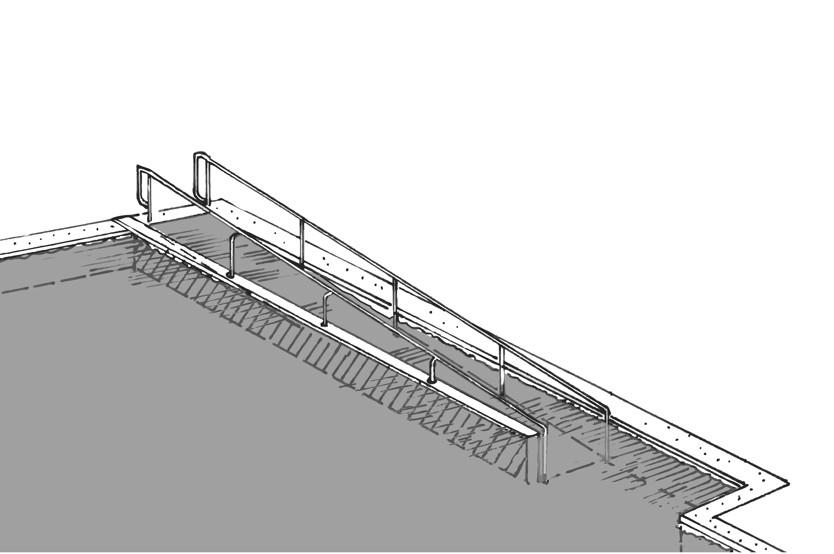 |  |  |  |  |  |  |  | Project
 |  |  |  |  |  |  |  | Building
 |  |  |  |  |  |  |  | Location
 |  |  |  |  |  |  |  | Date
 |  |  |  |  |  |  |  | Surveyors
 |  |  |  |  |  |  |  | Contact Information
 |  | Swimming pools, wading pools and spas should be accessible to everyone, including people with disabilities.
 |  | Institute for Human Centered Design  www.HumanCenteredDesign.org  Copyright © 2016 |  |  |  |  | ADA National Network  Questions on the ADA 800-949-4232 voice/tty  www.ADAchecklist.org

This checklist was produced by the New England ADA Center, a project of the Institute for Human Centered Design and a member of the ADA National Network. This checklist was developed under a grant from the Department of Education, NIDRR grant number H133A060092-09A. However the contents do not necessarily represent the policy of the Department of Education, and you should not assume endorsement by the Federal Government.
Questions or comments on the checklist contact the New England ADA Center at 617-695-0085 voice/tty or ADAinfo@NewEnglandADA.org
For the full set of checklists, including the checklists for recreation facilities visit www.ADAchecklist.org.
Copyright © 2016 ADA Checklist for Existing Materials. You can freely reproduce and distribute this content. Include proper attribution. But you must get permission before using this content as a fee-based product.

Swimming Pools, Wading Pools & Spas |  |  |  | Comments |  | Possible Solutions
Swimming Pools, Wading Pools & Spas (2010 Standards – 242 & 1009)
P1 | Is there an accessible route to the entrance of the facility containing a swimming pool, wading pool and spa?  Use the checklist for Priority 1: Approach & Entrance. | □Yes □No | 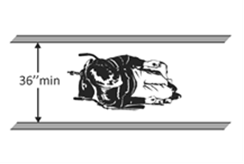 |  | Photo #: |  | •Regrade to 1:20  maximum slope  • Install a ramp  • Install a platform lift or limited –use/limited access elevator
P2 | Is there an accessible route from the facility entrance to the swimming pool, wading pool and/or spa?  Use the checklist for Priority 2: Access to Goods & Services. | □Yes □No | 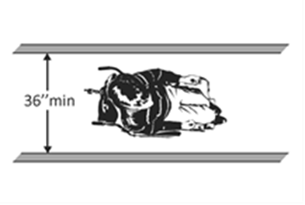 |  | Photo #: |  | •Regrade to 1:20  maximum slope  • Install a ramp  • Install a platform lift or limited –use/limited access elevator
P3 | If there is a swimming pool with 300 or more linear feet of pool wall:  Does it have a sloped entry or lift?  Is there a second means of entry that is a transfer wall, transfer system, sloped entry, lift or stairs? | □Yes □No  □Yes □No |  |  | Photo #: |  | • Add a sloped entry  • Install a lift  • Add a second means of entry
P4 | If there is a swimming pool with less than 300 linear feet of pool wall, does it have a sloped entry or lift? | □Yes □No |  |  | Photo #: |  | • Add a sloped entry  • Install a lift  •
P5 | If there is a wave action pool, leisure river, sand bottom pool, or other pool where user access is limited to one area, does it have a pool lift, sloped entry or transfer system? | □Yes □No |  |  | Photo #: |  | • Install a pool lift  • Add a sloped entry  • Install a transfer system
P6 | If there is a wading pool, does it have a sloped entry? | □Yes □No |  |  | Photo #: |  | • Add a sloped entry  •  •
P7 | If there is a spa, does it have a pool lift, transfer wall or transfer system? | □Yes □No |  |  | Photo #: |  | • Install a pool lift  •  •
P8 | If there is a catch pool does it have an accessible route to the edge of the pool?  Note: A catch pool has water slide flumes that drop users into the water. They are not required to provide an accessible means of entry or exit. | □Yes □No |  |  | Photo #: |  | •Regrade to 1:20  maximum slope  • Install a ramp  • Install a platform lift or limited –use/limited access elevator
P9 | POOL LIFT  If a pool lift is provided:  Is it located where the water level is no greater than 48 inches?  Note: If the entire pool depth is greater than 48 inches, the pool lift may be located at any water depth. | □Yes □No  Measurement: |  |  | Photo #: |  | • Relocate lift  •  •
P10 | Is there a clear deck space on the side of the seat opposite the water that is at least 36 inches wide and at least 48 inches long extending from 12 inches behind the rear of the seat? | □Yes □No  Measurement: | 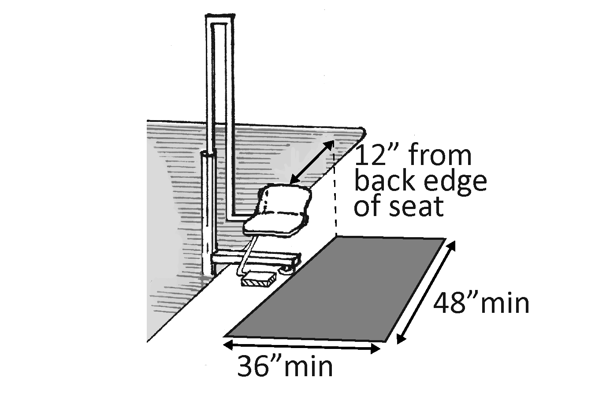 |  | Photo #: |  | • Add clear space  •  •
P11 | Is the slope of the clear deck space no greater than 1:48? | □Yes □No  Measurement: |  |  | Photo #: |  | • Regrade to 1:48 maximum slope  •  •
P12 | Does the height of the lift seat allow a stop at no less than 16 inches and no greater than 19 inches measured from the deck to the top of the seat surface when in the raised (load) position? | □Yes □No  Measurement: | 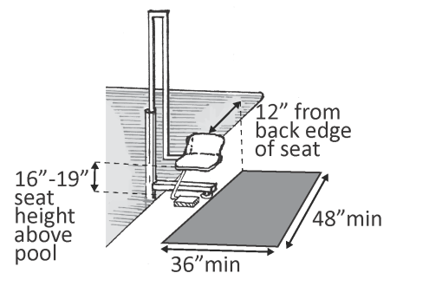 |  | Photo #: |  | • Change seat height  •  •
P13 | Is the lift seat at least 16 inches wide? | □Yes □No  Measurement: |  |  | Photo #: |  | • Alter seating  •  •
P14 | Does the seat submerge to a water depth of at least 18 inches below the stationary water level? | □Yes □No  Measurement: | 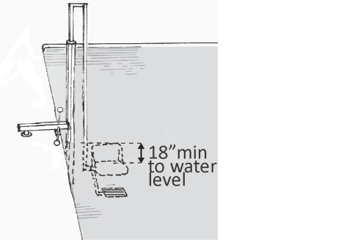 |  | Photo #: |  | • Change submersion depth  •  •
P15 | Is the centerline of the seat located over the deck and at least 16 inches from the edge of the pool? | □Yes □No  Measurement: |  |  | Photo #: |  | • Relocate seat  •  •
P16 | Does the deck surface between the centerline of the seat and the pool edge have a slope no greater than 1:48? | □Yes □No  Measurement: |  |  | Photo #: |  | • Regrade to 1:48 maximum slope  •  •
P17 | Is there a footrest that moves with the seat?  Note: Footrests are not required on pool lifts provided in spas. | □Yes □No |  |  | Photo #: |  | • Add a footrest  •  •
P18 | If there is an armrest, is it removable or does it fold clear of the seat when the seat is in the raised (load) position? | □Yes □No |  |  | Photo #: |  | • Add removable armrest  • Add folding armrest  •
P19 | Can the person using the lift do so without assistance and call the lift when it is in the deck and the water positions? | □Yes □No |  |  | Photo #: |  | • Alter lift  •  •
P20 | Are the controls and operating mechanisms unobstructed when the lift is in use? | □Yes □No |  |  | Photo #: |  | • Remove obstructions  • Relocate controls and/or operating mechanisms  •
P21 | Are the controls and operating mechanisms operable with one hand and without tight grasping, pinching or twisting of the wrist?  Do they require no more than 5 pounds of pressure to operate? | □Yes □No  □Yes □No  Measurement: |  |  | Photo #: |  | • Adjust controls and/or operating mechanisms  • Replace controls and/or operating mechanisms  •
P22 | Does the lift have a weight capacity of at least 300 pounds and capable of sustaining a static load of at least one and a half times the rated load? | □Yes □No  Max weight: |  |  | Photo #: |  | • Replace lift  •  •
P23 | SLOPED ENTRY  If a sloped entry is provided:  Is the width at least 36 inches? | □Yes □No |  |  | Photo #: |  | • Widen entry  •  •
P24 | Is the surface stable and firm?  Note: Sloped entry surfaces are not required to be slip resistant. | □Yes □No |  |  | Photo #: |  | • Resurface sloped entry surface  •  •
P25 | Does the sloped entry extend to a depth at least 24 inches and no greater than 30 inches below the stationary water level?  Or  If this is a wading pool, does the sloped entry and landings, if provided, extend to the deepest part of the pool? | □Yes □No  Measurement:  □Yes □No  Measurement: | 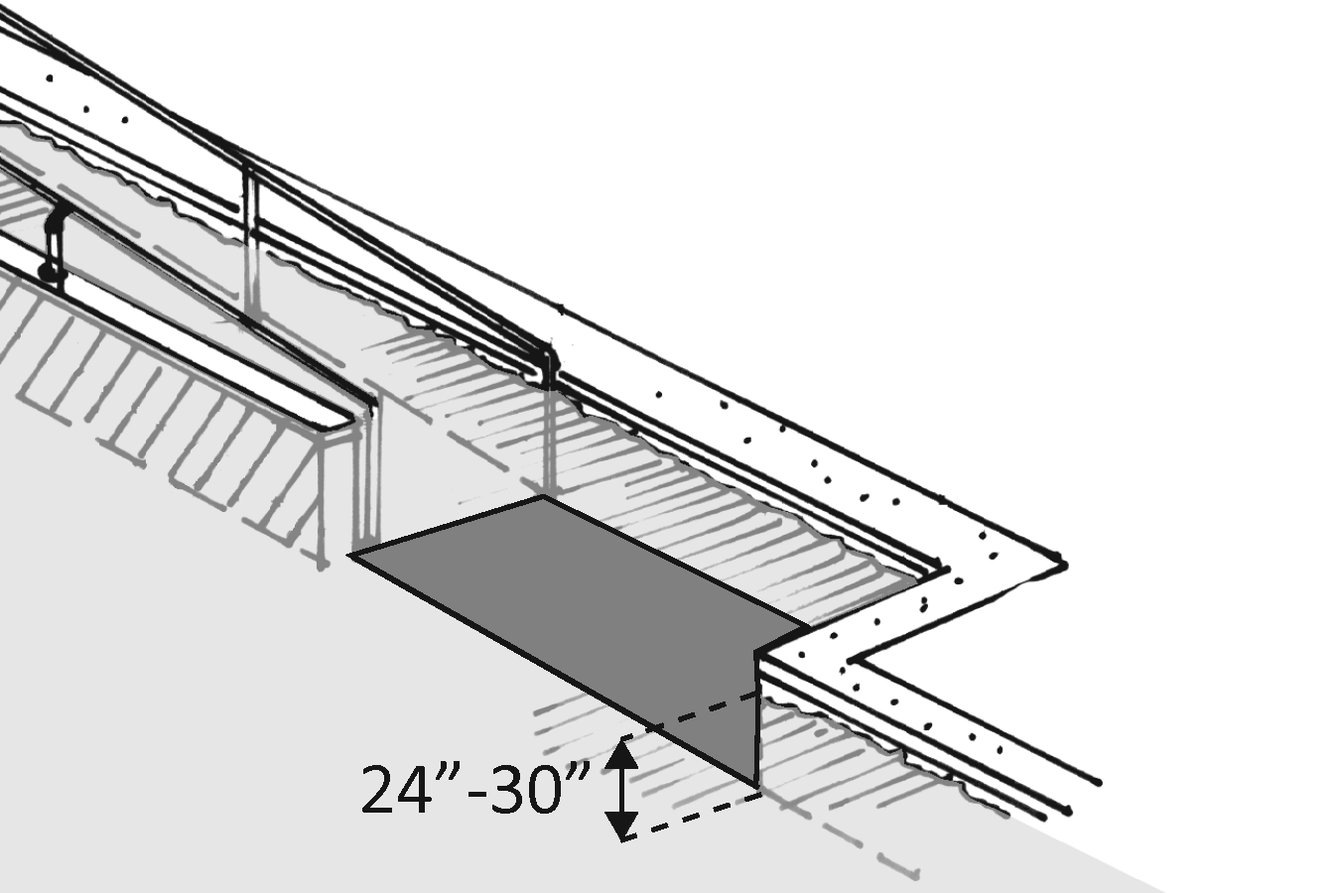 |  | Photo#: |  | • Lengthen sloped entry  •  •
P26 | Is the running slope no greater than 1:12? | □Yes □No  Measurement: | 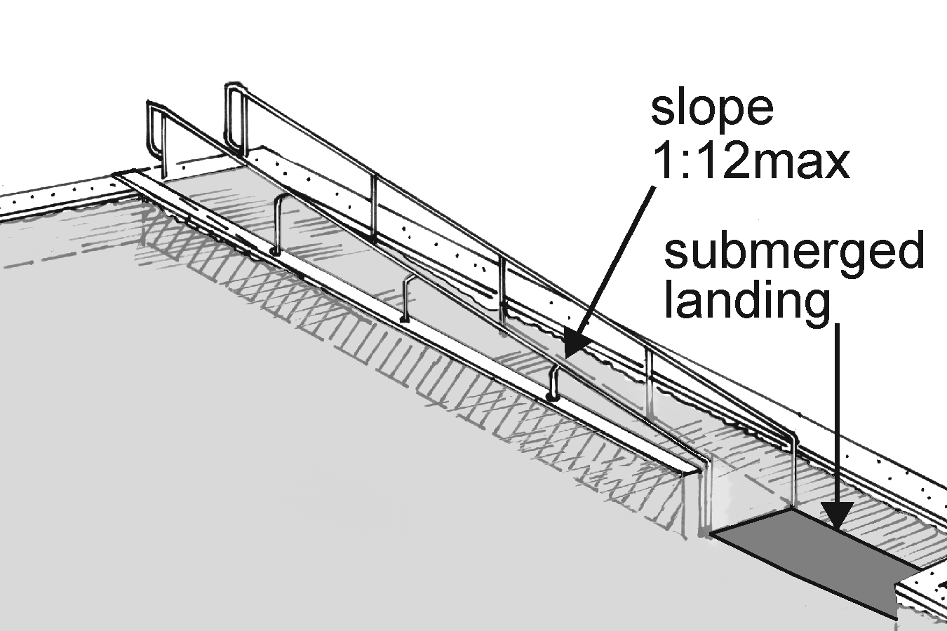 |  | Photo #: |  | • Regrade to 1:12 maximum slope  •  •
P27 | If the running slope is steeper than 1:20 are there level landings at the top and bottom of the sloped entry that are at least 60 inches long and as wide as the sloped entry? | □Yes □No  Measurement: | 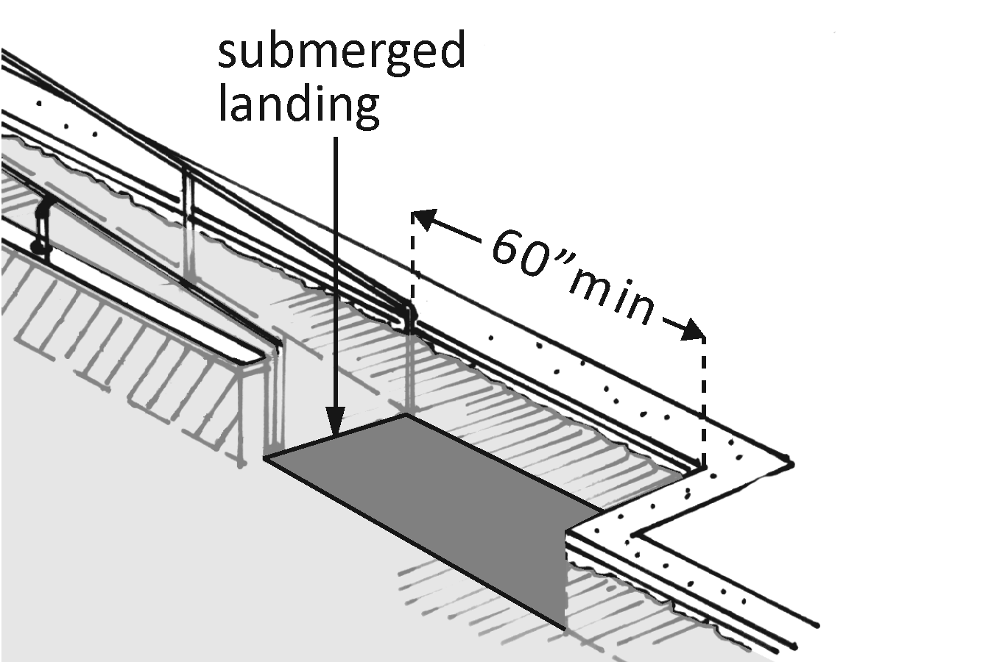 |  | Photo #: |  | • Add landings  •  •
P28 | If the running slope is steeper than 1:20 and the sloped entry is more than 30 feet long, are there level landings at least 60 inches long and as wide as the sloped entry at intervals no less than 30 feet? | □Yes □No  Measurement: |  |  | Photo #: |  | • Add landings  •  •
P29 | Is the cross slope no greater than 1:48? | □Yes □No  Measurement: |  |  | Photo #: |  | • Regrade to 1:48 maximum slope  •  •
P30 | Are there handrails on both sides of the sloped entry?  Note: If this is a wading pool, handrails are not required. If handrails are provided the 2010 Standards specifications for handrails do not apply. | □Yes □No |  |  | Photo #: |  | • Add handrails  •  •
P31 | Do the handrails extend at least 12 inches beyond the top of the sloped entry?  Note: Handrail extensions are not required at the bottom landing. | □Yes □No  Measurement: | 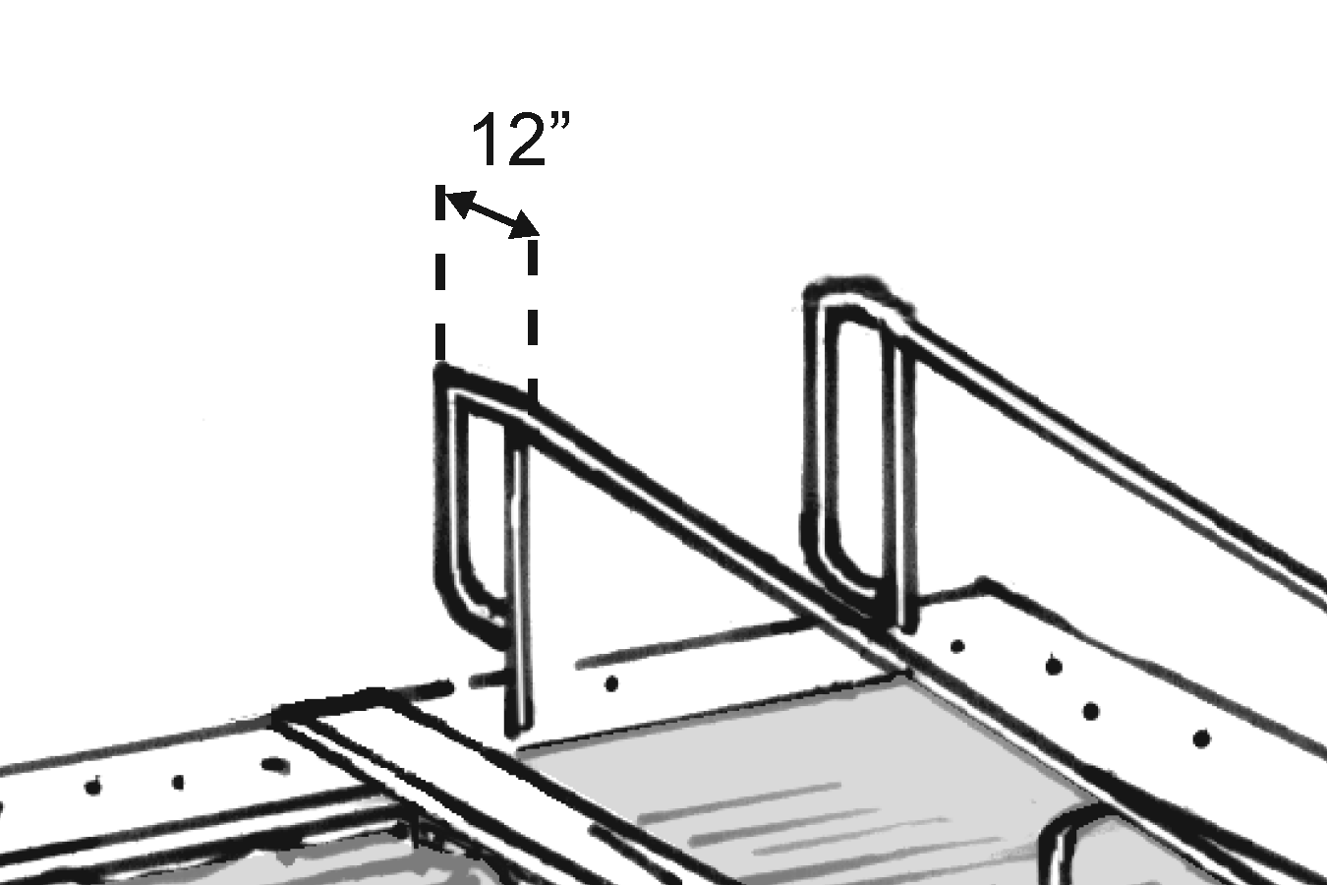 |  | Photo #: |  | • Add extensions  • Reconfigure handrails  •
P32 | Is the width between handrails at least 33 inches and no greater than 38 inches?  Note: If this is a wave action pool, leisure river, sand bottom pool, or other pool where user access is limited to one area, the width between handrails is not specified. | □Yes □No  Measurement: | 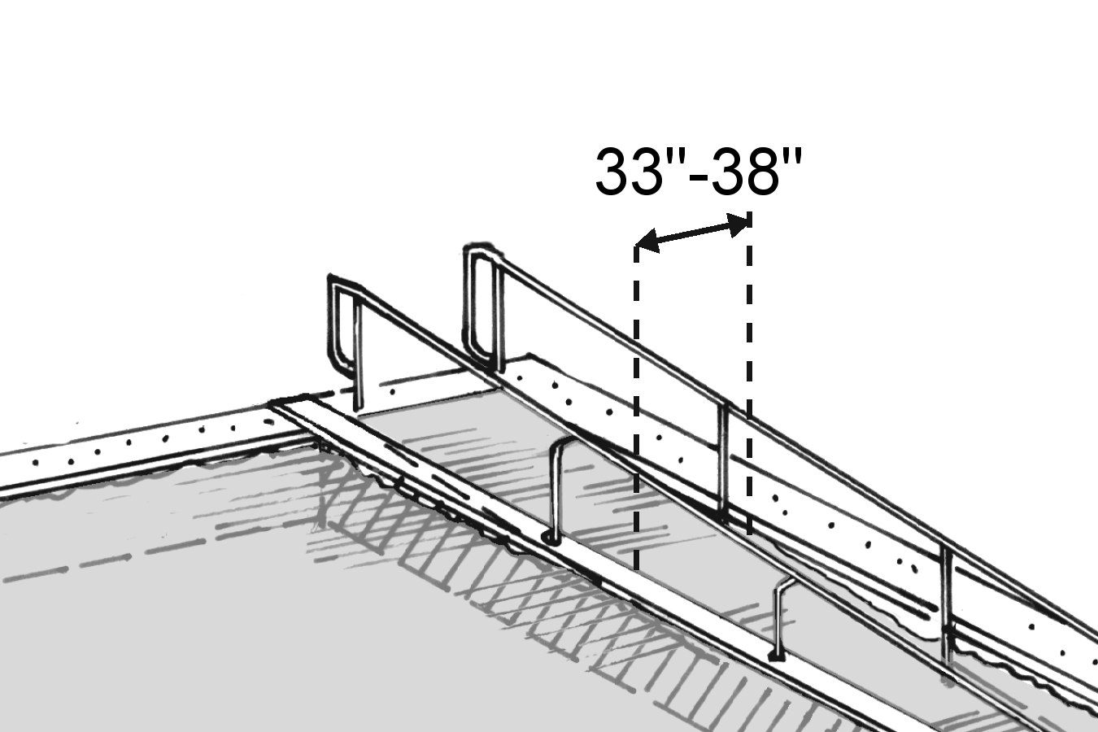 |  | Photo #: |  | • Relocate handrails  •  •
P33 | Is the top of the handrail gripping surface no less than 34 inches and no greater than 38 inches above the sloped entry surface?  Note: Handrails are not required below the stationary water level. | □Yes □No  Measurement: | 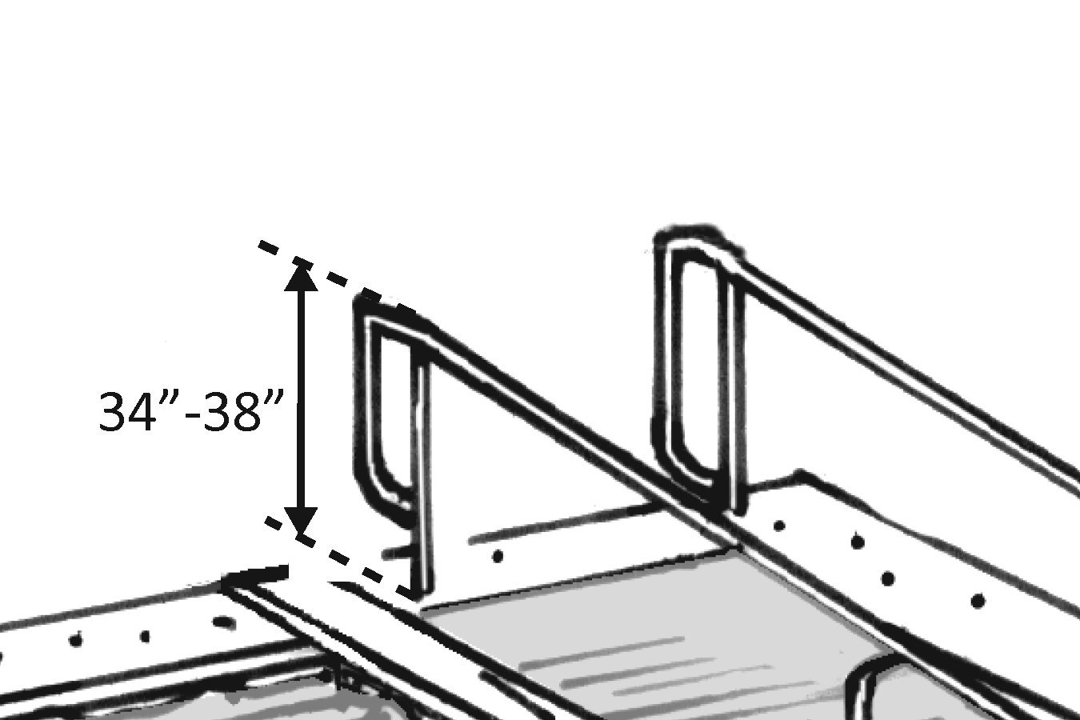 |  | Photo #: |  | • Change handrail height  •  •
P34 | If the handrail gripping surface is:  Circular, is the diameter no less than 1 ¼ inches and no greater than 2 inches?  Or  Non-circular, is the perimeter no less than 4 inches and no greater than 6 ¼ inches and the cross section no more than 2¼ inches? | □Yes □No  Measurement:  □Yes □No  Measurement: | 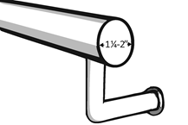  Or  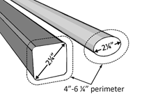 |  | Photo #: |  | • Replace handrail  •  •
P35 | TRANSFER WALL  If a transfer wall is provided:  Is there a clear deck space at the base of the transfer wall that is at least 60 inches wide and at least 60 inches long?  Note: A transfer wall allows a person to leave a mobility device, such as a wheelchair, transfer onto the wall and into the pool or spa. | □Yes □No  Measurement: | 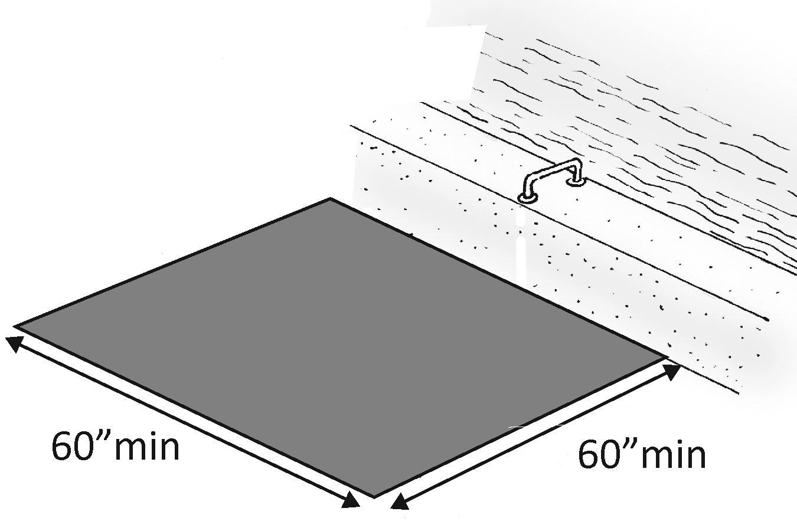 |  | Photo #: |  | • Add clear space  •  •
P36 | Is the slope of the clear deck space no greater than 1:48? | □Yes □No  Measurement: |  |  | Photo #: |  | • Regrade to 1:48 maximum slope  •  •
P37 | Is there at least one grab bar? | □Yes □No |  |  | Photo #: |  | • Add grab bar(s)  •  •
P38 | Is/are the grab bar(s) perpendicular to the pool wall? | □Yes □No |  |  | Photo #: |  | • Relocate grab bar(s)  •  •
P39 | Does/do the grab bar(s) extend the full depth of the transfer wall? | □Yes □No |  |  | Photo #: |  | • Add extensions  • Reconfigure grab bar(s)  •
P40 | Is the top of the grab bar(s) gripping surface at least 4 inches and no greater than 6 inches above the transfer wall? | □Yes □No  Measurement: |  |  | Photo #: |  | • Change grab bar height  •  •
P41 | If the grab bar(s) gripping surface is:  Circular, the diameter no less than 1 ¼ inches and no greater than 2 inches?  Or  Non-circular, is it no less than 4 inches and no greater than 4.8 inches in perimeter and no more than 2 inches in cross section? | □Yes □No  Measurement:  □Yes □No  Measurement: | 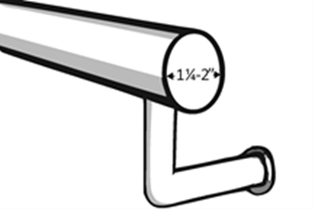 |  | Photo #: |  | • Replace grab bar(s)  •  •
P42 | Is the space between the grab bar(s) and projecting objects above at least 12 inches? | □Yes □No  Measurement: |  |  | Photo #: |  | • Relocate objects  •  •
P43 | Can the grab bar(s) support at least 250 pounds at any point on the grab bar(s), fastener, mounting device, or supporting structure? | □Yes □No  Max weight: |  |  | Photo #: |  | • Replace grab bar(s)  •  •
P44 | If there is one grab bar:  Is the clear deck space centered on the grab bar?  Is there at least 24 inches of clearance on both sides? | □Yes □No  □Yes □No  Measurement: | 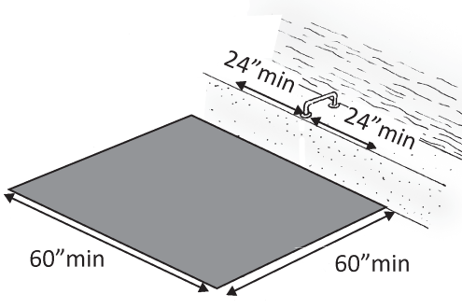 |  | Photo #: |  | • Relocate grab bar(s)  • Reconfigure space  •
P45 | If there are two grab bars:  Is the clear deck space centered on the clearance between the grab bars?  Is there at least 24 inches of clearance between the grab bars? | □Yes □No  □Yes □No  Measurement: | 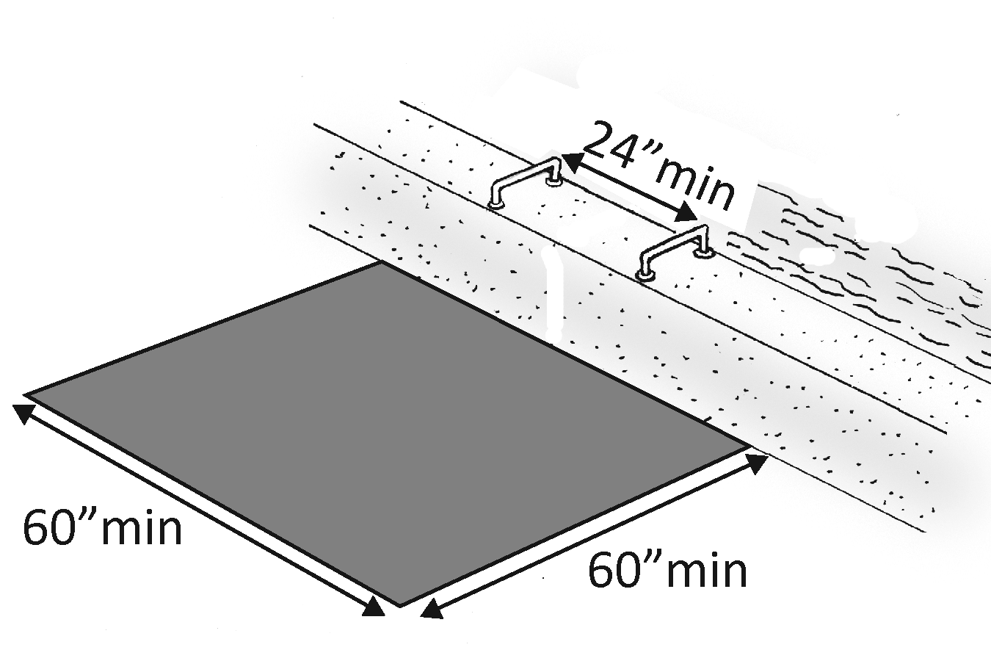 |  | Photo #: |  | • Relocate grab bar(s)  • Reconfigure space  •
P46 | Is the transfer wall:  No less than 16 inches and no greater than 19 inches in height, measured from the deck?  No less than 12 inches and no greater than 16 inches in depth?  No less than 60 inches in length? | □Yes □No  Measurement:  □Yes □No  Measurement:  □Yes □No  Measurement: | 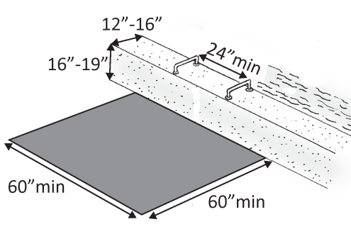 |  | Photo #: |  | • Change wall height  • Change wall depth  • Lengthen wall  •  •
P47 | Is the length of the transfer wall centered on the clear deck space? | □Yes □No |  |  | Photo #: |  | • Relocate wall  • Reconfigure clear deck space  •
P48 | Is the surface of the transfer wall smooth with rounded edges? | □Yes □No |  |  | Photo #: |  | • Resurface wall  •  •
P49 | TRANSFER SYSTEM  If a transfer system is provided:  Is there a transfer platform at the head of each system?  Is the transfer platform at least 19 inches deep and at least 24 inches wide?  Note: A transfer system has a platform and steps. Users transfer onto the platform from their wheelchair or other mobility device and bump in (and then out) of the pool on the steps. | □Yes □No  □Yes □No  Measurement: | 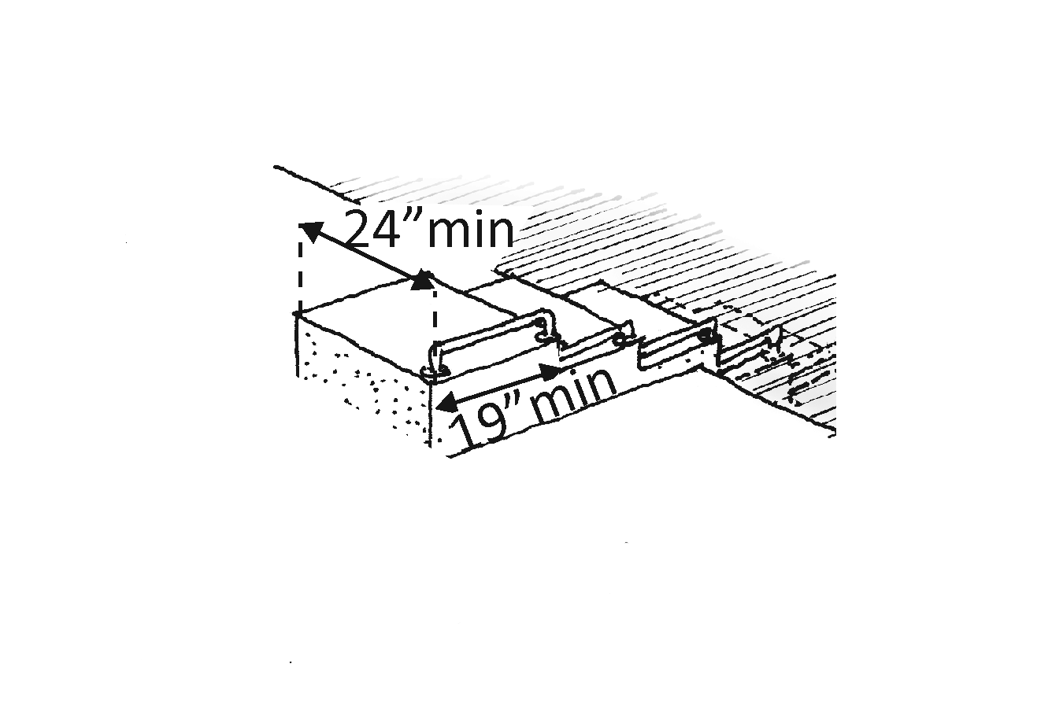 |  | Photo #: |  | • Install platform  •  •
P50 | Is the transfer platform no less than 16 inches and no greater than 19 inches in height, measured from the deck? | □Yes □No  Measurement: | 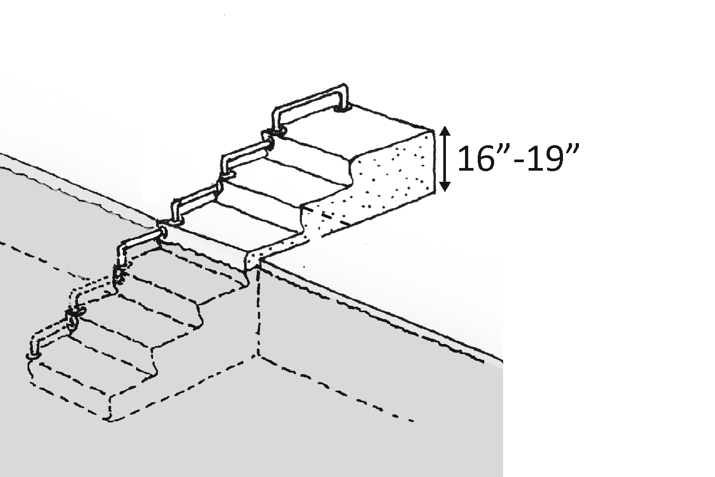 |  | Photo #: |  | • Change platform height  •  •
P51 | Is there a transfer space at least 60 inches wide and at least 60 inches long at the base of the transfer platform? | □Yes □No  Measurement: | 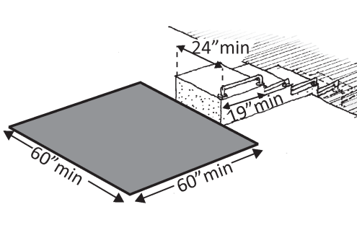 |  | Photo #: |  | • Add transfer space  • Reconfigure space  •
P52 | Is the slope of the transfer space no greater than 1:48? | □Yes □No  Measurement: |  |  | Photo #: |  | • Regrade to 1:48 maximum slope  •  •
P53 | Is the transfer space centered along a side of the transfer platform at least 24 inches long? | □Yes □No  Measurement: |  |  | Photo #: |  | • Relocate space  • Relocate platform  •
P54 | Is the side of the transfer platform serving the transfer space unobstructed? | □Yes □No |  |  | Photo #: |  | • Remove obstructions  • Relocate platform  •
P55 | Are transfer steps no greater than 8 inches in height? | □Yes □No  Measurement: | 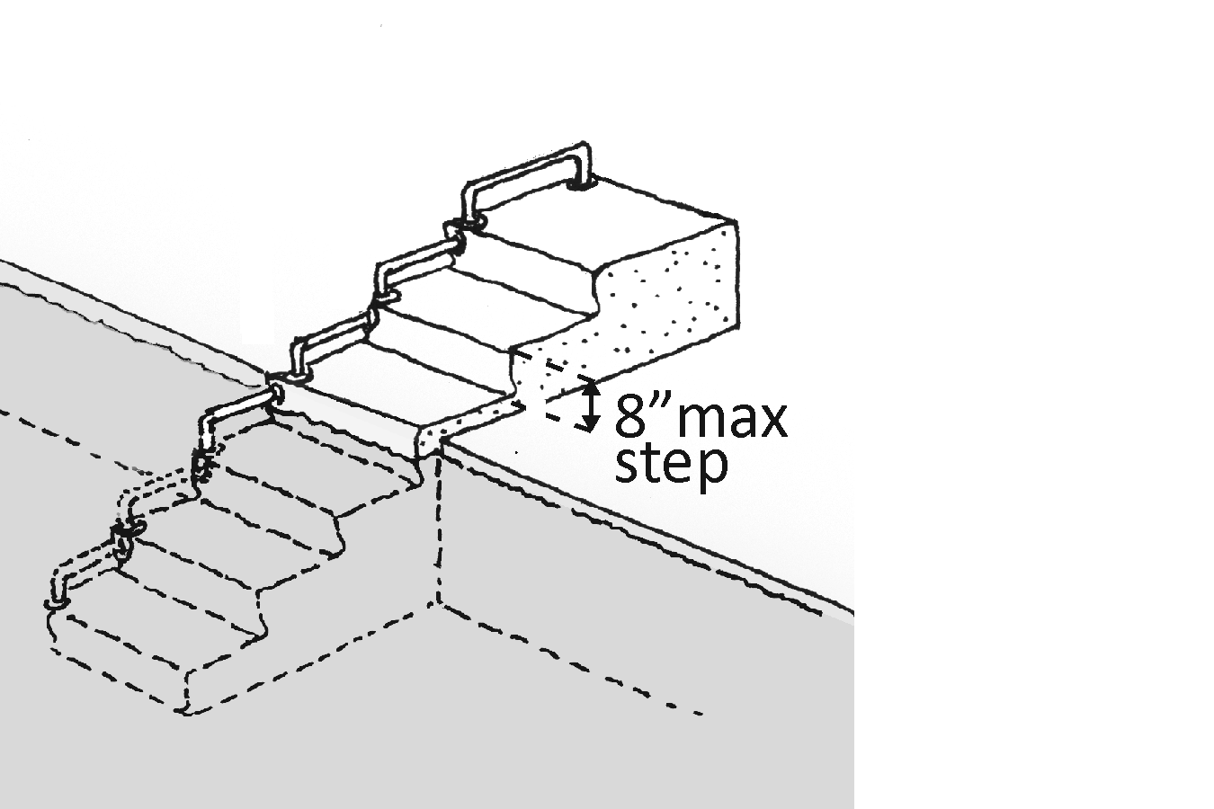 |  | Photo #: |  | • Change step height  •  •
P56 | Are transfer step treads:  At least 14 inches and no greater than 17 inches deep?  At least 24 inches wide? | □Yes □No  Measurement:  □Yes □No  Measurement: | 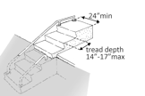 |  | Photo #: |  | • Change tread depth  • Change tread width  •
P57 | Does the surface of the bottom tread of transfer steps extend to a water depth of at least 18 inches below the stationary water level? | □Yes □No  Measurement: | 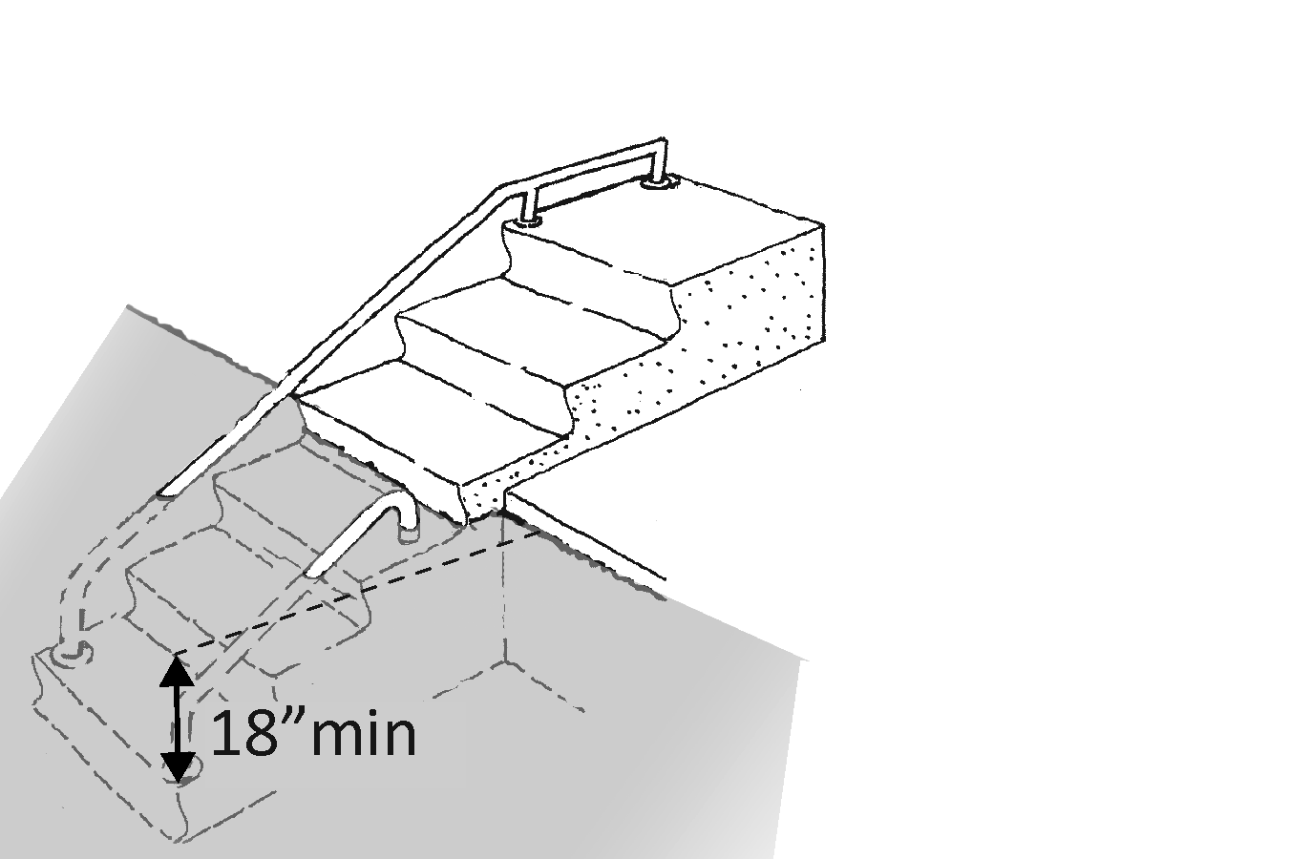 |  | Photo #: |  | • Alter steps  •  •
P58 | Is the surface of the transfer system smooth with rounded edges? | □Yes □No |  |  | Photo #: |  | • Resurface transfer system  •  •
P59 | Is there at least one grab bar on each transfer step and the transfer platform?  Or  Is there a continuous grab bar serving each transfer step and the transfer platform? | □Yes □No  □Yes □No |  |  | Photo #: |  | • Add grab bar (s)  •  •
P60 | Is there a grab bar on at least one side of the transfer system? | □Yes □No |  |  | Photo #: |  | • Add grab bar(s)  •  •
P61 | If there is a grab bar on each step, are the tops of the gripping surfaces at least 4 inches and no greater than 6 inches above each step and transfer platform? | □Yes □No  Measurement: |  |  | Photo #: |  | • Change grab bar height  •  •
P62 | If there is a continuous grab bar, is the top of the gripping surface at least 4 inches and no greater than 6 inches above the step nosing and transfer platform? | □Yes □No  Measurement: | 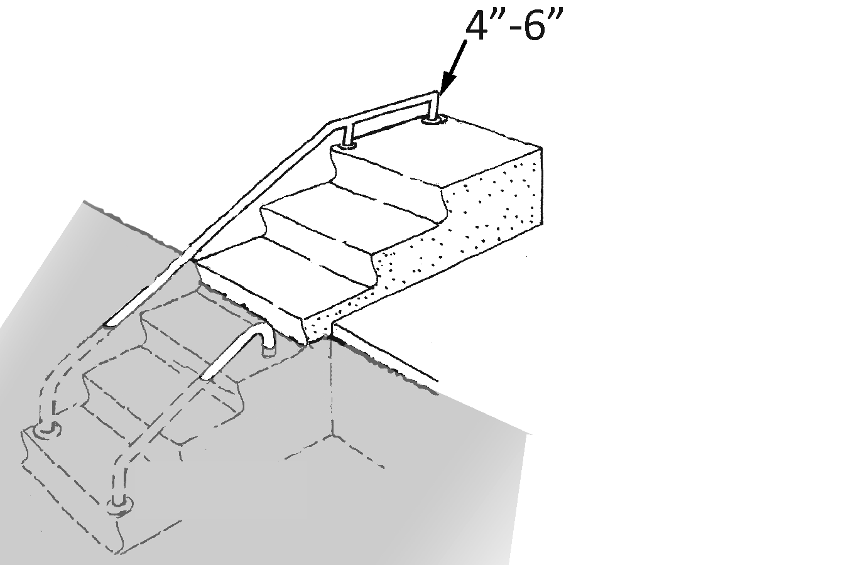 |  | Photo #: |  | • Change grab bar height  •  •
P63 | If the grab bar(s) gripping surface is:  Circular, is it no less than 1 ¼ inches and no greater than 2 inches in diameter?  Or  Non-circular, is the cross section no greater than 2 inches and the perimeter no less than 4 inches and no greater than 4.8 inches? | □Yes □No  Measurement:  □Yes □No  Measurement: | 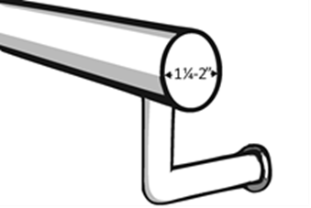 |  | Photo #: |  | • Replace grab bar(s)  •  •
P64 | Is the space between the grab bar(s) and projecting objects above at least 12 inches? | □Yes □No  Measurement: |  |  | Photo #: |  | • Relocate objects  •  •
P65 | Can the grab bar(s) support at least 250 pounds at any point on the grab bar(s), fastener, mounting device, or supporting structure? | □Yes □No  Max weight: |  |  | Photo #: |  | • Replace grab bar(s)  •  •
P66 | ACCESSIBLE POOL STEPS  If accessible pool steps are provided:  Are there handrails on both sides of the steps?  Note: Accessible pool steps assist with balance and support when moving from the pool deck and into and out of the water from a standing position. | □Yes □No |  |  | Photo #: |  | • Add handrails  •  •
P67 | Is the width between the handrails at least 20 inches and no greater than 24 inches? | □Yes □No  Measurement: | 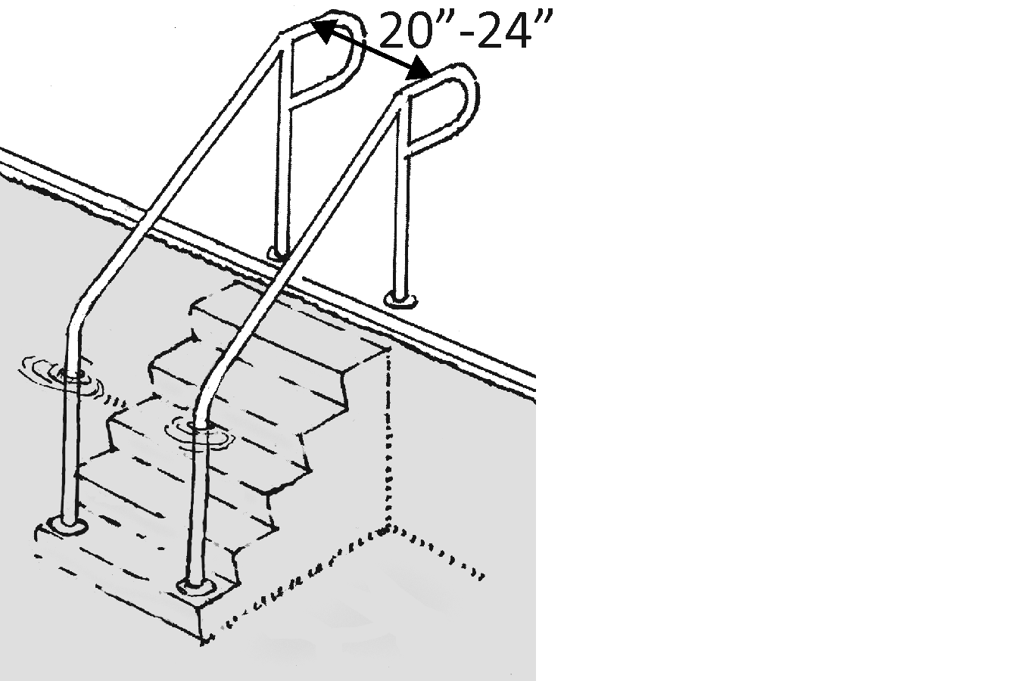 |  | Photo #: |  | • Relocate handrails  •  •
P68 | Is the top of the handrail gripping surface no less than 34 inches and no greater than 38 inches above the pool entry surface? | □Yes □No  Measurement: | 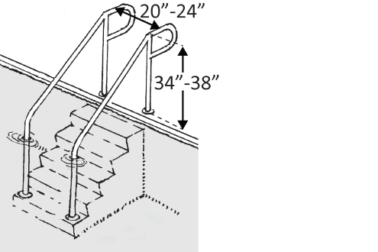 |  | Photo #: |  | • Change handrail height  •  •
P69 | If the handrail gripping surface is:  Circular, is the diameter no less than 1 ¼ inches and no greater than 2 inches?  Or  Non-circular, is the perimeter no less than 4 inches and no greater than 6 ¼ inches and the cross section no more than 2 ¼ inches? | □Yes □No  Measurement:  □Yes □No  Measurement: | Or |  | Photo #: |  | • Replace handrail  •  •
P70 | Do the handrails extend at least 12 inches horizontally beginning above the first riser nosing?  Note: Extensions at the bottom are not required | □Yes □No  Measurement: | 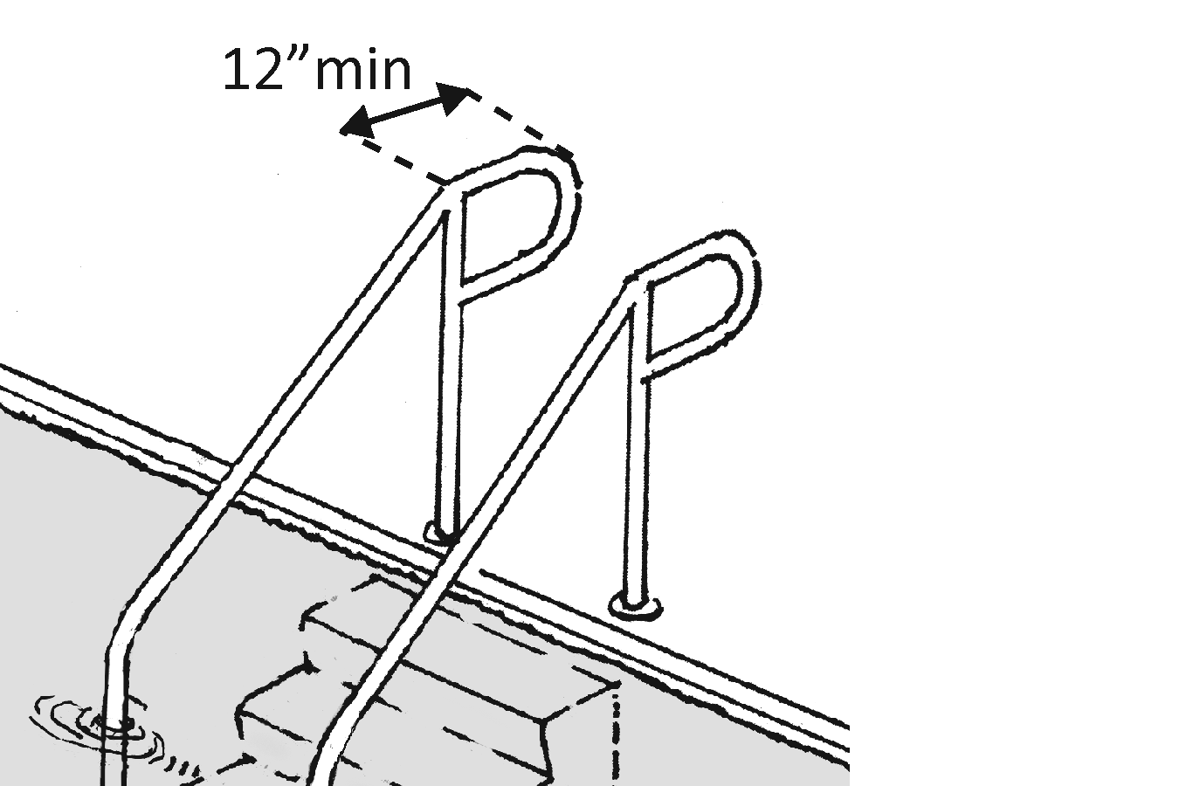 |  | Photo #: |  | • Add extensions  • Reconfigure handrails  •
P71 | Do the extensions return to a wall, guard or the deck surface? | □Yes □No | 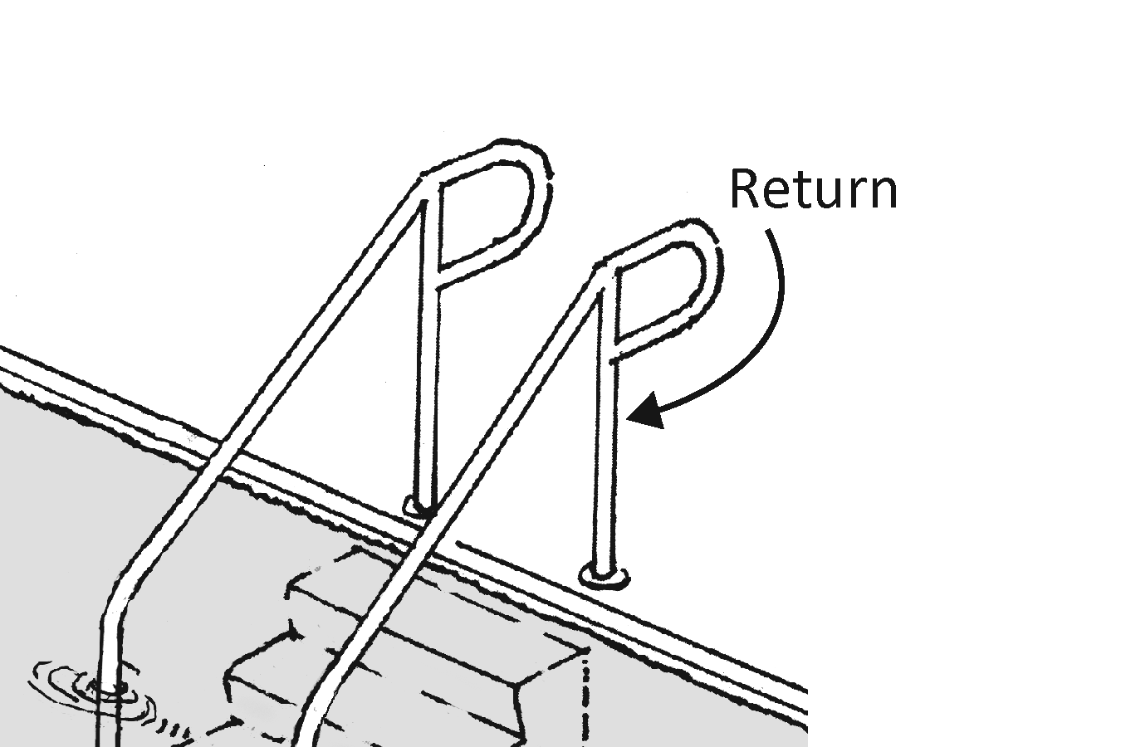 |  | Photo #: |  | • Reconfigure handrails  • Replace handrails  •
P72 | If a handrail is mounted on a wall, is the clear space between the handrail and wall 1½ inches? | □Yes □No  Measurement: |  |  | Photo #: |  | • Reconfigure handrails  •  •
P73 | Are riser heights of the steps uniform? | □Yes □No | 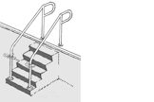 |  | Photo #: |  | • Alter risers  •  •
P74 | Are tread depths uniform? | □Yes □No | 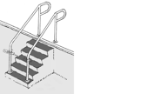 |  | Photo #: |  | • Alter treads  •  •
P75 | Are treads at least 11 inches deep? | □Yes □No  Measurement: | 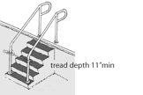 |  | Photo #: |  | • Alter treads  •  •
P76 | Is the radius of curvature at the leading edge of the step treads no greater than ½ inch? | □Yes □No  Measurement: |  |  | Photo #: |  | • Alter tread edges  •  •
P77 | If nosings project beyond the risers:  Is the underside of the leading edge curved or beveled?  Do nosings extend no greater than 1½ inches over the tread below? | □Yes □No  □Yes □No  Measurement: |  |  | Photo #: |  | • Alter nosings  •  •
P78 | If the riser slopes under the tread is the slope angle no greater than 30 degrees from vertical? | □Yes □No  Measurement: |  |  | Photo #: |  | • Alter riser slope angle  •  •
P79 | Are risers solid?  Note: Open risers are not allowed. | □Yes □No |  |  | Photo #: |  | • Alter risers  •  •
 |  | □Yes □No |  |  | Photo #: |  | •  •  •
 |  | □Yes □No |  |  | Photo #: |  | •  •  •
 |  | □Yes □No |  |  | Photo #: |  | •  •  •
 |  | □Yes □No |  |  | Photo #: |  | •  •  •

